Low Power Design Solution

Low power design is essential to emerging IC design. High performance computing (HPC) device suffers heat dispatching problem. Mobile device requires low stand-by power consumption. Power efficiency is the key for various applications.

GUC low power methodology provides a complete solution, including in-design power shut off methodology, multiple supply voltage, dynamic voltage frequency scaling methodology, low power DFT and physical design, low voltage library characterization and signoff margin, etc., to help customer to provide a power competitive solution.

PowerMagic®

Target | Methodology | Implementation Approach
Leakage Power Reduction | Power Shut Off (PSO) | External Power Shut Down
Leakage Power Reduction | Power Shut Off (PSO) | MTCMOS Power Gating / SRPG
Leakage Power Reduction | Library | Multi-VT, Low power cell (XOR/XNR/HA/Hold-Opt)
Dynamic Power Reduction | Frequency | Clock Gating, CTS clone/de-clone
Dynamic Power Reduction | Voltage & Freq. | Multi Supply Voltage (MSV), Low Voltage for Power Efficiency
Dynamic Power Reduction | Voltage & Freq. | Dynamic Voltage Frequency Scaling (DVFS)
Dynamic Power Reduction | Library | Multi-bit flip-flop, Low power cell (XOR/XNR/HA/Hold-Opt)
Dynamic IR Prevention | Physical Design / DFT | Effective De-cap Insertion, Power Density Prediction, IR Mitigation with Early-stage Bump Current Prediction, In-rush Current Budgeting
Peak Power Reduction | DFT | IR-power aware BIST Memory Grouping, Scan Clock Grouping, Power Aware Scan, Low Power ATPG
Peak Power Reduction | Physical Design | Min-current Power Switching Routing, Power-up sequence optimization, Distributed Clock Useful Skew to Reduce Peak Current
Implementation | Auto Power Plan (APP), Activity-Based Power Optimization
Verification | Low Power Intent and Verification (UPF/VCLP), LP-EC, Power Integrity (Redhawk-SC/Voltus)
GUC Propertied Library, IP and Tool Kits

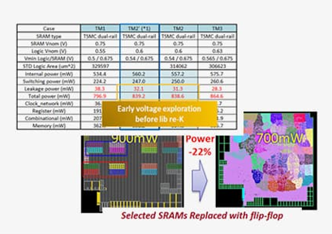 |  |  | 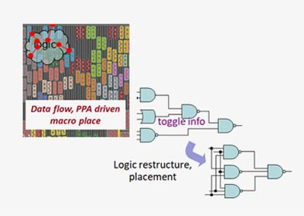
Design architecture exploration  - Predictable multi-objective PPA (leakage vs. dynamic power) early exploration  - Design activity driven, Vmin aware memory and flip-flop concurrent configuration |  |  | Power aware physical implementation  - Data flow, PPA driven macro auto-placement  - Activity driven logic restructuring and placement for power reduction and flip-flop concurrent configuration  - Proprietary auto power switch stitch for ramp-up current mitigation
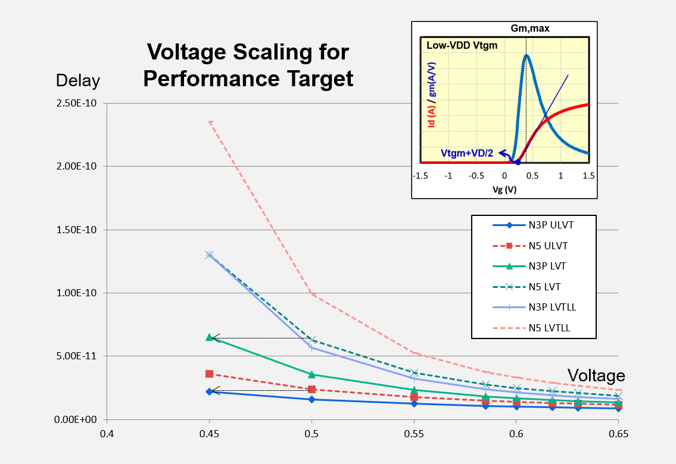 |  |  |  | 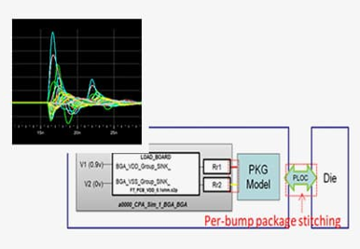
Low voltage library characterization, customization  - MV/AVS sign-off customization  - Library characterization for N3P, N4P/N5, N6/N7 and mature processes  - Robust timing margin characterization for high variation at low VDD condition  - GUC proprietary low power library benefit average 20% power reduction |  |  |  | Production of MSV/DVFS, and voltage binning  - Robust STA sign-off for cross power domain variation and voltage binning  - Robust CP/FT power integrity by co-sim with ATE probe card / load board model  - Production BKM for leakage in immature process
Low Voltage for Power Efficiency

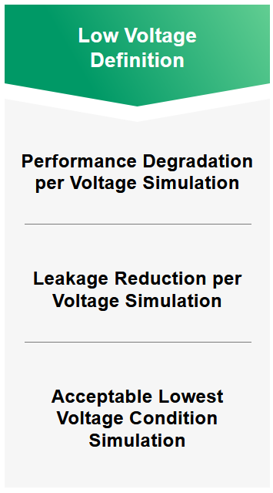 | 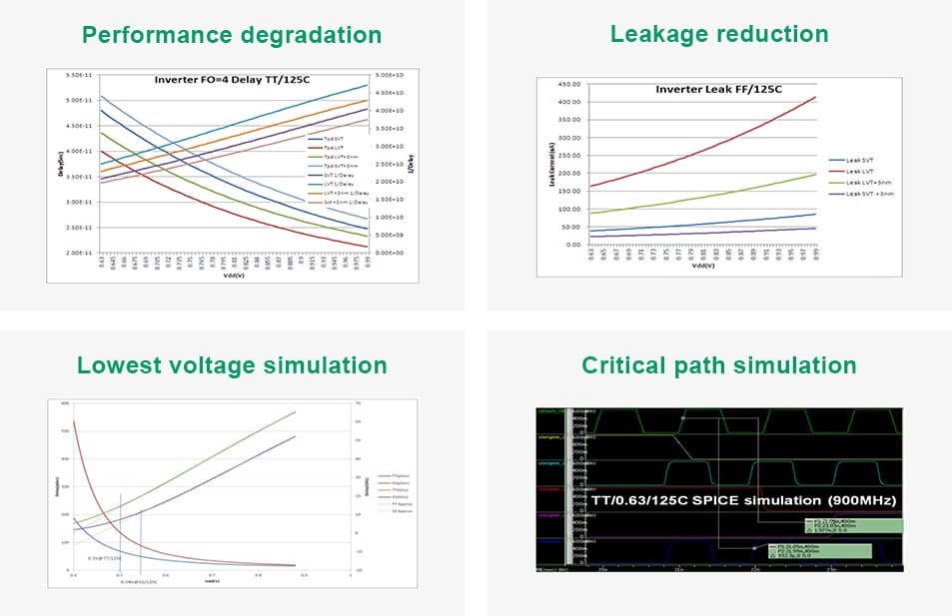
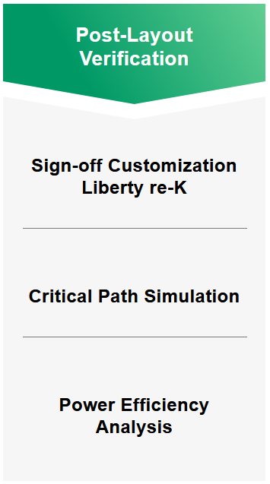 |  | 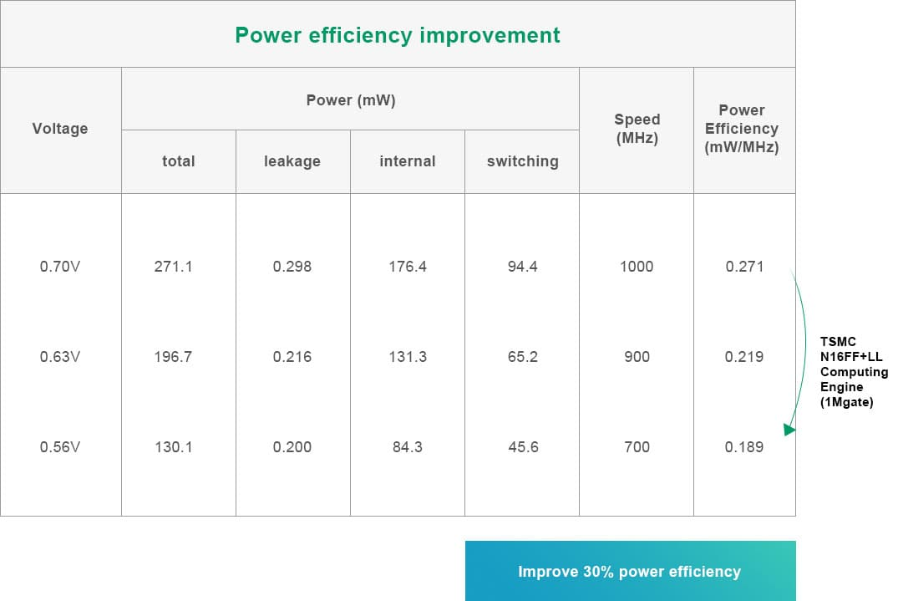

Success Story

Process | Gate Count | Speed | Application | Key Feature
5nm | 5600M | 2GHz | Data Center AI | PSO + Multi-VT
5nm | 150M | 900MHz | Network | MTCMOS + MSV + Multi-VT
5nm | 2650M | 1GHz | Data Center AI | Low VDD + MSV + Multi-VT
7nm | 81M | 500MHz | AI Inference | PSO + Multi-VT
12nm | 140M | 800MHz | AI Inference | MTCMOS + MSV + Multi-VT
12nm | 147M | 2.2GHz | Drone | MSV + Multi-VT
16nm | 100M | 2GHz | AP Testchip | PSO/MTCMOS + Multi-VT + DVFS
16nm | 30M | 2GHz | CPU | PSO/MTCMOS + Multi-VT + MSV
22nm | 13M | 480MHz | Multimedia | MTCMOS
22nm | 30M | 600MHz | Multimedia | MSV MTCMOS
28nm | 100M | 1.5GHz | Drone | PSO/MTCMOS + Multi-VT + MSV
28nm | 100M | 700MHz | SSD SoC | PSO/MTCMOS + Multi-VT
28nm | 30M | 500MHz | SSD SoC | PSO/MTCMOS + Multi-VT + DVFS
28nm | 6M | 800MHz | UFS Controller | PSO + Multi-VT
28nm | 50M | 400MHz | Digital Camera | PSO/MTCMOS + Multi-VT
28nm | 33M | 1.6GHz | Processor | PSO/MTCMOS + Multi-VT
40nm | 5M | 300MHz | Camcorder | PSO + Multi-VT + Customized IO
65nm | 8M | 300MHz | Cell Phone | PSO + Multi-VT + DVFS + Data Retention

