Production Engineering
The service includes
- New product introduction
- Skew characterization
- Yield and quality enhancement
- Physical failure analysis.

Yield Management
- ATE measurement vs system performance correlation for device and test condition optimization
- Manufacturing data automatic reporting and defense methodology
- Yield system and data analysis softwares
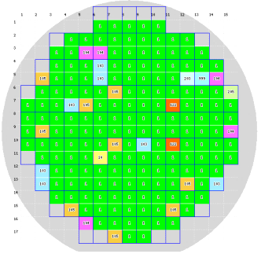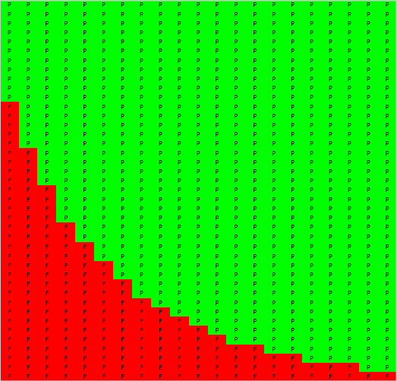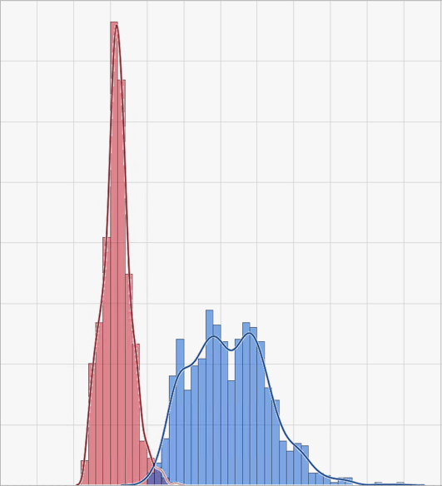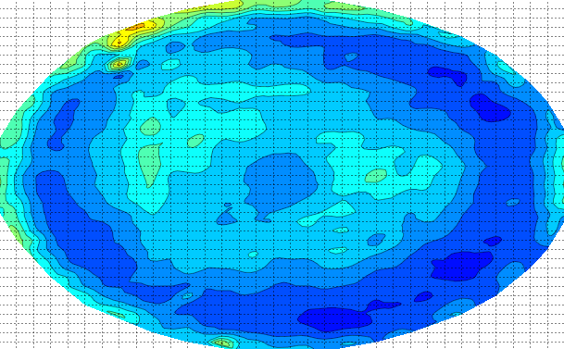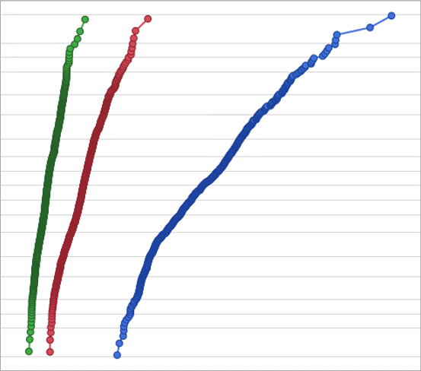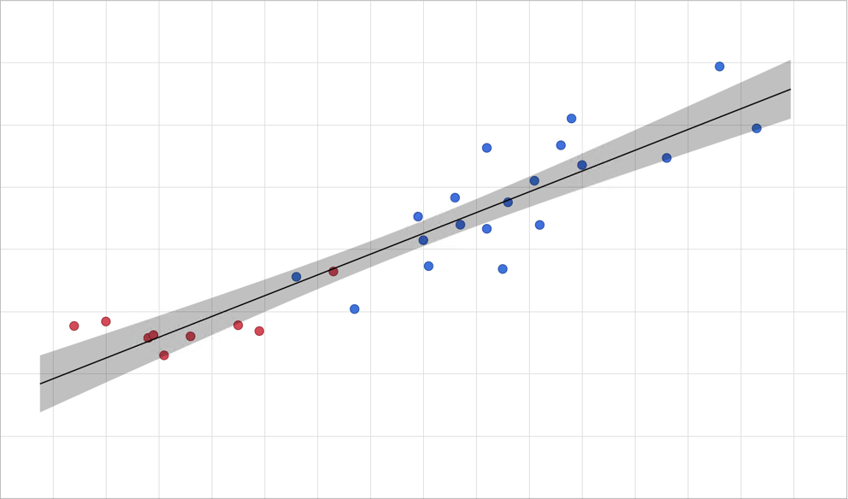
Yield map
notch
X-axis
Y-axis
Shmoo
Parameter
Percentage
Histogram
Die coordinate_X
Die coordinate-Y
Contour
Parameter
Percentage
Probability
Parameter-1
Parameter-2
Correlation
Manufacturing Screen
- Production test SYL & SBL control
- DPAT (Dynamic Part Average Test) outlier screen option
- Geometrical GDBC (Good Die in Bad Cluster) and GDRB (Good Die at Repeating Bad) screen option
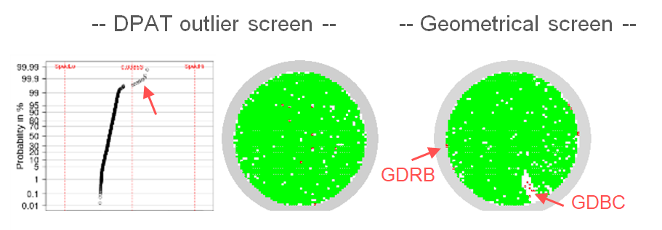
Failure Analysis
- Partner with local labs to perform non-destructive and destructive FA for RMA or yield improvement
- FIB support for circuit repair verification
- DFT DCScan & MBIST diagnosis and PFA
