Success Story
<前言>
GUC has been a key IP provider for both GUC ASIC and IP ecosystem. The IP portfolio includes HBM, Die-to-Die (2.5D) IP, Die-on-Die (3D) IP, Mixed Signal Front-End IP and Foundation IP. The following are some success stories that GUC would like to share with you.

<第一大單元>
--------------------
- Mixed Signal Front-End and Foundation IP

GUC owns the proprietary embedded memory design and verification know-how to offer exceptional SRAM customization service based on TSMC’s SRAM cells, to enable customer’s product success with great differentiation value. The following are a few examples to show case the customization value in PPA.

Case 1-1 (1)
- 1-port register file design platform on N16/N7
  - N7 compiler level benchmark (average of 100 instances) vs. TSMC
    - Area: 25% smaller
    - Read/write power 10% smaller, Leakage 45% smaller

Case 1-2 (2)
- 1Based on this design platform, we provided N7 ultra-high-speed 1-port and 1R/1RW 2-port SRAM for supercomputing chip
  - Delivered in 4 months, PPA much beyond customer’s expectation

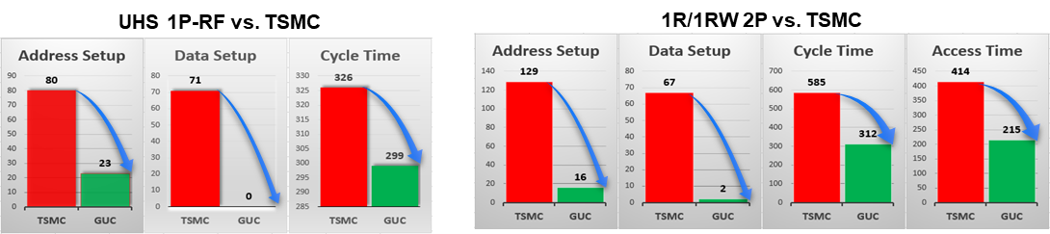

Case 1-2
- Special behavior customization for Networking application: N6 Async-R/Sync-W 2P-SRAM
  - Fast access, remarkable area gain vs. latch-based synthesis approach (>9X saving)

-----------------------------
Case 1-3
GUC Announces a New Performance Monitor Methodology and Solution, Published on IEEE
Monitoring system-on-chip performance under process, voltage, and temperature (PVT) variations is very challenging, especially when the parasitic effects dominate the whole chip performance in advanced process nodes. Most of the previous works presented the performance monitoring methodologies based on known/predicted candidates of critical paths under different operating conditions. However, those methodologies may fail when the critical path is misrecognized or mispredicted. This paper proposes a novel machine-learning based chip performance monitoring methodology to accurately match the chip performance without requiring the information of critical paths under various PVT conditions. The experimental results based on measured chip performance show that the proposed methodology can achieve 98.5% accuracy in the worst case under wide-range PVT variations.
For more information:
https://ieeexplore.ieee.org/abstract/document/9586155

<第二大單元>

- HBM, Die-to-Die, and Die-on-Die IP

For supporting Advanced Package, GUC has developed a complete IP portfolio, covering Die-to-Die (2.5D) IP such as GLink and UCIe, and HBM IP. These IPs go through full silicon validation and are applicable to AI/HPC/Networking products.

------------------
2-1 Die-to-Die, and Die-on-Die IP

Awards

GUC UCIe 32G won 2024 EE Awards in the category of Best IP/Processor
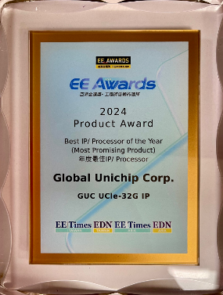

GUC GLink-2.5D won 2022 World Electronics Achievement Awards in the category of EDA/IP/Software


GUC GLink-2.5D won 2021 EE Awards as the Promising Product of the Year.

GUC GLink-3D won 2022 EE Awards for Best IP/Process of the Year.
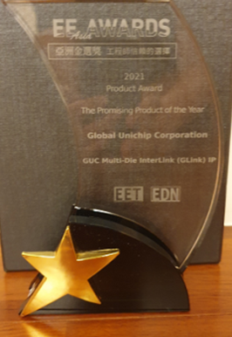


----------------
2-1-1 GUC Announces Successful Launch of Industry's First 32G UCIe Silicon on TSMC 3nm and CoWoS Technology

Global Unichip Corp. (GUC) announced the successful launch of industry’s first Universal Chiplet Interconnect Express™ (UCIe™) PHY silicon, achieving a data rate of 32 Gbps per lane, the highest speed defined in the UCIe specification. The 32G UCIe IP, supporting UCIe 2.0, delivers an impressive bandwidth density of 10 Tbps per 1 mm of die edge (5 Tbps/mm full-duplex). This milestone was achieved using TSMC’s advanced N3P process and CoWoS® packaging technologies, targeting AI, high-performance computing (HPC), xPU, and networking applications.
For more information:
https://www.guc-asic.com/en/news-cont.php?k=GUCPR_202503_ENG

----------------
2-1-2 GUC Taped Out UCIe 40Gbps IP using Adaptive Voltage Scaling (AVS)

GUC had successfully taped out Universal Chiplet Interconnect Express™ (UCIe™) PHY IP with 40Gbps per lane on TSMC’s N5 process, beyond UCIe’s highest speed, for AI/HPC/xPU/Networking applications. UCIe 40G chiplet interface provides industry leading bandwidth density 1,645 GB/s per mm of die edge. The IP supports any speed up to 40Gbps and uses Adaptive Voltage Scaling (AVS) to reduce supply voltage achieving 2x better power efficiency for required speed. The chip is assembled using TSMC’s CoWoS® (Chip on Wafer on Substrate) advanced packaging technology.
For more information:

GUC Taped Out UCIe 40Gbps IP using Adaptive Voltage Scaling (AVS)

-----------------

2-1-3 GUC Taped Out UCIe 32G IP using TSMC's 3nm and CoWoS Technology
GUC had successfully taped out Universal Chiplet Interconnect Express™ (UCIe™) PHY IP with 32Gbps per lane, the highest UCIe speed, for AI/HPC/xPU/Networking applications. UCIe 32G chiplet interface provides industry leading bandwidth density 10 Tbps per 1mm of die edge (5 Tbps/mm full-duplex). The chip uses TSMC’s N3P silicon process and CoWoS® advanced packaging technology.
For more information:
https://www.guc-asic.com/en/news-cont.php?k=202401_PR

2-2-4 GUC Taped Out 3nm 8.6Gbps HBM3 and 5Tbps/mm GLink-2.5D IP using TSMC Advanced Packaging Technology

GUC had successfully taped out a test chip with an 8.6Gbps HBM3 Controller and PHY and GLink 2.3LL for AI/HPC/xPU/Networking applications. GLink 2.3LL die-to-die interface provides best-in-class Power, Performance, and Area (PPA) with 5ns end-to-end latency, 5Tbps/mm beach-front (2.5T full-duplex) and 0.27pJ/bit power efficiency. The test chip’s taped out at the TSMC 3nm process and adopts the TSMC CoWoS® advanced packaging technology.
For more information:
https://www.guc-asic.com/en/news-cont.php?k=3nm_HBM_GLink

--------------------

2-1-5 GUC Unveils GLink 2.3LL, The World’s Most Powerful D2D Interconnect IP Using 2.5D Technology

GLink 2.3LL (GUC’s die-to-die Link) interface IP for TSMC CoWoS® and InFO chiplets integration platforms passed silicon validation and has been showcased at the TSMC 2022 Open Innovation Platform® (OIP) Ecosystem Forum in Santa Clara Convention Center
For more information:
https://www.guc-asic.com/en/news-cont.php?k=GLink2022

---------------
2-1-6 GUC Announces GLink-3D Die-on-Die Interface IP using TSMC 5nm and 6nm Process for 3DFabricTM Advanced Packaging Technology

GUC announces the world first 3D interconnect IP, GLink-3D, to support future AI, HPC, and Networking applications.
For more information:
https://www.guc-asic.com/en/news-cont.php?k=GLink3D

2-2 HBM IP

Awards
GUC HBM3 IP won 2023 EE Awards for Best IP/Process of the Year.
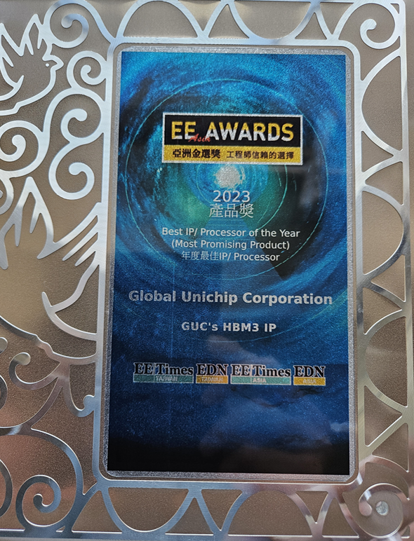

--------------------

2-2-1 GUC Announces Tape-Out of the World's First HBM4 IP on TSMC N3P

The HBM4 IP supports data rates of up to 12Gbps under all operating conditions. By leveraging a proprietary interposer layout, GUC has optimized signal integrity (SI) and power integrity (PI) to achieve these high speeds for all types of CoWoS technology. In line with previous GUC HBM, GLink, and UCIe IPs, this HBM4 IP integrates proteanTecs’ interconnect monitoring solution to provide high visibility for testing and characterizing the PHY while improving in-field performance and reliability for end products.
For more information:
https://www.guc-asic.com/en/news-cont.php?k=GUCPR_202504_ENG

-------------------------
2-2-2 GUC Announces Adoption of HBM3E IP by CSP Data Center

GUC is pleased to announce that its 3nm HBM3E Controller and PHY IP have been adopted by a leading Cloud Service Provider (CSP) and several High-Performance Computing (HPC) solution providers. This cutting-edge ASIC features the latest 9.2Gbps HBM3E memory technology.
For more information:
https://www.guc-asic.com/en/news-cont.php?k=202409_PR

-----------------------
2-2-3 GUC Announced 5nm HBM3 PHY and Controller Silicon Proven at 8.4 Gbps

GUC announced that they have silicon proved 8.4 Gbps HBM3 solution on TSMC’s 5nm process technology. The platform was demonstrated at the Partner Pavilion of the TSMC 2023 North America Technology Symposium. It contains full functional HBM3 Controller and PHY IP and vendor’s HBM3 memory using TSMC’s industry leading CoWoS® technology.
For more information:
https://www.guc-asic.com/en/news-cont.php?k=202309_PR

------------------
2-2-4 GUC Taped Out 3nm 8.6Gbps HBM3 and 5Tbps/mm GLink-2.5D IP using TSMC Advanced Packaging Technology

GUC had successfully taped out a test chip with an 8.6Gbps HBM3 Controller and PHY and GLink 2.3LL for AI/HPC/xPU/Networking applications. GLink 2.3LL die-to-die interface provides best-in-class Power, Performance, and Area (PPA) with 5ns end-to-end latency, 5Tbps/mm beach-front (2.5T full-duplex) and 0.27pJ/bit power efficiency. The test chip’s taped out at the TSMC 3nm process and adopts the TSMC CoWoS® advanced packaging technology.
For more information:
https://www.guc-asic.com/en/news-cont.php?k=3nm_HBM_GLink

----------------------
2-2-5 GUC Demonstrate World’s First HBM3 PHY, Controller, and CoWoS Platform at 7.2 Gbps

GUC announced that they have silicon proved their 7.2 Gbps HBM3 solution, using SK hynix’s first available HBM3 samples. The platform was demonstrated at the Partner Pavilion of the TSMC 2022 North America Technology Symposium; it contained an HBM3 Controller, a PHY, GLink-2.5D die-to-die interface, and a 112G SerDes. The platform supports both the TSMC CoWoS-S (silicon Interposer) and the CoWoS-R (organic interposer) advanced packaging technologies.
For more information:
https://www.guc-asic.com/en/news-cont.php?k=HBM3_SKh

