Success Story

GUC provides 2.5D and 3D Multi-die Advanced Packaging Technology Platform to serve ASIC customers in AI/HPC/Networking application. GUC’s Total 2.5D/3D ASIC service solutions include critical IP (UCe, GLink-2.5D/GLink-3D and HBM), 2.5D/3D packaging (CoWoS, InFO, SoIC and System on Wafer) design & SI/PI co-sim, and 2.5D/3D manufacturing & production.

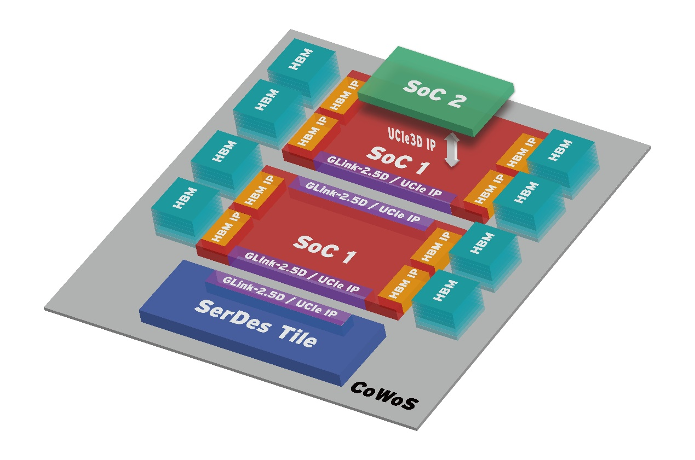
[Figure] GUC 2.5D and 3D Multi-die Advanced Packaging Technology Platform

- GUC Provides 3DIC ASIC Total Service Package to AI/HPC/Networking Customers
GUC announces that its GLink-3D IP for TSMC 3DFabricTM SoIC-X 3D stacking platform passed comprehensive silicon testing, validating 3DIC interface hardening flow.
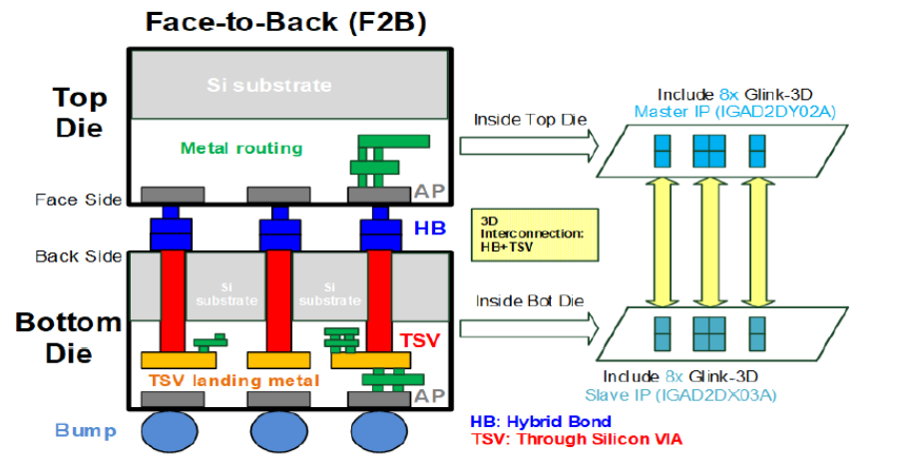
For more information:
https://www.guc-asic.com/en/news-cont.php?k=202404_PR

- GUC Announces 2.5D and 3D Multi-Die APT Platform for AI, HPC, Networking ASICs
GUC announces the availability of a platform to shorten design cycles and for low risk, high yield production of ASICs adopting TSMC 2.5D and 3D Advanced Packaging Technology (APT). The platform supports TSMC’s CoWoS-S, CoWoS-R, and InFO technologies. GUC provides a total solution: silicon-proven interface IPs, CoWoS® and InFO silicon-correlated design, signal and power integrity, thermal simulation flows, and high volume product proven DFT and production tests.

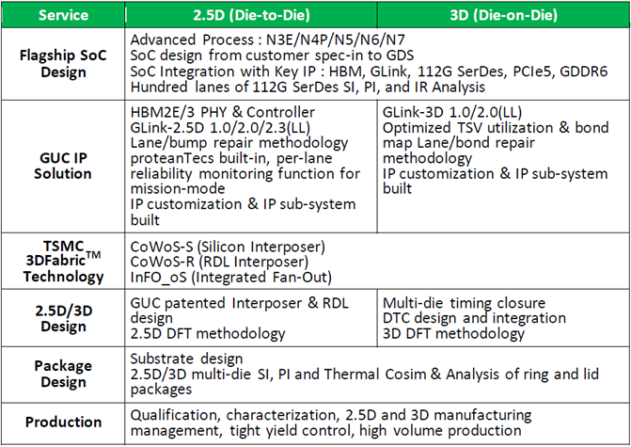
[Table] GUC provides 2.5D and 3D multi-die APT platform solution for AI, HPC, Networking ASICs

For more information:
https://www.guc-asic.com/en/news-cont.php?k=apt_platform

- GUC Tapes Out AI/HPC/Networking Platform on TSMC CoWoS® Technology Validating 7.2 Gbps HBM3 Controller and PHY, 112G-LR SerDes and GLink-2.5D IPs
GUC had successfully taped out AI/HPC/Networking CoWoS® Platform with 7.2 Gbps HBM3 Controller and PHY, 112G-LR SerDes and GLink-2.5D IPs. The main die of the platform contains the world’s first HBM3 Controller and PHY IP with a record-high 7.2 Gbps performance. The platform meets strict signal and power integrity (SI and PI) requirements of 112G-LR SerDes routed through TSMC CoWoS technologies.
For more information:
https://www.guc-asic.com/en/news-cont.php?k=HBM3

- FuriosaAI and GUC Partner on RNGD, the Most Efficient AI Accelerator for LLMs
GUC has been crucial in helping FuriosaAI to achieve an aggressive timeline for RNGD. Developing a new AI accelerator – especially one like RNGD, which utilizes advanced technology like HBM3 and a large-scale 653mm2 SoC with 40 billion transistors – is only possible with excellent partners like GUC, which brings deep expertise in designing system-on-chip (SoC) solutions.
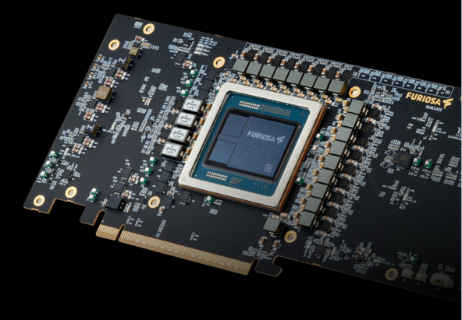
For more information:
https://www.guc-asic.com/en/news-cont.php?k=20240731_PR

- GUC Tapes Out Complex 3D Stacked Die Design on Advanced FinFET Node Using Cadence Integrity 3D-IC Platform
Global Unichip Corporation (GUC), a leading global ASIC provider, has successfully taped out a complex 3D stacked die design on an advanced FinFET node process. The design, which involves a memory-on-logic configuration achieved with a wafer-on-wafer (WoW) structure using a flip-chip chip scale package, was created using the Cadence Integrity 3D-IC Platform. Seamless integration between the Cadence Integrity System Planner and Cadence Innovus Implementation System in the Integrity 3D-IC platform enabled the die-to-die interface planning and hierarchical die stacking in this complex design. This WoW design has been validated with first-pass silicon success.
For more information:
https://www.cadence.com/zh_CN/home/company/newsroom/press-releases/pr/2023/guc-tapes-out-complex-3d-stacked-die-design-on-advanced-finfet-node-using-cadence-integrity-3d-ic-platform.html

