Success Story
AI & HPC

At the forefront of semiconductor innovation, GUC specializes in designing cutting-edge AI and HPC chips that leverage advanced process technologies and sophisticated packaging solutions. Our expertise includes seamless integration of HBM memory dies and high-speed SerDes, delivering exceptional data bandwidth and operational efficiency. We provide comprehensive system-level solutions that enhance power, signal, and thermal integrity to maximize performance. Leveraging our chiplet design expertise and die-to-die interconnect IPs, we enable scalable, low-latency architectures. With proven experience in full-reticle die sizes, optimized thermal design power, and intricate subsystem integration, we empower customers to overcome the challenges of today’s compute-intensive workloads. Explore the following cases to discover our engineering excellence in AI and HPC applications.

Case 1 for HPC Application
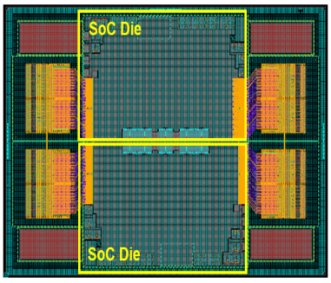
- TSMC N3 process
- 2GHz (Main clock)
- HBM3E with Interposer
- GLink-2.5D for D2D interconnect with 2 SoCs
- CPU, DDR, PCIe, Accelerator

Case 2 for AI Application
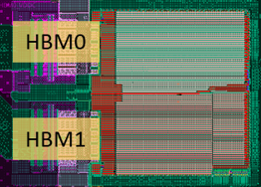
- TSMC N5 process
- > 5000Mgates
- 1GHz (Main clock)
- HBM3 with Interposer, PCIe Gen5
- TDP ~150W

