Success Story
Networking

GUC delivers advanced networking ASIC solutions tailored to the diverse requirements of modern infrastructure, from hyperscale datacenter switches to power-efficient optical networking. Our expertise spans high-performance CPU implementation, high-lane-count SerDes integration, low-power design, and advanced packaging solutions. For datacenter switches and Optical Transport Network (OTN), we enable ultra-high bandwidth with high-speed SerDes solutions while ensuring strong signal integrity, power integrity, and thermal integrity. In optical networking applications, we optimize low-power, low-voltage designs with compact packaging and enhanced power integrity. With deep experience across these domains, we empower customers to develop next-generation networking solutions that achieve high throughput, energy efficiency, and reliable performance. Explore the following cases to discover our engineering excellence in Networking applications.

Case 1 for Coherent Optical Application
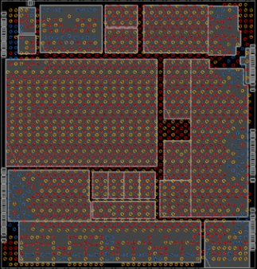
- TSMC N5 process
- > 150Mgates
- 900Mhz (Max clock)
- ADC, DAC, SerDes, SGMII, PVT sensor
- Low Voltage: 0.45V, 6W, AVS design

Case 2 for Data Center Switch Application
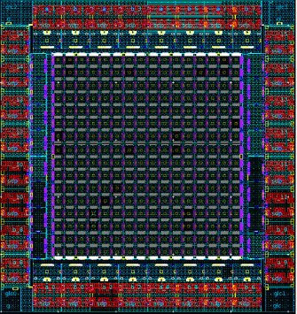
- TSMC N7 process
- > 3000Mgates, 1500Mbs SRAM
- 256 CPU cores
- 256 lanes of 112G SerDes
- TDP > 700W

Case 3 for Datacenter Switch Application
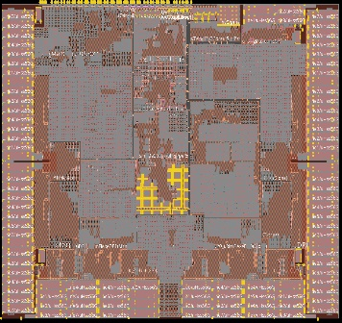
- TSMC N12 process
- > 390Mgates, 790Mbs SRAM
- 100 lanes of 56G SerDes
- GUC TCAM, LVDS, PLL, THM, CPM
- TDP > 120W
TDP > 124X

Case 4 for Optical Transport Network (OTN) Application
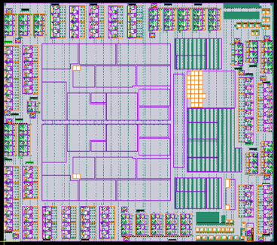
- TSMC N28 process
- > 240Mgates, 124Mbs SRAM (11K insts.)
- 750Mhz (Max clock)
- 90 lanes of 28G SerDes
- TDP > 100W

