Success Story
Automotive

GUC offers industry-leading, customized ASIC design services tailored for automotive products, covering a wide range of applications such as ADAS, autonomous driving, digital cockpits, radar, LiDAR, cameras, microphones, and more. By leveraging optimized process design technologies and advanced packaging solutions, GUC leads the way in enabling the success of automotive products. Our solutions address the growing demand for exponential computational power while adhering to ISO 26262 and AEC-Q100 standards, ensuring high quality and reliability for our customers. Explore the following cases to discover our engineering excellence in automotive applications.

Case 1 for ADAS Application
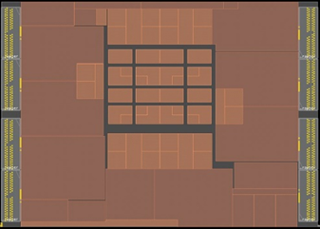
- TSMC N5A process
- 1.5B Gates
- 1.4GHz (Main clock)
- PCIe-Gen5/DDR5/USB 2.0 /USB3.1/MIPI /eDP/DP/MPHY
- APR for safety island with Function Safety Format

Case 2 for LiDAR Application
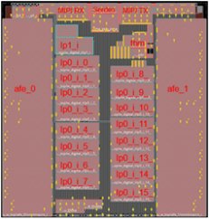
- TSMC N16FFC process
- Power on and in-system-test BIST
- AEC-Q100 grade2
- MIPI RX/TX and Serdes
- AFE and ADC

