Success Story
Miscellaneous
(Inc. Storage, Consumer, Industrial)

Consumer, Storage, and Industrial applications are increasingly integrating advanced functionality, driving the need for optimized process nodes and low-power design expertise to deliver cost-effective solutions. At GUC, we provide industry-leading low-power design solutions to enhance power efficiency, combined with IP subsystem integration capabilities and comprehensive system design solutions ensuring power, signal, and thermal integrity. With extensive experience across multiple process nodes and application segments, GUC empowers customers to develop high-quality, low-power, and cost-effective products. Explore the following cases to discover our engineering excellence in Consumer, Storage, and Industrial applications.

Case 1 for Consumer Application
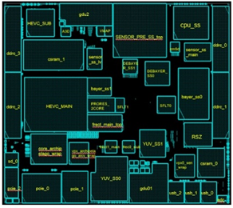
- TSMC N6 process
- > 450M Gates, SRAM 370Mbits
- LPDDR4/5 6400Mbps/PCIe-Gen4/Display-IF/Sensor-IF
- 3-Level Hierarchical Design
- Low power with power switch

Case 2 for Industrial Application
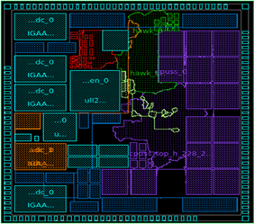
- TSMC N22ULL process
- > 3.8M Gates, SRAM 11.5Mbits
- GUC 12bit 200MHz ADC
- Manual Analog signal and power route
- LDO for ADC/PLL and core std/sram

Case 3 for Storage Application
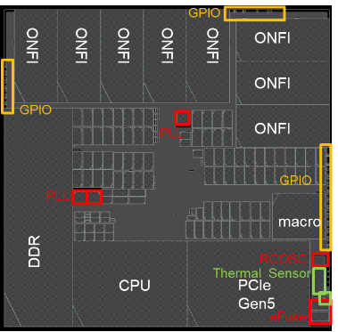
- TSMC N12FFC process
- > 40M Gates, SRAM 140Mbits
- 1200MHz/0.72V (Top clock frequency)
- PCIe Gen5x4 & ONFI5.0 IO
- 7.72W TT/0.8V/85C

