版型說明：
外層(白)：簡易文案，標題及短敘述，使用者可點選「了解更多」進入內層
內層(藍)：頁面內視窗顯示詳細的圖文內容，可點選「x」回外層
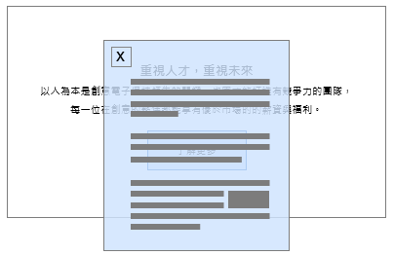

- 外層
標題：Achieve your dream and create unlimited future.
短敘述：Through learning and development programs, closely aligning with the GUC's sustainable development strategies and employee capability enhancement plans, we actively cultivate top talents and support employees in their career development.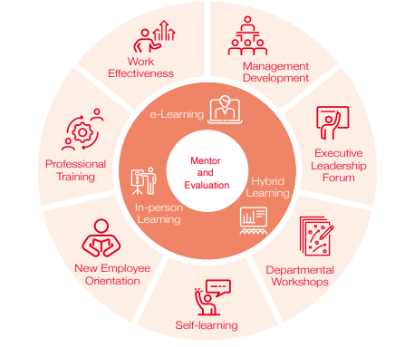
- 內層
Comprehensive Training and Development Program
GUC offers a comprehensive training program based on a development roadmap for employees at all stages of their career, encompassing new comers, managers and non-managers. Starting from newcomers, we have a "Mentorship Program" to facilitate a quicker integration into the environment. This program aims to cultivate relationships, facilitate knowledge transfer, and foster mutual learning. Additionally, We've implemented a "Key Talent and Managerial Development Program" to ensure continuous enhancement and cultivation of abilities through comprehensive training and development, thereby ensuring that the Company possesses a high-quality and abundant talent pool. Our dedication in training and development is not merely a promise for the future, but also a commitment to corporate governance and sustainable development; further fostering a positive environment for employees to share and learn from one another.
對象 | 項目 | 內容
New Comers and Regular Employees | Newcomer Training and Mandatory Course | In order to help newcomers quickly integrate into the company, learn the Company's core values and visions for future development, we introduce their rights and responsibilities upon their arrival. Following our training roadmap, self-learning common competency and mandatory courses are then provided to new comers via eLearning.
New Comers and Regular Employees | ESG-related Courses | In addition to the onboarding course on the first day of employment, we provide newcomers with a comprehensive range of courses from facility introduction to company sustainability policies and systems. These include important topics such as safety and health management, prevention of workplace misconduct, and adherence to professional ethical standards are included.
All Employees | Annual Mandatory  Training | The courses include the protection of confidential information, integrity management procedures, ethical regulations, prevention of unlawful infringement, prohibition of insider trading, the Code of Conduct for Responsible Business Alliance, and Prevention of Workplace Misconduct (including bullying, discrimination, and sexual harassment, etc.)
All Employees | Personal Effectiveness and Foundational Training | To adapt to future technological advancements, assist employees in enhancing their work efficiency, and help improve their capabilities, we have provided a rich variety of learning and development courses this year. These include courses on presentation skills, AI tool applications, communication techniques, and seminars on emerging technologies. Additionally, we have introduced lifestyle and stress relief courses, ensuring that every employee can acquire useful knowledge and skills both within and outside of work.
All Employees | External Training | We encourage our employees to learn on their own and attend external training to strengthen their job skills according to their professional field and job-related needs. GUC provides full tuition reimbursement for such learning opportunities.
Managers | Middle and Senior-level | As pivotal figures in the Company, middle and senior-level managers play a crucial role in bridging the gap between upper management and frontline employees, making leadership decisions, and driving the organization forward. Their training programs focus not only on communication, leadership, and management skills but also emphasize practical application and the development of their team members. In addition to the courses themselves, various pre-course activities and post-training discussions are organized to facilitate mutual exchange among managers and ensure that the courses are aligned with current management practices. Furthermore, we employ team coaching methods to enable senior managers to swiftly immerse themselves in work scenarios and find solutions.

Performance Management and Development
GUC regularly conducts annual employee performance reviews as an important basis for employee promotions, merit increase and other personnel operations. Each employee, regardless of gender, age, or job grade is required to participate in the annual performance evaluation. Through performance assessment, managers and employees jointly review the past goal achievement and provide high recognition and encouragement for excellent performance and guidance for short comings. In addition to evaluating work effectiveness, we strongly emphasize developing the potential of our employees and providing them with future prospects, aiming to effectively guide them to pursue higher work quality. For this reason, GUC has implemented the Performance Management and Development (PMD) system. The PMD system is divided into a probationary period for new comers, an annual performance evaluation, and a performance improvement plan based on the development of employees at each stage in the company.

Our performance management system not only considers individual performance but also incorporates the evaluation of team objectives. Team objectives are decomposed from top to bottom according to the principles of Management by Objectives (MBO), ensuring that each employee's contributions accurately reflect the achievement of the overall team goals. Furthermore, executives are required to report team and individual performance goals to the Board of Directors annually. Once approved, the results of team and individual performance for the next year are submitted in the first quarter to ensure the Company's annual objectives are achieved. Through the MBO system, we ensure that all employees understand their job objectives clearly and strive towards the overall goals of the Company, thereby improving work efficiency and performance. The PMD management system balances "performance" and "development" and underscores continuous interaction and communication. We firmly believe that through such practices, we can establish a fair, just, and performance-enhancing work environment.

