版型說明：
外層(白)：簡易文案，標題及短敘述，使用者可點選「了解更多」進入內層
內層(藍)：頁面內視窗顯示詳細的圖文內容，可點選「x」回外層
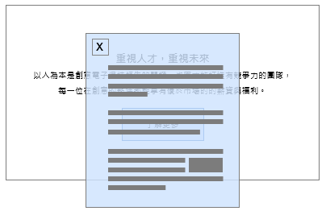

- 外層
標題：Value Talent, Share Success.
短敘述：We believe that the value of every talent deserves to be recognized and appreciated. Through attractive compensation and benefits policies, we are committed to sharing fair and competitive rewards with each member, fostering mutual growth and success.

- 內層
Overall Compensation System to Employee
GUC adheres to the labor laws and regulations of each operating location, establishing a competitive and appropriate compensation strategy to motivate employees. We actively participate in regional salary surveys, aligning compensation system with company objectives, to attract and retain talents in the fiercely competitive labor market, enhancing overall strength and competitiveness. Meanwhile, the Company upholds the concept of profit-sharing with employees, attracting, retaining, and motivating talents across the globe. The base pay and benefits for each employee are in same rule, no difference between race, religion, gender, nationality, or political affiliation.

The total rewards framework at GUC is as follows:
• Fixed Salary: A 12 months base salary and structured allowances and subsidy plans in accordance with local regulations at each operating location.
• Incentive Bonuses: An incentive bonus system directly tied to individual performance.
• Profit Sharing : Allocating bonuses from profits based on company charter tied to company business result, team performance, and individual outcomes.
• Employee Stock Ownership Trust: The program makes employees to contribute a certain percentage of salary to purchase stocks, and the Company pay additional contribution to purchase stocks for employee (limited to the Taiwan region).

According to the latest data disclosed by the Taiwan Stock Exchange, the GUC's compensation ranks among the top in the semiconductor industry among full-time employees not in managerial positions.
For the latest data, please refer to the" Corporate Governance" section under the Taiwan Stock Exchange's Market Observation Post System for relevant information on employee benefits and compensation statistics.

Employee Stock Ownership Trust
To enhance the cohesion between employees' engagement and the Company's business outcomes, GUC established an Employee Stock Ownership Trust (ESOT) in Taiwan since 2011, initiating the program which allows employees to voluntarily participate. Through this system, a specific amount (Employee Contribution) is contributed from each individual's monthly salary, which is matched by the Company (Company Contribution) and jointly invested in regular intervals by a designated bank through a trust mechanism.
This program allows employees to hold company stocks and share the business achievements.

The voluntary participation rate in the Employee Stock Ownership Trust program has continued to grow steadily, indicating that employees have a high level of confidence of both this benefit system and the GUCs operational prospects.

