版型說明：
外層(白)：圖片縮圖
內層(藍)：頁面內視窗顯示詳細的大圖及簡短說明，可點選「x」回外層
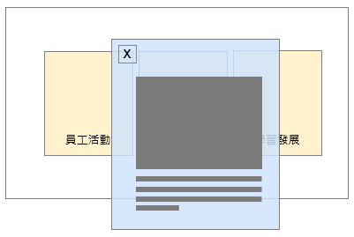

- 外層
標題：Friendly Spaces, Comfortable Places.
左圖：待補充

中間：
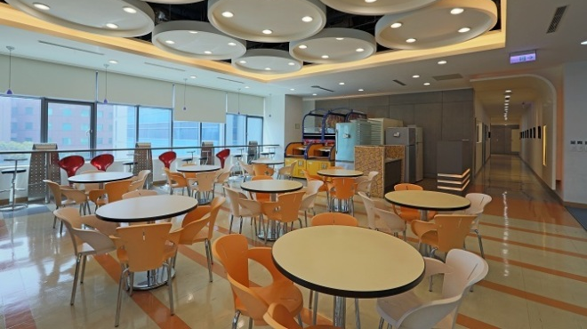
右圖：
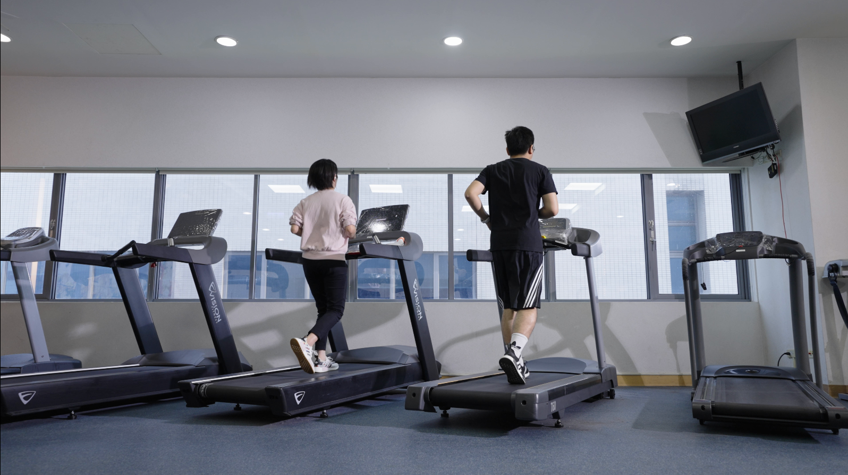
- 內層
左圖說明：A friendly, comfortable, and bright office space that enables employees to focus on their work while fostering high-quality growth and value creation.
中間說明：A diverse workspace and recreational environment that ensures a positive employee experience, fosters team communication, enhances work efficiency, and sparks creative thinking.。
右圖說明：Recognizing the importance of employees' needs outside of work, the company provides recreational spaces and equipment, including treadmills, a table tennis room, and a basketball court.

