版型說明：
外層(白)：文字+icon
內層(藍)：頁面內視窗顯示詳細的圖文說明
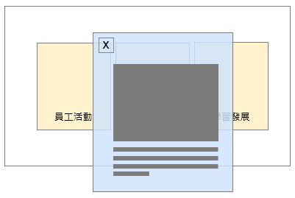

- 外層
標題：Welcoming Top Talent in Comprehensive IC Design Services.
Ａ圖：文字「研發設計」+icon（廠商協助搜尋）
Ｂ圖：文字「工程技術」+icon（廠商協助搜尋）
Ｃ圖：文字「業務行銷」+icon（廠商協助搜尋）
Ｄ圖：文字「管理支援」+icon（廠商協助搜尋）

- 內層
Ａ圖說明：The business model of GUC focuses on recruiting IC design professionals for stages ranging from IP development to design services. Job openings include positions in digital/analog IC design, verification, chip physical design services for both front-end and back-end (APR), as well as design for testability (DFT). Through collaboration across various functions, we ensure the successful completion of projects.
Job | Description
Digital IC design | 文字待補
Analog IC design | 文字待補
IP/SoC Design and Verification | 文字待補
Physical Design Front-end | 文字待補
Physical Design Back-end | 文字待補
Design for Testability | 文字待補
CAD Engineer | 文字待補
Layout Engineer | 文字待補

Ｂ圖說明：GUC maintains a strong partnership with its affiliate, TSMC, providing advantages in advanced process mass production. We are seeking outstanding engineering and technical talent to join us in delivering exceptional mass production services.
Job | Description
Package Design | 文字待補
SI/PI | 文字待補
Testing Engineering | 文字待補
Product Engineering | 文字待補
Supply Chain Management | 文字待補
Reliability & Quality Management | 文字待補

Ｃ圖說明：GUC is expanding its customer base in global markets, relying on an outstanding sales and marketing team to achieve the company's operational growth goals across diverse regions.
Location | Description
Taiwan(Headquarters) | 文字待補
North America | 文字待補
Japan | 文字待補
Europe | 文字待補
China | 文字待補

Ｄ圖說明："In addition to its exceptional R&D, engineering, and sales teams, GUC relies on talented management and support professionals to build a robust operational support system, collaborating to enhance the company's development efficiency.
Job | Description
Information Technology | 文字待補
Finance | 文字待補
Legal | 文字待補
Human Resource | 文字待補

