版型說明：
外層(白)：圖片縮圖
內層(藍)：頁面內視窗顯示詳細的大圖及簡短說明，可點選「x」回外層
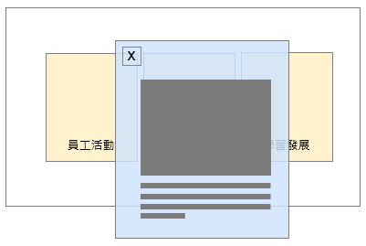

- 外層
標題：Event Highlights
左圖：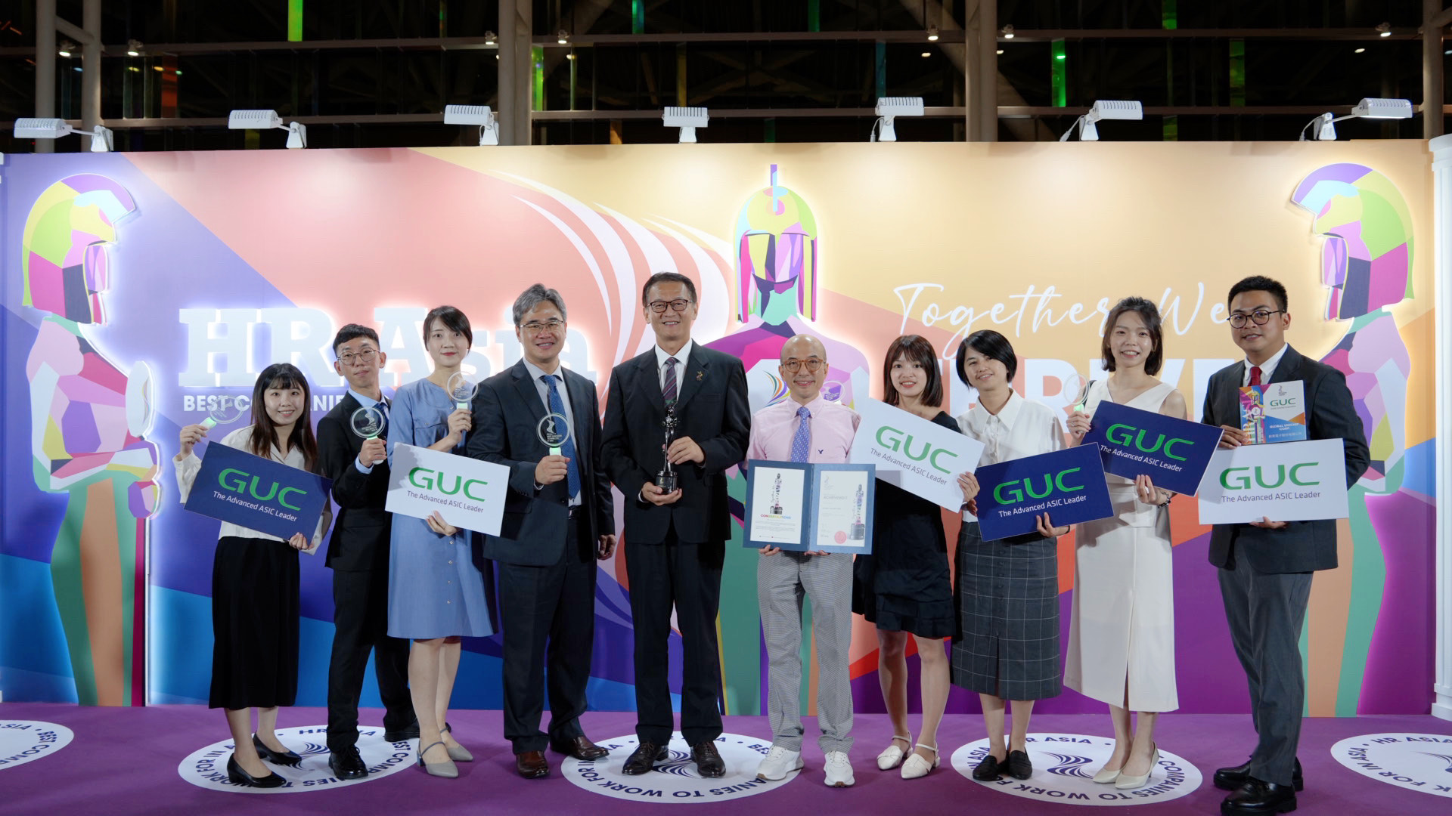
中間：
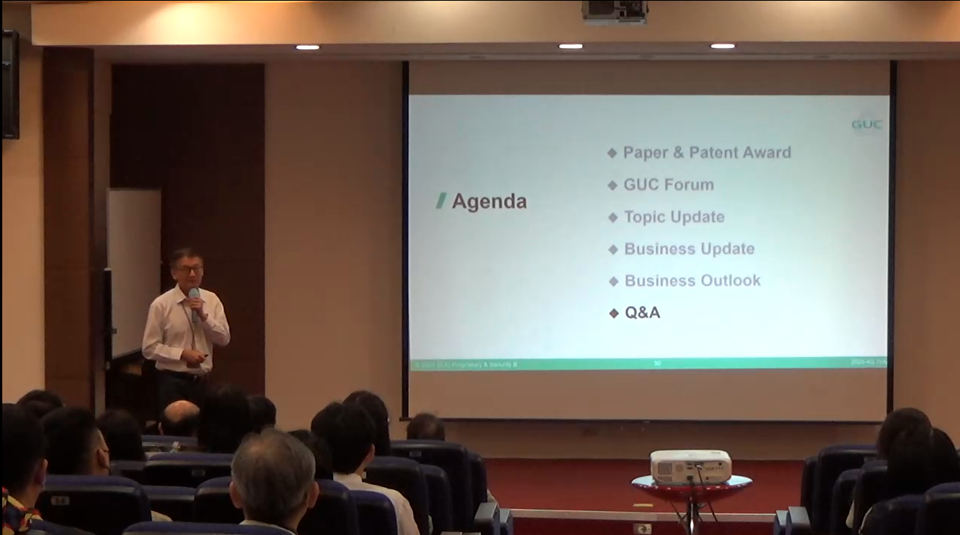
右圖：
待補充
- 內層
左圖說明： In 2024, GUC once again claimed the title of HR Asia Best Companies to Work for In Asia, standing out in the IC design industry. This recognition highlights the company's consistent efforts in building a friendly and supportive workplace.
中間說明：values employee input and is dedicated to ensuring organizational alignment. Through regular town hall meetings, the company fosters smooth and effective internal communication.
右圖說明：To enhance workplace adaptation for new employees, GUC implements a mentorship program to ensure that every newcomer receives adequate support and integrates seamlessly with the organization.

