版型說明：
外層(白)：簡易文案，標題及短敘述，使用者可點選「了解更多」進入內層
內層(藍)：頁面內視窗顯示詳細的圖文內容，可點選「x」回外層
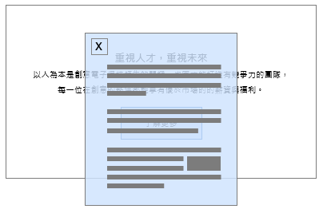

- 外層
標題：Life-Encompassing Benefits
短敘述：GUC values its talents and places even greater emphasis on employees’work-life balance. Through comprehensive benefits policies, we enable our employees to embrace every remarkable moment in their lives with ease and confidence.

- 內層
Exceptional Benefits
GUC places a high priority on the health and well-being of its employees. In addition to adhering to local regulatory standards, the company offers benefits and leave policies that exceed legal requirements. For instance, at its Taiwan office, GUC provides comprehensive benefits, including group commercial insurance, enhanced leave policies, retirement pensions, emergency overseas travel assistance, wedding and maternity bonuses, funeral subsidies, birthday gifts, year-end party allowances, and discounts at partner stores. The company also organizes occasional group outings, travel, and club activities, helping employees achieve a balance between work, personal life, and family. GUC hopes that during their careers here, employees can confidently embrace every remarkable moment in their lives.

Leave and Attendance Policy Revised January 2022 Provides More PTO than Industry Average and Labor Laws
GUC is committed to providing a supportive workplace that accommodates the family care and maternity needs of our employees. Across all our global locations, we offer leave policies that exceed local legal requirements. Taking Taiwan as an example, in addition to statutory leave, we provide specific flexible leave of 7 days, 15 days of paid sick leave, 10 days of paternity examination leave and paternity leave, and 12 weeks of maternity leave. During the childcare period, in addition to the option to apply for parental leave without as permitted by law, the Company also offers a comprehensive leave management system. This allows employees to use their leave more flexibly, ensuring peace of mind in caring for newborns and supporting their family care needs.
Superior to Statutory Leave | Statutory Standards | Content
National Holidays | 12 days of national holidays each year. | 7 days reserved for personal commemoration, available for flexible leave arrangements.
Annual Leave | Employees who have served for at least 6 months but less than 1 year are entitled to 3 days of special leave. | To accommodate the leave needs of new employees, they may request leave immediately upon joining the Company for the current year based on their proportion of service.
Sick Leave | 30 days of half-paid sick leave throughout the year. | 15 days of paid sick leave and 15 days of half-paid sick leave throughout the year.
Maternity Leave | Female employees are entitled to full-paid maternity leave for 8 weeks, totaling 56 days. | Paid maternity leave for female employees can be extended to 12 weeks, totaling 84 days.
Paternity Examination and Paternity Leave | During the period from the spouse's pregnancy until the day of delivery, as well as 7 days before and after the delivery, totaling within 15 days, male employees are entitled to 7 days of paternity examination leave and paternity leave. | During the period from the spouse's pregnancy until the baby's first year, male employees are entitled to use the leave, with an additional extended to 10 days of paternity examination leave and paternity leave.

