版型說明：
外層(白)：簡易文案，標題及短敘述，使用者可點選「了解更多」進入內層
內層(藍)：頁面內視窗顯示詳細的圖文內容，可點選「x」回外層
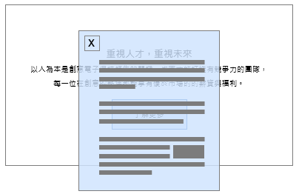

- 外層
標題：Total Health Management
短敘述：GUC believe that having a healthy body and a stable mindset helps to spark creative thinking and maintain high work efficiency. We are committed to creating a workplace environment that supports employee health by providing comprehensive health management services and resources for our employees.
- 內層
EAP Employee Assistance Program
In recent years, mental health has gradually received attention by society. GUC has been promoting an Employee Assistance Program (EAP) for many years through external professional organizations. Individual counseling services such as psychological, health, career, legal, and crisis counseling are provided by personnel who maintain absolute confidentiality and expertise in their respective fields. Also, we organized relevant lectures to support employees in addressing personal and family challenges, maintaining a balance between work and life.

Employee Health Promotion and Risk Management
Regular physical examination are the first step in promoting health, and GUC provides an annual physical examination that goes beyond regulatory requirements. It assists employees in understanding their true health status amidst their busy schedules, thereby achieving the effectiveness of early diagnosis and treatment. For the past three years, the participation rate of physical examination has remained above 97%. Additionally, by analyzing the overall health data of employees, common health issues can be identified. This helps in planning health promotion activities and tracking abnormal groups.

Implementing Occupational Disease Prevention
GUC is an IC design service company that does not have production lines or engage in operations involving specific hazards. Employees in the workplace can avoid many occupational diseases risk factors. To further safeguard employees and establish a safe working environment, four major programs have been developed based on the Prevention Guidelines announced by the Occupational Safety and Health Administration of the Ministry of Labor: ''Preventive Plan for Abnormal Workload-Induced Diseases'', the ''Maternal Health Protection Plan'', the ''Occupational Musculoskeletal Disorder Prevention Plan'' and the ''Unlawful Infringement In The Workplace Prevention Plan.'' The Company regularly convenes the Safety, Health, and Environmental Protection Committee to review

