版型說明：
外層(白)：圖片縮圖
內層(藍)：頁面內視窗顯示詳細的大圖及簡短說明，可點選「x」回外層
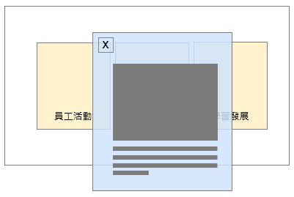

- 外層
標題：Diverse Activities
左圖：
照片待補
中間：
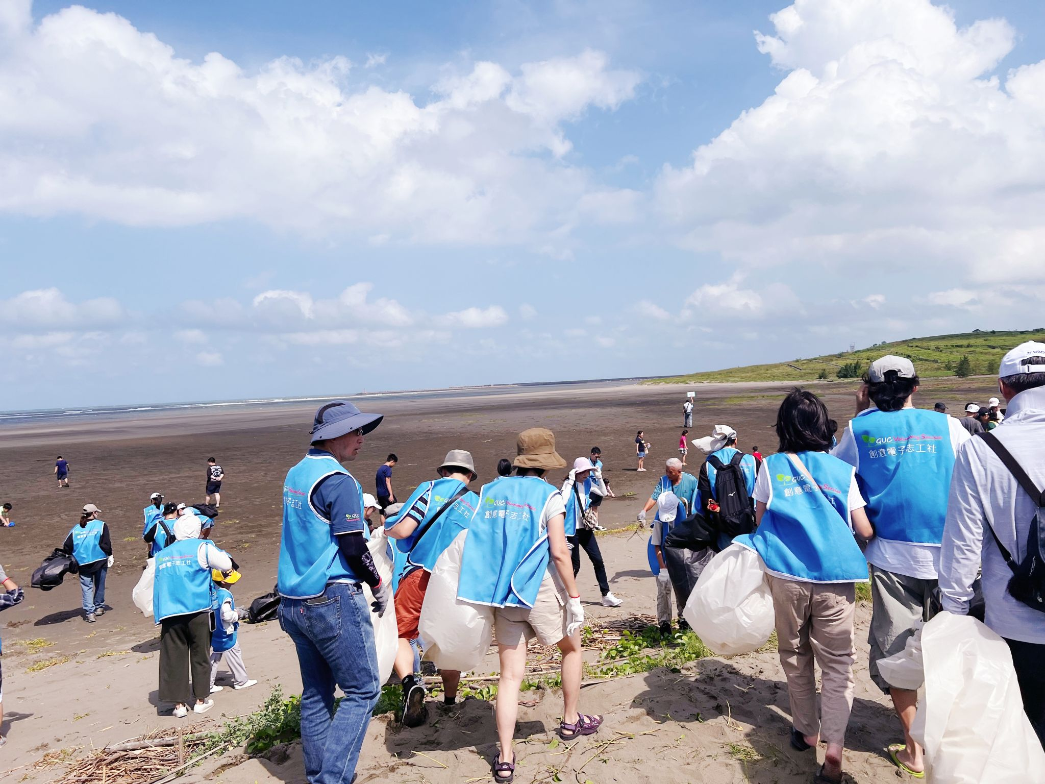
右圖：
照片待補
- 內層
左圖說明：GUC offers employees generous annual travel subsidies, encouraging them to relax and address their leisure needs. Employees have the flexibility to freely plan their travel schedules, destinations, and modes. Every year, a substantial proportion of employees utilize the subsidies for their travels.
中間說明：GUC encourages employees to form clubs, explore and develop diverse interests, and foster team cohesion. These activities include sports, recreational events, and volunteer services, providing employees with a variety of enriching life experiences.
右圖說明：GUC organizes several large-scale events annually, open for all employees to freely participate. Through diverse formats and themes, these events cater to employees’ leisure needs, providing a refreshing break that fosters better growth and development in their professional roles.

