新聞標題：創意電子宣佈再次加入「2024 TALENT, in Taiwan，臺灣人才永續行動聯盟」
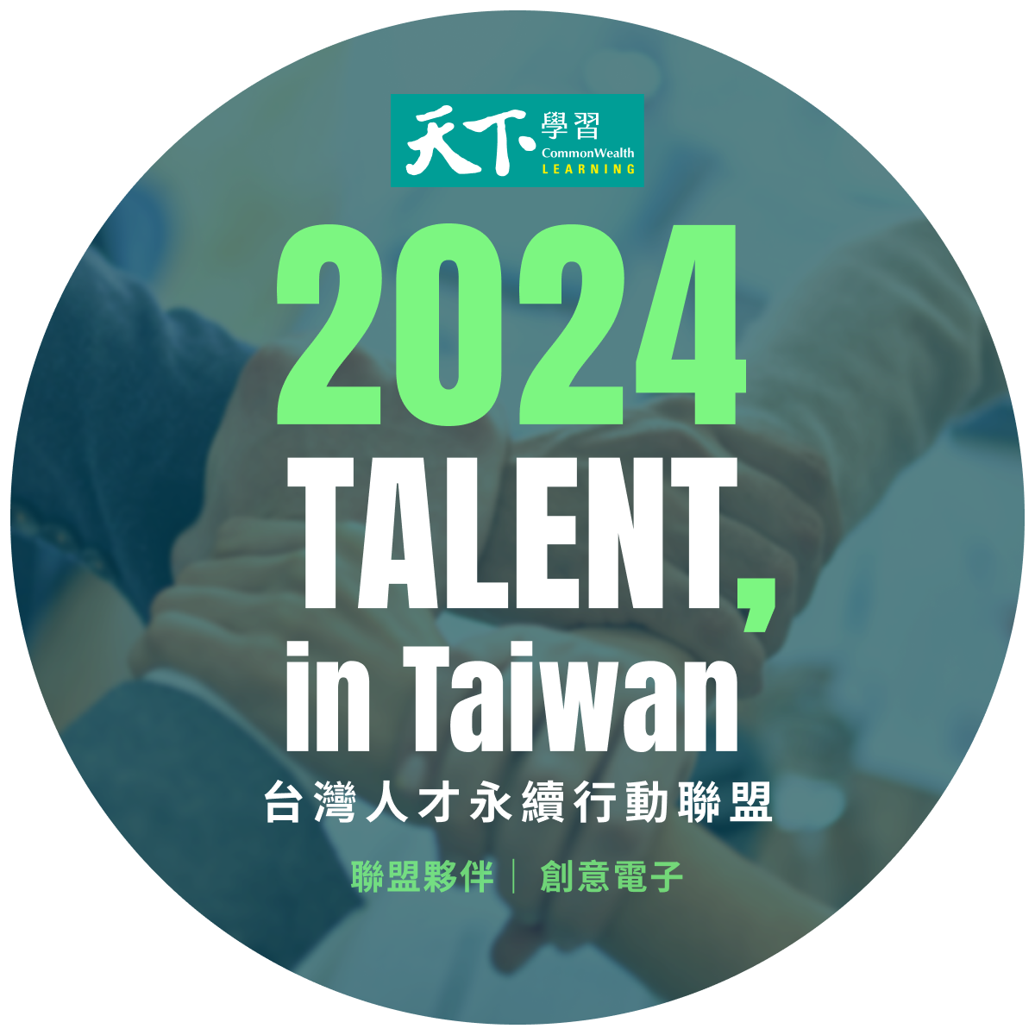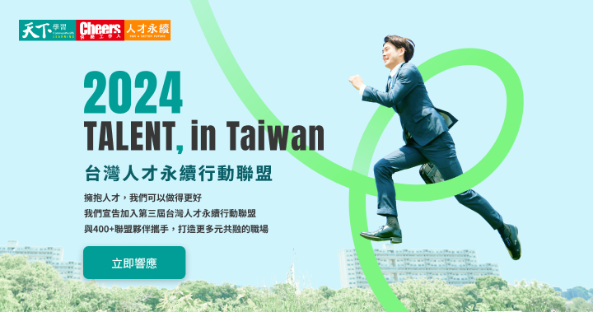

擁抱人才，我們還可以做得更好。人才永續一直是我們重視的目標，為了打造更加多元、平等、共融的職場，我們再次宣佈創意電子加入「2024 TALENT, in Taiwan，臺灣人才永續行動聯盟」

今年，我們承諾為人才做到以下幾件事：
1.意義與價值：秉持以人為本的核心價值鼓勵及尊重員工，積極宣導企業文化，高階主管以身作則、激勵員工追求共同目標，並將此核心價值融入各項人力資源政策中
2.多元與包容：積極招募多元族群員工，建立多元包容的工作環境
3.獎酬與激勵：提供合理及具競爭性的薪酬，公開表揚優秀員工、及時給予員工獎勵
4.身心健康：提供全方位的健康規劃和員工協助方案、優於法規的休假辦法，並確保零歧視、騷擾及霸淩的職場環境
5.培育與成長：提供豐富的學習資源，協助員工充分發揮個人優勢及潛能
6.溝通與體驗：提供多元的溝通管道，聆聽員工的聲音

我們將持續以行動支援，和 #天下學習、 #Cheers快樂工作人、 #人才永續頻道、及400+聯盟夥伴推動倡議，為每一位工作人創造更好的未來。
活動官網 >> https://web.cheers.com.tw/event/talent/index.html
#talent_in_taiwan #人才永續
Headline: GUC Announces Its Return to the "2024 TALENT, in Taiwan:"
Embracing Talent, We Can Do Even Better.
Sustainability in talent development has always been one of our key goals. To foster a more diverse, equitable, and inclusive workplace, we are proud to announce that GUC has once again joined the "2024 TALENT, in Taiwan"
This year, we are committed to achieving the following for our talent:
- Meaning and Value: Upholding a people-centered core value, we encourage and respect our employees, actively promoting our corporate culture. Senior leaders lead by example, inspiring employees to pursue common goals while embedding these core values into all human resources policies.
- Diversity and Inclusion: We actively recruit employees from diverse backgrounds, creating a work environment that is inclusive and welcoming to all.
- Rewards and Recognition: We provide competitive and fair compensation, publicly recognizing outstanding employees and offering timely rewards for their contributions.
- Physical and Mental Health: We offer comprehensive health plans and employee assistance programs, provide vacation policies that exceed legal requirements, and ensure a workplace free from discrimination, harassment, and bullying.
- Development and Growth: We offer rich learning resources to help employees fully realize their strengths and potential.
- Communication and Experience: We provide multiple communication channels to listen to employees' voices and enhance their overall experience.
We will continue to support these initiatives through action, collaborating with #CheersLearning, #CheersHappyWorkforce, #TalentSustainabilityChannel, and over 400+ alliance partners to promote these goals and create a better future for every worker.
Official event website >> https://web.cheers.com.tw/event/talent/index.html
#talent_in_taiwan

