- Sustainable Development Management Unit
GUC's sustainable development is overseen by the " Strategy and Sustainable Development Committee," and an "ESG Committee" is established, chaired by President Sean Tai. Representatives from various departments are appointed as committee members, forming functional sub-groups for operations. The "ESG Committee" implements the resolutions of the " Strategy and Sustainable Development Committee," keeps track of international sustainability trends, and, based on various international standards and regulations, leads functional organization members to develop sustainable development plans. The committee also identifies stakeholder needs to assess key issues and related risks in the areas of environmental, social, and corporate governance (ESG). The committee adapts and mitigates the potential impacts of major issues, such as climate change, on operations, while formulating application strategies and execution plans. The Board of Directors reviews and guides the company's ESG development direction.
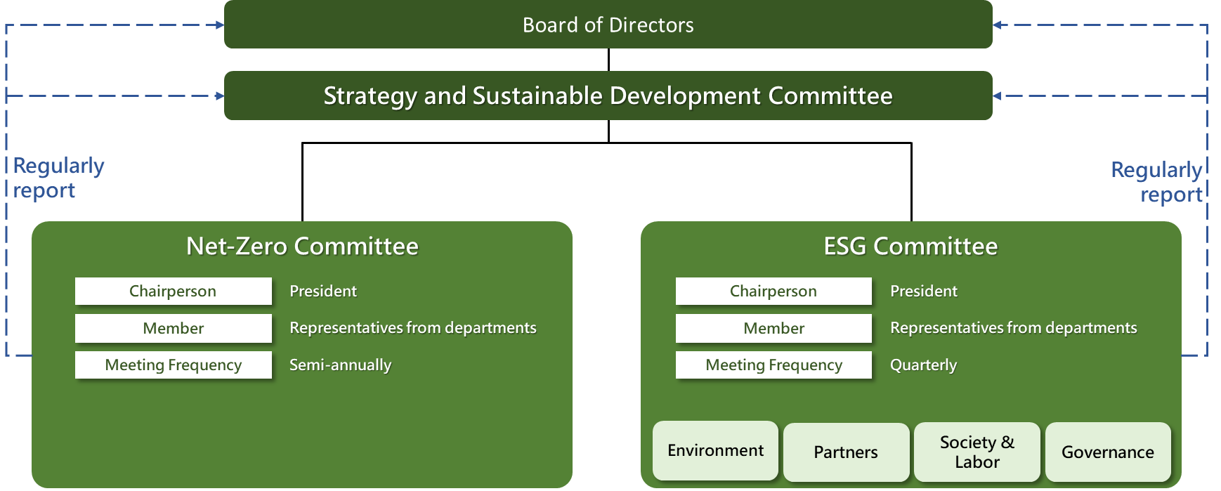

- Annual Regular Report to the Board of Directors
1. Identify material topics, develop strategies and response plans each year.
2. Outline the progress, achievements, and goals for the following year regarding ESG initiatives annually.
3. Report ESG execution progress and effectiveness biannually.

Board Reporting Schedule
Date | Agenda Items
2024/1/31 | ✓ Key Sustainability Topics and Strategies  ✓ Setting Annual Sustainability Goals
2024/5/16 | ✓ Submission of the 2023 Sustainability Report for Board Approval
2024/7/25 | ✓ Mid-Year Sustainability Performance and Progress Report
2024/11/28 | ✓ Full-Year Sustainability Performance Summary  ✓ Setting Sustainability Strategies and Goals for the Coming Year

