- Climate Change Response
As global warming intensifies and extreme weather events become more frequent, countries and enterprises around the world are experiencing significant economic losses. The World Economic Forum’s Global Risks Report 2023 listed natural disasters caused by extreme weather as one of the top global risks. Addressing climate change has become an irreversible trend, and achieving net-zero carbon emissions is now a critical and unavoidable challenge for all industries.
Global Unichip Corp. (GUC) recognizes the profound impacts of climate change on society, the environment, and the global economy. Accordingly, GUC has committed to achieving net-zero carbon emissions by 2050 as a primary goal in our climate strategy. Our management team has completed a comprehensive assessment of climate-related risks and has formulated a concrete net-zero action plan. Progress and implementation status of our carbon reduction initiatives are reported regularly to the Board of Directors.
- TCFD Framework
In order to effectively manage climate-related risks and fulfill our corporate social responsibilities, GUC follows the framework of the Task Force on Climate-related Financial Disclosures (TCFD). We actively assess the potential social, environmental, and economic impacts of our products and services, and incorporate climate-related risks and opportunities into our strategic planning and scenario analysis.

- Identification of Climate-Related Risks and Opportunities
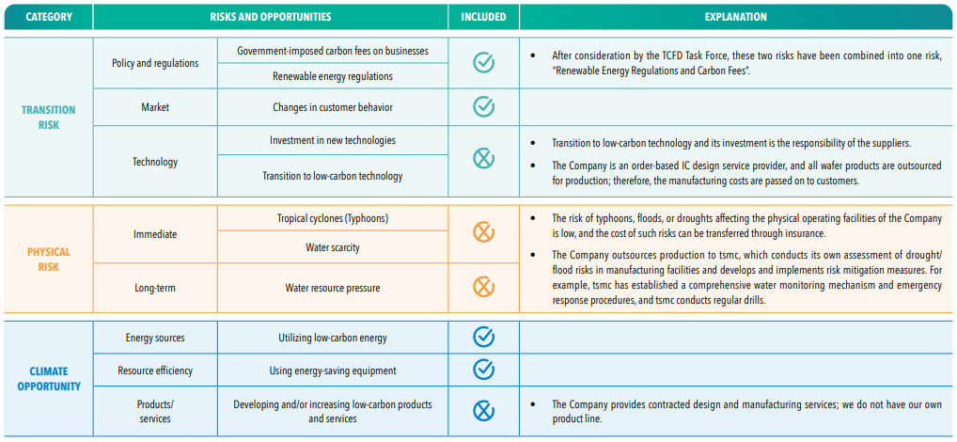
- Response Strategies
GUC has comprehensively evaluated global sustainability trends and aligned them with our operational development goals. We disclose the mitigation and adaptation strategies that have been formulated in response.
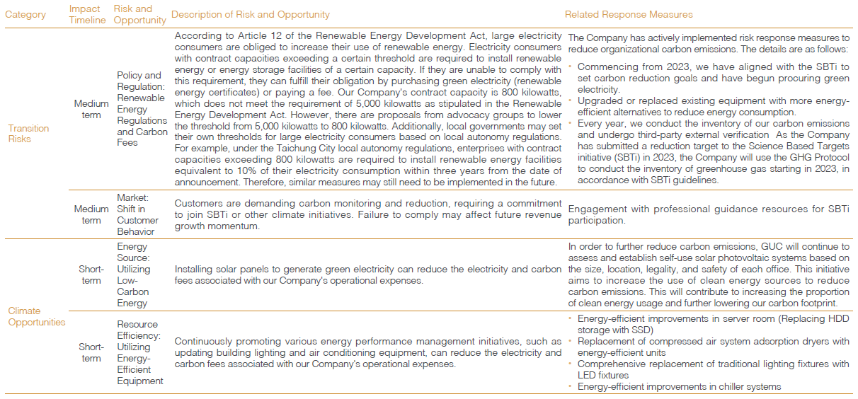
- Financial Impact Assessment of Climate Risks and Opportunities
GUC has conducted financial assessments of identified climate risks and opportunities to understand their potential impact on our operations and long-term value.
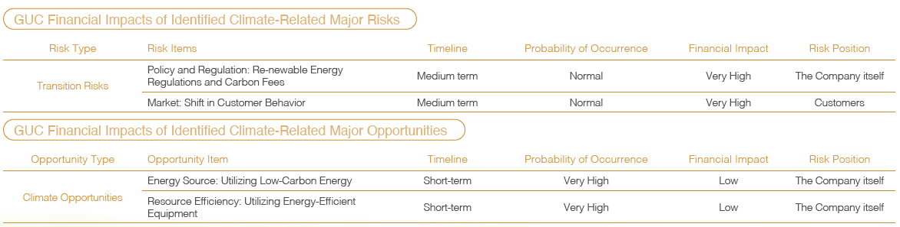
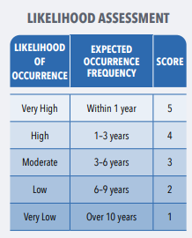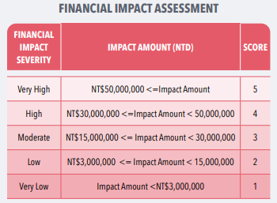
⊕ [Download GUC TCFD Report]
⊕ [Download TCFD Limited Assurance Report by Certified Public Accountant]

