- Approved by the Science Based Targets initiative (SBTi)
In May 2024, Global Unichip Corp. (GUC) received official approval from the Science Based Targets initiative (SBTi) for our submitted science-based emissions reduction targets.
SBTi is the world’s leading framework for establishing net-zero standards for businesses, supporting companies in setting both near- and long-term science-based emissions reduction goals. It provides clear pathways to reduce emissions, mitigate climate change, and safeguard growth against future risks.
GUC’s targets align with the 1.5°C scenario, the most stringent level of ambition under SBTi. Based on 2022 as the base year, we aim to reduce greenhouse gas emissions by 42% by 2030 (Scopes 1 and 2) across all domestic and overseas operations. This reduction will be achieved through initiatives such as energy efficiency programs, replacement of energy-intensive equipment, installation of solar photovoltaic systems, and increased use of renewable energy.
In the future, GUC will collaborate with suppliers to further promote energy-saving and carbon reduction efforts. We will disclose progress annually in our Sustainability Report, demonstrating our firm commitment to achieving net-zero emissions in our operations by 2050.
⊕ [Download SBTi Target Approval Document]
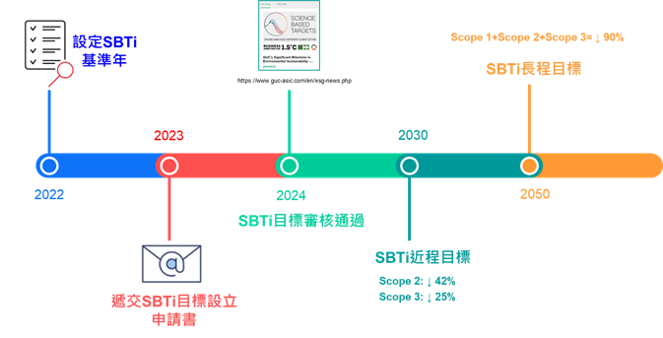

- Greenhouse Gas (GHG) Inventory
Since 2019, GUC has conducted voluntary GHG inventories and implemented emissions management. Beginning in 2021, we adopted ISO 14064-1 standards and engaged third-party verification to ensure our processes meet international best practices. In 2023, to comply with SBTi Scope 3 classification and verification standards, GUC transitioned to using the GHG Protocol.
Our main emission source is Scope 3, followed by Scope 2 (energy use). Scope 1 includes:
- Stationary sources: Diesel for emergency generators
- Mobile sources: Gasoline for company vehicles
- Fugitive emissions: Refrigerants and fire extinguishers
GUC operates as an office-based organization with no manufacturing processes, and therefore, no process-related GHG emissions.
⊕ [Download Greenhouse Gas Verification Statement]

GHG Emissions and Intensity (tCO₂e)
Category | 2022 | 2023 | 2024
Scope 1 | 174.8613 | 933.0934 | –
Scope 2 | 8,708.6177 | 9,417.9627 | –
Scope 3 | 1,598.0109 | 892,149.6187 | –
Total Emissions | 10,481.490 | 902,500.675 | –
Revenue (NT$ million) | 24,040 | 26,241 | –
GHG Emission Intensity* | 0.000044% | 0.003439% | –
*GHG Emission Intensity = Total Emissions / Annual Revenue

- Energy Management Plan
To reduce GHG emissions and actively address climate change, GUC has set clear energy-saving and carbon reduction goals and is taking concrete action. We emphasize green innovation design and the promotion of sustainable office practices, while raising employee environmental awareness through educational campaigns and practical initiatives.
Our actions include upgrading facility performance, replacing outdated equipment, optimizing operational efficiency, and implementing site-wide energy-saving policies in both factories and offices.

Sustainable Office Culture
- Encourage stair use instead of elevators
- Lights off during lunch breaks in office areas
- Natural lighting through windows and skylights in corridors
- Energy- and water-saving reminders near switches and restrooms

Time-Controlled Energy Management
- Water dispensers managed by electronic timers for off-peak sterilization and heating
- Central monitoring system optimizes equipment runtime
- Shortened ventilation fan operation in parking areas, except during peak hours
- Emergency staircase pressure fans controlled with timed switches

Efficiency Maintenance
- Use of energy-efficient appliances (air conditioners, refrigerators)
- Chilled water system output temperature set to above 8°C
- Indoor AC temperature set at optimal 26°C
- Cooling tower fan activation based on water return temperature, with added control valves for heat dissipation

