- Supply Chain and Environment
In response to global trends in human rights protection, customers insist on avoiding the use of minerals sourced from conflict-affected areas in their products. To address this, GUC actively manages due diligence on conflict minerals—including cobalt and mica—within its supply chain. With the periodic updates of the Conflict Minerals Reporting Template (CMRT) and Cobalt Reporting Template (CRT), GUC has established a comprehensive CMRT & EMRT management process and continuously monitors supplier compliance with conflict minerals due diligence.
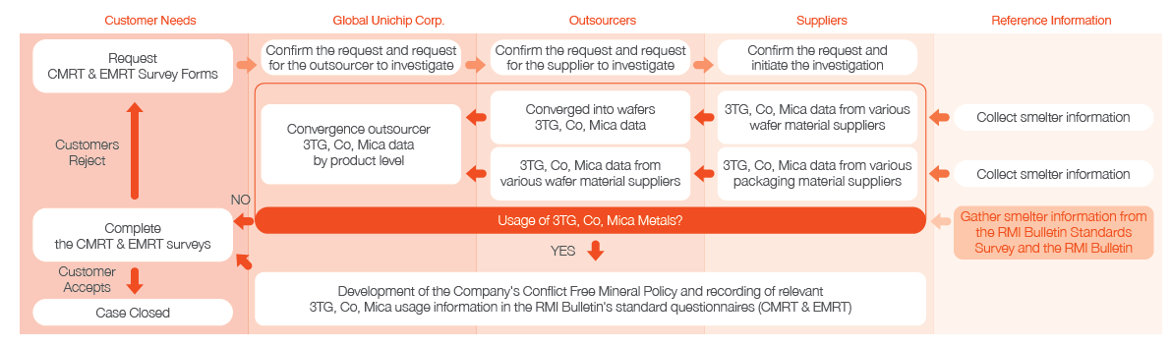

- Five Key Supply Chain Management Strategies
GUC requires its suppliers to adhere to the Supplier Code of Conduct established by the company. Through collaboration based on GUC’s five supply chain strategies, we aim to co-create valuable products and services for our customers.
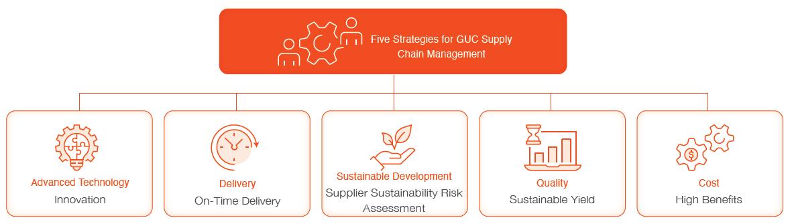

- Supplier Evaluation and Adherence to International Responsibility Standards
To promote sustainable practices among suppliers, GUC has formulated the GUC Supplier Code of Conduct and conducted training and requirement sessions for first-tier key suppliers, achieving a 100% completion rate in both assessments and signed commitments.
This commitment includes compliance with the Responsible Business Alliance (RBA) 8.0 Code of Conduct, covering five major areas:
- Labor and human rights
- Health and safety
- Environmental protection
- Business ethics
- Management systems
The Code includes 42 specific criteria aligned with globally recognized social responsibility standards. Suppliers are required to fully commit to these standards and the principles of corporate social responsibility.
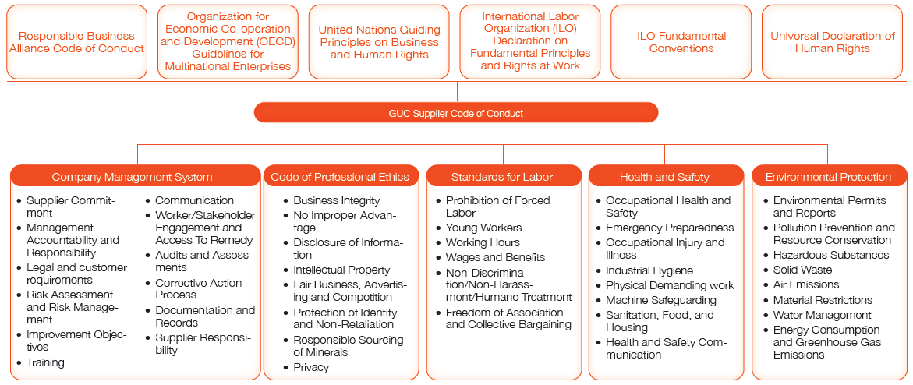

- Supplier Identification / Risk Survey and Assessment
As part of GUC’s sustainable supply chain risk management efforts, we conduct a Supply Chain Monitoring and Responsibility Risk Assessment Survey. Based on ESG trends and corporate sustainability priorities, 12 core themes were identified and included in the Supplier ESG Sustainability Management & Risk Assessment Questionnaire, categorized into three dimensions: economic, social, and environmental.
Suppliers are evaluated using weighted performance scoring across the three ESG pillars. GUC enhances supply chain resilience through audits, investigations, and continuous improvement measures, fostering strong cooperation and mutual growth toward sustainability.
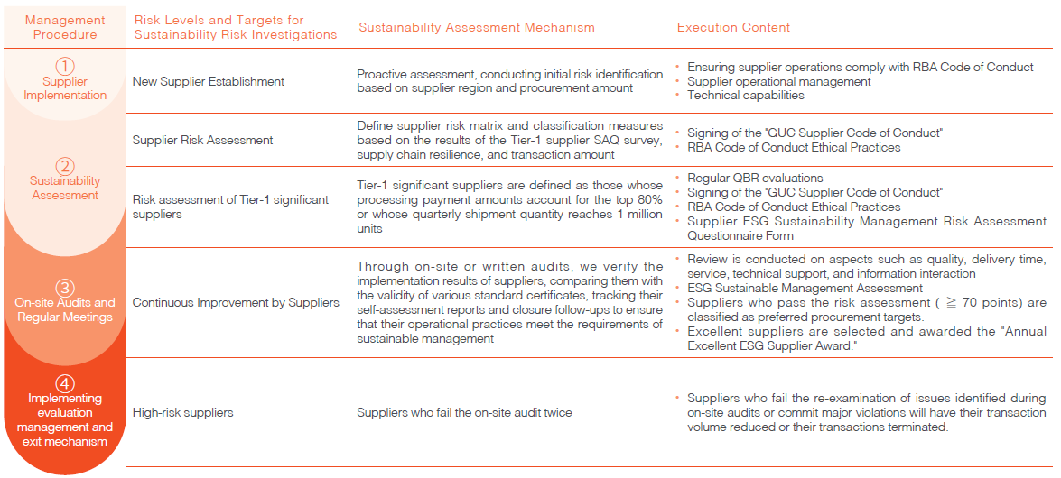

- Biodiversity Commitment and Zero Deforestation Declaration in the Supply Chain
GUC has developed a Biodiversity Commitment and Zero Deforestation Declaration as part of its ecological responsibility efforts. This declaration sets performance indicators and targets not only for GUC but also for its first-tier key suppliers, aiming to enhance the entire value chain’s positive impact on biodiversity.
Suppliers are encouraged to assess biodiversity risks at their operational sites and work to reduce negative environmental impacts. Key suppliers are required to comply with the following biodiversity protection commitments via the Biodiversity Commitment Survey:
- Commit to avoiding operations in or near areas of critical biodiversity significance.
- If deforestation is identified in current operations or provided services, commit to compensation through reforestation and cease any future development.
- Ensure all operations and services align with zero-deforestation standards and are monitored through internal environmental management systems for regulatory compliance.
- If operations are near identified biodiversity areas, commit to mitigation strategies (including avoidance, impact minimization, restoration, or compensation).
- Conduct regular ecological surveys and impact assessments surrounding operational sites.
- Collaborate with external partners to fulfill this biodiversity commitment.

