- Public Welfare and Charitable Activities
GUC has long been dedicated to social welfare and the support of arts and cultural organizations. Passionate employees have also formed a volunteer club, enabling the collective love and goodwill of team members to be more effectively integrated and mobilized. Their efforts focus on assisting underprivileged groups and children in remote areas, as well as contributing to environmental and ecological conservation in Taiwan. The goal is to preserve a beautiful and sustainable environment for future generations.
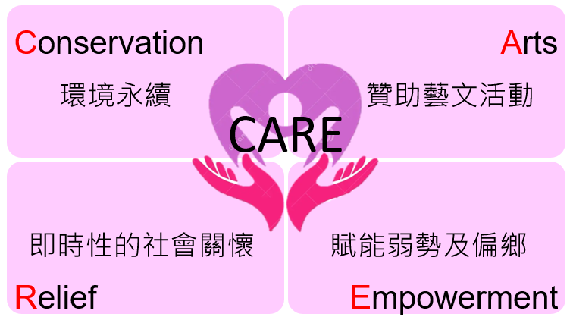
CARE represents GUC’s commitment to social responsibility—through environmental sustainability, sponsorship of the arts, timely care, and empowerment of the disadvantaged, we aim to co-create a better future.
By combining the power of the company and its employees, GUC continues to build positive energy for both society and the environment. We believe that through every small act of CARE, we can help shape a world filled with sustainability, creativity, warmth, and hope.
Join us in our actions—because we believe that even the smallest act of care can create a tremendous impact.
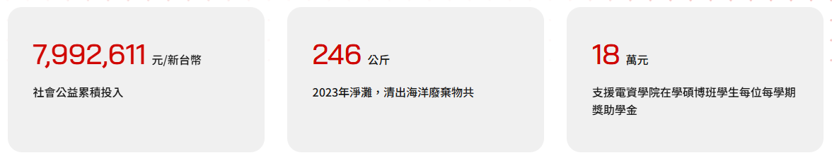
(示意圖，內文項目建議可讓我們擴增，目前暫規劃4個，分別為當年度的社會公益捐助金額、海廢/河廢累計清除、捐血袋數、志工服務時數)
- 環境永續(標題、內文、圖片都可置換，如果可以讓我們新增或刪減更好)
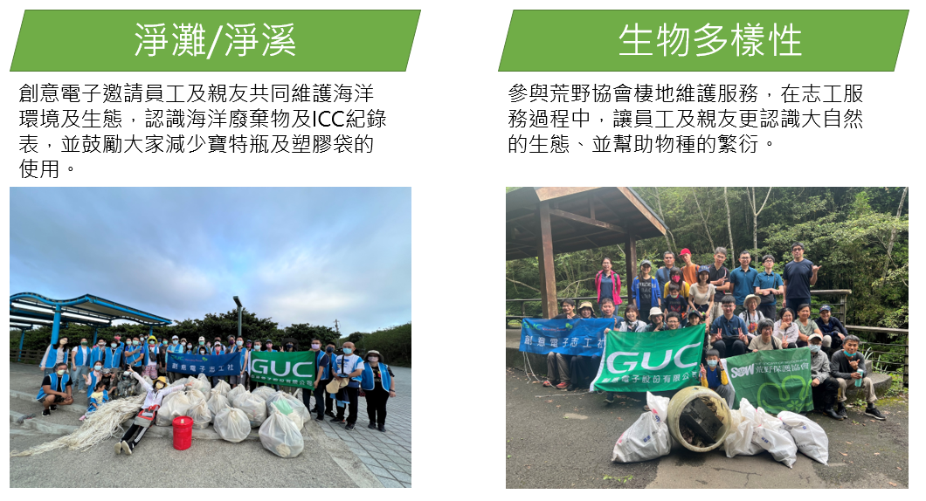
- 贊助藝文活動
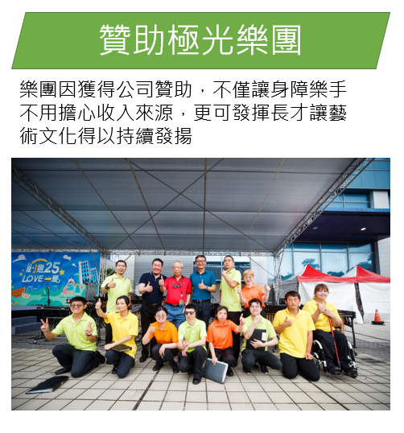
- 即時性的社會關懷
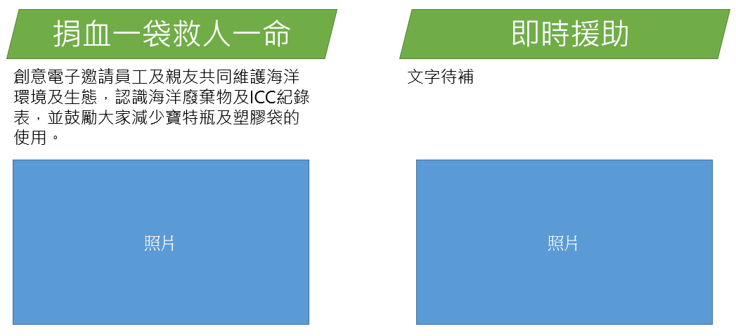
- 弱勢對象及偏鄉兒童
