I. Information Security Governance System, Goals and Strategies
GUC aims at building a tight and effective information security defense network as its information security vision. With consistency in information security governance, the Company is gradually improving its comprehensive protection capabilities, and hopes to become an enterprise with outstanding performance and maturity in information security governance. The Information Security Department is in overall charge of the information security system and relevant compliance. It also promotes the implementation of relevant operations to continue the improvement of information security awareness and professional capabilities. Through the application of technologies, the information security risks and weaknesses are identified, for which effective reinforcement measures are taken to build up a sound governance system and comprehensive information security protection capabilities, and meanwhile to cultivate employees' information security awareness.
II. Security Policy Implementation
1. Formulate information security management guidelines in line with regulatory and customers’ requirements.
2. Build a consensus on the comprehensive implementation of information security protection through all employees’ awareness.
3. Protect the confidentiality, completeness, availability and legal compliance of the Company’s and customers’ information.

III. Security Organizations
1. Security Committee
The "Information Security Committee" is responsible for the management and planning of information operations security, and the establishment and maintenance of information security management systems. As the top information security supervisors, they oversee the execution of the company’s entire information security operations and the efficacy of the information security risk management mechanism, report to president, update the progress in the management meeting of senior executives each quarter, and present the execution outcome of the overall information security management organization related information security operation and system to the Board of Directors each year to ensure that senior executives and Board members fully understand the company’s current information security management status and enforce management’s requirements for information security policies. Act as the highest-ranking officer responsible for information security. A “meeting of information security representatives” is held at least once per year and the meeting participants cover the responsible personnel of relevant information systems and external information security consultants in a number exceeding 13 persons to review the information security development plans and implementation results, and to announce policies related to information security and implementation focuses.
2. Proprietary Information Protection (PIP) Committee
PIP Committee: The PIP is constituted by the representatives designated by supervisors of the respective divisions of the entire company (including its branches throughout the world). The committee has a total of 21 colleague members including the chairperson; the executives at the vice general manger level holds quarterly meetings, responsible for the research/discussion, establishment, audit, promotion, etc. of all the Company’s proprietary information control operations. Protecting proprietary information is GUC's commitment to customers, shareholders and the Company’s employees. GUC understands that proprietary information protection is closely related to the Company's current and future competitive advantages. Thus, the《Proprietary Information Protection (PIP) Policy》has been formulated to clearly define the Company's proprietary information protection management procedures and regulations, by which the Company can properly control its trade secrets and undisclosed confidential information related to GUC to ensure the best interests of the Company, shareholders, employees, customers and suppliers. GUC's proprietary information protection is carried out based on the management cycle of Plan-Do-Check-Act (PDCA), which continuously strengthens the ability to protect proprietary information, and enhances personnel's correct concept about and vigilance over proprietary information protection, thereby reducing the risk of proprietary information leakage.GUC has also formulated management measures to incorporate information security and ethical management within employee performance evaluations.
2.1 Inspections are conducted on a quarterly basis to ensure the implementation of the Company's proprietary information protection measures.
2.2 Raise the awareness of proprietary information and the rules to follow through everyday work and various occasions.
2.3 Conduct educational training to improve employees' information security awareness and capability. In addition to listing proprietary information control as a mandatory topic for new employees’ training, all employees should also be re-trained twice every year to continuously strengthen and enhance their information security awareness.

PIP training | 2022 | 2023 | 2024
Total number of employees in the prevailing year | 759 | 819 | 839
Ratio of employees who completed the training | 100% | 100% | 100%

2.4 Regarding PIP violations, management measures have been formulated, and reporting mechanisms have been established to assess responsibility and administer penalties. Relevant punishments and required corrections have been made in accordance with the cause of the violation and the degree of the impact, and dissemination as well as educational training has continued. The PIP violations occurring over the years are listed as follows:
The total number of violations resulting from employee’s failure to comply with the proprietary information protection procedure in 2024 accounts for 0.12% of the number of employees.

PIP violation condition | 2022 | 2023 | 2024
Number of violations by colleagues | 1 | 1 | 1
Number of violations by outsourcing suppliers | 0 | 0 | 0

IV. Security risk management framework countermeasures
1. Information security defense capability reinforcement and maturity evaluation:
Conduct regular information security tests for system strengthening, and continue the implementation of business continuity drills. Develop cybersecurity incident response plans, and take corresponding reporting and recovery actions. At the same time, risk analysis is conducted through third-party verification (3rd-Party Risk Assessment), utilizing objective results and threat intelligence from platforms such as Security Scorecard and Panorays to further enhance the information security management framework.
The target score for Security Scorecard in 2024 is set at 95 or above, with the score maintained at 98 or higher since January 2024.
The target score for Panorays in 2024 is set at 90 or above, with the score maintained at 97 or higher since January 2024.

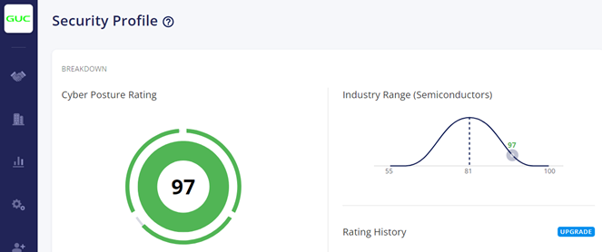
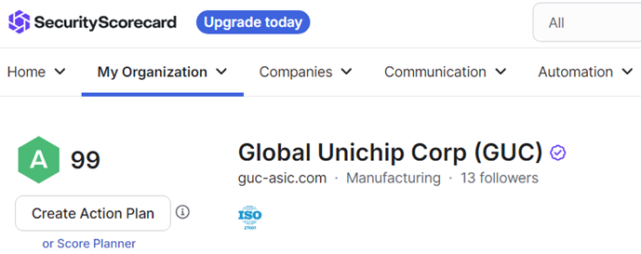
The frequency of External Vulnerability Scan has been increased from once per week to currently once per day. Any high-risk vulnerability being identified can be fixed at once.
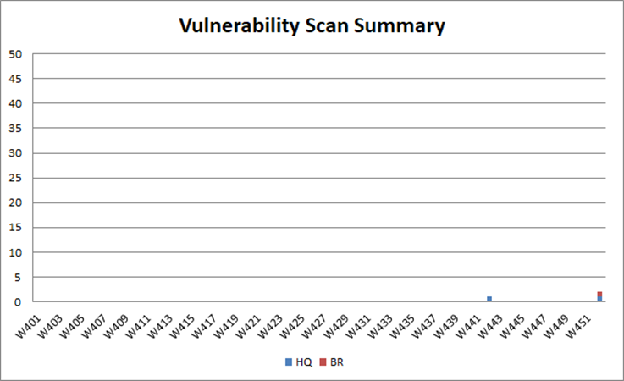
To further reinforce its anti-hacking capabilities, the Company engaged a locally-renowned white hat hacker team to simulate offensive and defensive assessments with a Red Team in 2022 and conducted penetration testing in 2024. Apart from taking the initiative to understand hacker’s thinking and strengthening employees’ anti-hacking awareness, such experience has been used to continue to improve the intranet automatic joint defense system.
2. Information security management procedures upgrade:
Creative Electronic successfully met the ISO 27001 international standard for information security in 2021 and obtained certification. Through annual surveillance audits, the company continuously improves its information security management system.
In response to the International Organization for Standardization (ISO) officially releasing the ISO/IEC 27001:2022 standard on October 25, 2022, the company completed the document review and on-site audit in October 2024, Passing the transition review and re-certification audit with no nonconformities.
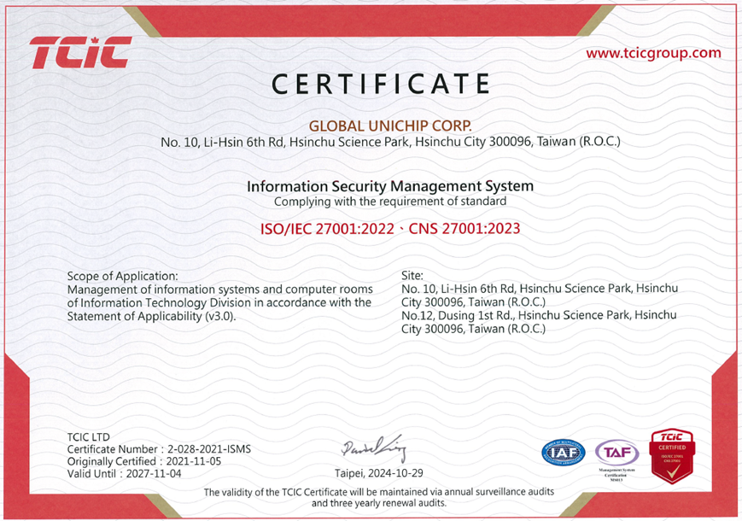

3. Risk management
The major risks concluded from the analysis of various possible combinations of threats and weaknesses assessed in annual risk assessments are as follows:
3.1 Fraudsters use fake emails to trick company’s employees into sending money or making transactions.
3.2Those who commit industrial espionage or a company’s competitors use hacking techniques to continuously hack into the company’s internal hosts and steal the company’s internal information.
3.3 Crime groups work with hackers to distribute contents with malicious links through emails, text messages, social software, and communication software. A victim's computer data may be encrypted and kidnapped, and a high ransom will then be asked for the recovery.
3.4 Hackers launch a large number of connection requests through the Internet, interrupting the normal operations of a company's network.
3.5 Internal employees use illegal software, or copy the company's confidential and sensitive information to portable storage devices, which may lead to information leakage if the devices are lost, stolen or sold.
3.6 Information software/hardware may be damaged due to natural or man-made disasters, resulting in service interruption or data loss.
3.7 The evaluation suggests that likely losses resulting from the overall information security risk is still low and falls within the range of self-protection. The results of annual evaluations are also reported to the Board of Directors.

3.8 Currently no Information Security Insurance has been taken out; however, for the above-mentioned risk concerns, several measures such as the application of information security management principles, introduction of technological solutions, and reinforcement of information security educational training are concurrently employed to establish fortified information security management mechanisms. The key measures are as follows:

(3.8.1) .Regular internal and external audits are conducted to ensure compliance. The company obtained ISO 27001:2013 certification in Q4 2021 and successfully passed the annual certification audit and transition review to the updated standard in October 2024. The company has obtained the new ISO 27001:2022 certification and continues to enhance its information security management system.

(3.8.2) Two social engineering attack simulation exercises are conducted every year. Employees who fail an exercise or who fail two consecutive exercises are required to then attend information security reinforcement training. Such training enhances employees’ sense of alertness against email fraud.

social engineering attack simulation | 2022 | 2023 | 2024
Total number of employees in the prevailing year | 759 | 819 | 839
Ratio of employees who completed the simulation | 100% | 100% | 100%

(3.8.3) Install antivirus and MDR(Managed Detection and Response) protection systems on the client side to provide real-time anomaly detection and alerting as well as forensic analysis and endpoint recovery functions. Block USB storage device connection and stop users from installing software. Moreover, provide Backup File Server for users to back up important data.

(3.8.4) With respect to the network layer, incorporate the use of firewalls to control network traffic and applications. Develop a security monitoring and management mechanism for intranet protection and database access.

(3.8.5) Employ the DRM (Digital Right Management) confidential and sensitive document management system and disk encryption technologies to protect the confidentiality of documents.

(3.8.6) Adopt mail filtering and auditing systems and Anti-APT solutions to reduce the risks arising from email usage.

(3.8.7) Introduce fingerprint identification systems and swipe-card systems in gateway management to meet the physical security requirements of two-factor authentication.

(3.8.8) Centralize the management of hosts and establish environmental control and alarm mechanisms for the data center. Perform regular data backups and carry out emergency recovery drills on a yearly basis.

(3.8.9) The multi-factor authentication mechanism has been compulsorily used for the remote access, so as to reduce the risk of password theft and credential stuffing attack. In addition, full video-taping has also been made to effectively record the use behavior and establish the audit track.

3.9 An important information system’s disaster recovery drill has been performed twice per year to ensure timely response when system abnormalities occur, reduce system downtime, and lower the impact on the company’s operations.

3.9 An important information system’s disaster recovery drill has been performed twice per year to ensure timely response when system abnormalities occur, reduce system downtime, and lower the impact on the company’s operations.

3.10 The Red Team Assessment was conducted in 2022 to simulate an invasion attack while not affecting the company’s operations so as to authenticate information security detection and response abilities and grasp the potential risk condition. The eight information security leaks found in the assessment have all been promptly improved upon and protection measures have been adopted.

3.11 In 2024, a penetration test was conducted to identify and remediate potential vulnerabilities in systems containing highly sensitive data. This initiative aimed to further improve and strengthen security measures. As a result, two vulnerabilities have already been addressed and reinforced.

3.12 The responsible persons of respective information systems have been weekly convened to discuss current week’s information security incidents and adopt required protection measures.

4. Training
The Information Security Department also conducts Information Security Awareness-raising Educational Training for all employees on a quarterly basis. The topics are determined based on the encountered internal/external threats. The topic for each quarter of 2023 is listed as follows:

2024 Information Security Awareness-raising Educational Training
Quarter | Topic
Quarter 1 | What is Stealer Malware
Quarter 2 | Precautions When Using Social Media
Quarter 2 | How to Prevent Deepfake AI Scam Videos
Quarter 4 | How to Identify Fake News in the Digital Age

V. Resources invested in information security
The Company keeps investing resources in information security related fields. Resources being invested in improving the fundamental structure for governance and technology, strengthening the equipment for information security defense, information/data monitoring and analysis, incident response drills, educational training, etc. to comprehensively enhance the information security capabilities.

VI. Incidents
A specific information security reporting and handling process has been established to report and handle information security incidents. Information security incidents are accepted and graded by the reporting point of contact of the information unit. If the incident is a major information security incident, it will be reported to the risk management panel, and the information unit shall eliminate and solve the incident within the scheduled time limit, and conduct a root cause analysis and adopt remedy measures after the incident is fully handled, so as to prevent a repeat occurrence.

Cyber security incidents | 2022 | 2023 | 2024
Material cyber security incidents | 0 | 0 | 0
Number of data leaks | 0 | 0 | 0
Number of employee and customer’s personal information leaks | 0 | 0 | 0
Amount of penalties resulting from information security incidents | 0 | 0 | 0
So far in 2024, we have not suffered any losses due to major security incidents.

資訊安全政策

一、資訊安全治理制度、目標與策略
創意電子以打造嚴密有效的資安防禦網為資訊安全願景，以資安治理一致性為基礎，逐步提升全方位防護能力，期望成為於資安治理成熟度表現傑出之企業。資訊安全部統籌資訊安全制度及合規遵循，並推動相關作業的落實，持續提升資安意識與專業能力。透過技術的運用，識別資安風險與弱點，並進行有效的強化，建構完善的治理制度與全方位的資安防護能力，同時培養同仁良好的資訊安全意識。

二、資訊安全政策落實
1. 建立符合法規與客戶需求之資訊安全管理規範
2. 透過全員認知，達成資安防護，全面落實的共識
3. 保護公司與客戶資訊的機密性、完整性、可用性與法律遵循性

三、資訊安全組織

1. 資訊安全委員會
「資訊安全委員會」負責執行資訊作業安全管理規劃，建置與維護資訊安全管理體系，由資訊安全主管督導全公司資訊安全作業執行以及資安風險管理機制之有效性，向總經理報告，每季必須向高階主管管理會議與每年向董事會呈報整體資訊安全管理組織相關資安管理作業及制度之執行成效，讓高階主管與董事會成員充分了解公司資安管理現況，並落實管理階層對資安相關policy的要求，為資訊安全最高負責主管。每年至少召開一次「資安代表會議」，與會者包括相關資訊系統負責人與外部資安顧問，與會人數超過13位，負責審查資訊安全發展計畫、執行成果及宣達相關資訊安全政策與執行要點。

2. 機密資訊保護(Proprietary Information Protection, PIP)委員會
PIP委員會：由各部門主管指派代表組成，包含主席共計21位同仁，由副總級主管每季召開會議，負責全公司的機密資訊管制作業之研議、建置、稽核與推動等事項
保護機密資訊是創意電子對顧客、股東及公司同仁的承諾。創意電子了解機密資訊保護攸關公司現在與未來的競爭優勢，制定《機密資訊保護（Proprietary Information Protection, PIP）》政策明定公司機密資訊保護的管理程序及規範，妥善控管公司的營業秘密及相關創意電子未經公開揭露的機密資訊，以確保公司、股東、員工、客戶及供應商的最佳利益。創意電子的機密資訊保護，是依據規劃、執行、查核與行動（Plan-Do-Check-Act, PDCA）的管理循環，持續不斷強化機密資訊保護的能力，並提升人員對機密資訊保護的正確觀念及警覺性，降低機密資訊外洩的風險。並制定管理辦法，將資訊安全與誠信經營納入員工的績效考核，讓員工意識到機密資訊保護的重要性。
2.1 每季定期進行查核活動，以確保公司的機密資訊保護措施的落實。
2.2 透過日常工作與各種場合，宣導機密資訊的觀念與遵守事宜。
2.3 落實員工的教育訓練，提高員工資安意識與能力。除了將機密資訊管制相關內容，列為新進人員的必訓課程外，每年所有員工均必須進行二次資安教育複訓，以期能不斷強化與提升員工資安意識。

PIP訓練 | 2022 | 2023 | 2024
該年度員工總數 | 759 | 819 | 839
完成訓練比例 | 100% | 100% | 100%

2.4 針對PIP違規事件，訂定管理辦法，建立相關舉報制度、調查與懲處權責。並已經依據違規事由及影響程度進行相關懲處與必要校正措施，並持續宣導及教育訓練。歷年PIP違規事件如下表所列。Y2024員工因未遵守機密資訊保護程序的總違規事件佔員工比率為0.12%。

PIP違反狀況 | 2022 | 2023 | 2024
同仁違反事件數 | 1 | 1 | 1
外包廠商違反事件數 | 0 | 0 | 0

四、資安風險管理架構因應對策

1. 強化資安防禦能力及成熟度評鑑：
定期進行資安系統測試並加以補強，持續進行營運持續應變演練。建立網路安全事件應變計畫，採取對應的通報及復原行動。
同時透過第三方驗證（3rd-Party Risk Assessment），包括Security Scorecard and Panorays，之客觀結果與威脅情資，進行風險分析，進階強化資安管理體制。
2024 年度 Security Scorecard 預期目標為95 分以上，從 2024 年 1 月起，分數維持在98分以上。
Panorays預期目標為90 分以上，從 2024 年 1 月起，分數維持在97分以上。

2022年起，外部弱點掃描頻率從每週一次增加到目前每天一次，一旦發現高風險漏洞都能在第一時間完成修補，執行成效如下圖。

為了進一步強化防駭能力，2022年並雇用國內知名白帽駭客團隊進行紅隊演練模擬攻防，2024年進行滲透測試，除了主動了解駭客思維強化員工防駭意識外，並以此經驗持續改善內網自動化聯防系統。

2. 精進資安管理程序 :
創意電子已於 2021 年度符合資訊安全相關的 ISO 27001 國際標準並取得驗證，透過年度的複審作業不斷地進行持續改善。因應國際標準組織（ISO）已於 2022 年 10 月 25 日正式公布 ISO / IEC 27001:2022 標準，已於 2024 年 10 月通過驗證公司的書審與與實地稽核作業，完成轉版審查暨重新驗證稽核，且沒有不符合項(Nonconformities) 。

3. 風險管理
透過每年的風險評鑑作業，從各項可能的威脅與弱點組合中，分析出主要的項目包括：
3.1 詐騙集團利用偽冒的電子郵件，誘騙企業員工匯款或交易。
3.2 商業間諜或競爭對手運用駭客技術，持續滲透內部主機，竊取企業內部資料。
3.3 犯罪集團結合駭客，透過電子郵件、簡訊、社群軟體、通訊軟體，散佈具有惡意連結的內容，使受害電腦資料被加密綁架，要求付出高額贖金。
3.4 駭客透過網路發動大規模數量的連線要求，阻斷公司正常網路的運作。
3.5 內部員工使用非法軟體或將公司機敏資料複製到隨身儲存裝置，因遺失、遭竊或販賣，致使資料外洩。
3.6 天災人禍造成資訊軟硬體或受到損害，導致服務中斷或資料遺失。
3.7 每年進行資安風險之評估，並尋求適當的資安保險轉嫁風險。經評估後，整體資安風險的可能損失仍低，尚屬自保之範圍，每年評估結果亦報告董事會。
3.8目前雖暫未投保資安險；在無投保資安險的情況下，針對以上的風險項目，運用資安管理準則、導入科技解決方案與強化資安教育訓練，多管齊下做好資訊安全的管理機制，包括以下重點措施：
3.8.1定期執行內外部稽核，2021.Q4通過ISO 27001:2013驗證，2024.10通過年度驗證稽核與新版驗證標準的轉版審查作業，並取得新版ISO 27001:2022證書，持續精進資安管理體系運作。
3.8.2每年進行二次社交工程攻擊模擬演練，針對未通過或是連續二次未通過的同仁，必須再上強化資安教育訓練，提升員工對於郵件防護意識。
3.8.3用戶端安裝防毒MDR(Managed Detection and Response)與EDR(Endpoint Detection and Response)端點防護系統，提供實時異常檢測和警報，取證分析和端點修復功能。同時封鎖USB儲存裝置的連接與自行安裝軟體的權限。另提供備份檔案服務器備份重要資料。
3.8.4針對網路層，結合防火牆，針對網路的流量與應用進行管制。發展內網防護與資料庫存取安全監控管理機制。
3.8.5透過機敏文件管控系統DRM（Digital Right Management；數位版權管理）與磁碟加密技術，保護文件機密性。
3.8.6運用郵件過濾及郵件稽核系統及Anti-APT，降低電子郵件使用的風險。
3.8.7導入指紋辨識系統與刷卡系統於閘門管理，達到雙因子認證實體安全需求。
3.8.8主機集中管理，建立機房環控與告警機制，定期執行資料備份，並每年執行災難備援演練。
3.8.9 所有遠端存取，強制使用多重要素驗證（Multi-factor authentication）機制，降低密碼被盜與撞庫攻擊的風險，並進行全程錄影，有效記錄使用行為與建立稽核軌跡。
3.9 每年進行兩次重要的資訊系統的災難復原演練，以確保當系統異常發生時，在關鍵時刻能及時應變，降低系統downtime與減少對公司的營運影響。
3.10 在Y2022進行紅隊演練(Red Team Assessment)，在不影響公司的營運下進行模擬入侵攻擊，用以驗證資安防守的偵測與反應能力，掌握潛在風險狀況。並針對發現的8個資安漏洞，立即進行相關改善與防護措施，均已經完成改善。
3.11在Y2024進行滲透測試(Penetration Test)，針對存有高機敏資料的系統找出可能存在的漏洞並加以修補，以進一步改善與強化防護措施，並已經完成2個漏洞的改善與強化。

社交工程 | 2022 | 2023 | 2024
該年度員工總數 | 759 | 819 | 839
完成社交工程比率 | 100% | 100% | 100%

4. 教育訓練
資訊技術處每季亦針對全體同仁進行資安宣導教育訓練，其宣導主題依據時下內外部威脅狀況進行規劃，2024年度各季度之主題如下：

2024年度資訊安全教育訓練宣導
季度 | 主題
第一季度 | 何謂竊資軟體
第二季度 | 使用社群網站要注意
第三季度 | 如何防範深偽 AI 詐騙影片
第四季度 | 數位時代如何識別假新聞

五、資訊安全所投入之資源
持續投入資源於資訊安全相關領域，資源投入事項包含完善治理面及技術面之基礎架構、強化資安防禦設備、情資監控分析、紅隊演練、資安事件應變演練與教育訓練等，全面提升資訊安全能力。

六、資訊安全事件
對資訊安全事件的通報與處理，明確訂立資安通報及處理流程，資安事件由資訊單位通報窗口進行收錄並訂定事件等級，如為重大資安事件將通報風險管理小組，資訊單位需於目標處理時間內排除及解決資訊安全事件，並在事件處理完畢後進行根因分析與採取矯正措施，以預防事件重複發生。

2024年度迄今本公司無因重大資通安全事件所遭受之損失。

資通事件 | 2022 | 2023 | 2024
重大資通安全事件 | 0 | 0 | 0
資料外洩件數 | 0 | 0 | 0
員工&客戶個資外洩件數 | 0 | 0 | 0
因資安事件被罰款金額 | 0 | 0 | 0

信息安全政策

一、信息安全治理制度、目标与策略
创意电子以打造严密有效的资安防御网为信息安全愿景，以资安治理一致性为基础，逐步提升全方位防护能力，期望成为于资安治理成熟度表现杰出之企业。信息安全部统筹信息安全制度及合规遵循，并推动相关作业的落实，持续提升资安意识与专业能力。透过技术的运用，识别资安风险与弱点，并进行有效的强化，建构完善的治理制度与全方位的资安防护能力，同时培养同仁良好的信息安全意识。
二、资讯安全政策落实
1. 建立符合法规与客户需求之资讯安全管理规范
2. 透过全员认知，达成资安防护，全面落实的共识
3. 保护公司与客户资讯的机密性、完整性、可用性与法律遵循性
三、资讯安全组织
1. 信息安全委员会
「信息安全委员会」负责执行信息作业安全管理规划，建置与维护信息安全管理体系，由信息安全主管督导全公司信息安全作业执行以及资安风险管理机制之有效性，向总经理报告，每季必须向高阶主管管理会议与每年向董事会呈报整体信息安全管理组织相关资安管理作业及制度之执行成效，让高阶主管与董事会成员充分了解公司资安管理现况，并落实管理阶层对资安相关policy的要求，为信息安全最高负责主管。每年至少召开一次「资安代表会议」，与会者包括相关信息系统负责人与外部资安顾问，与会人数超过13位，负责审查信息安全发展计划、执行成果及宣达相关信息安全政策与执行要点。

2. 机密资讯保护(Proprietary Information Protection, PIP)委员会
PIP委员会：由全公司(含全球分公司)各部门主管指派代表组成，包含主席共计21位同仁，由副总级主管每季召开会议，负责全公司的机密信息管制作业之研议、建置、稽核与推动等事项。并因应机密保护需求，召开临时会议保护机密信息是创意电子对顾客、股东及公司同仁的承诺。创意电子了解机密信息保护攸关公司现在与未来的竞争优势，制定《机密信息保护（Proprietary Information Protection, PIP）》政策明定公司机密信息保护的管理程序及规范，妥善控管公司的营业秘密及相关创意电子未经公开揭露的机密信息，以确保公司、股东、员工、客户及供货商的最佳利益。创意电子的机密信息保护，是依据规划、执行、查核与行动（Plan-Do-Check-Act, PDCA）的管理循环，持续不断强化机密信息保护的能力，并提升人员对机密信息保护的正确观念及警觉性，降低机密信息外泄的风险。并制定管理办法，将信息安全与诚信经营纳入员工的绩效考核，让员工意识到机密信息保护的重要性。

2.1 每季定期进行查核活动，以确保公司的机密信息保护措施的落实。
2.2 透过日常工作与各种场合，宣导机密资讯的观念与遵守事宜。
2.3 落实员工的教育训练，提高员工资安意识与能力。除了将机密信息管制相关内容，列为新进人员的必训课程外，每年所有员工均必须进行二次资安教育，以期能不断强化与提升员工资安意识。

PIP训练 | 2022 | 2023 | 2024
该年度员工总数 | 759 | 759 | 839
完成训练比例 | 100% | 100% | 100%

2.4针对PIP违规事件，订定管理办法，建立相关举报制度、调查与惩处权责。并已经依据违规事由及影响程度进行相关惩处与必要校正措施，并持续倡导及教育训练。历年PIP违规事件如下表所列。Y2024员工因未遵守机密信息保护程序的总违规事件占员工比率为0.12%。

PIP违反状况 | 2022 | 2023 | 2024
同仁违反事件数 | 1 | 1 | 1
外包厂商违反事件数 | 0 | 0 | 0

四、资安风险管理架构因应对策

1. 强化资安防御能力及成熟度评鉴：
定期进行资安系统测试并加以补强，持续进行营运持续应变演练。建立网络安全事件应变计划，采取对应的通报及复原行动。同时透过第三方验证（3rd-Party Risk Assessment），包括Security Scorecard and Panorays，之客观结果与威胁情资，进行风险分析，进阶强化资安管理体制。

2024 年度 Security Scorecard 预期目标为95 分以上，从 2024 年 1 月起，分数维持在98分以上。
Panorays预期目标为90 分以上，从 2024 年 1 月起，分数维持在97分以上。
2022年起，外部弱点扫描频率从每周一次增加到目前每天一次，一旦发现高风险漏洞都能在第一时间完成修补，执行成效如下图。

为了进一步强化防骇能力，2022年并雇用国内知名白帽黑客团队进行红队演练模拟攻防，2024年进行渗透测试，除了主动了解黑客思维强化员工防骇意识外，并以此经验持续改善内网自动化联防系统。

2. 精进资安管理程序 :
创意电子已于 2021 年度符合信息安全相关的 ISO 27001 国际标准并取得验证，透过年度的复审作业不断地进行持续改善。因应国际标准化组织（ISO）已于 2022 年 10 月 25 日正式公布 ISO / IEC 27001:2022 标准，已于 2024 年 10 月通过验证公司的书审与与实地稽核作业，完成转版审查暨重新验证稽核，且没有不符合项(Nonconformities) 。

3. 风险管理
透过每年的风险评鉴作业，从各项可能的威胁与弱点组合中，分析出主要的项目包括：
3.1 诈骗集团利用伪冒的电子邮件，诱骗企业员工汇款或交易。
3.2 商业间谍或竞争对手运用骇客技术，持续渗透内部主机，窃取企业内部资料。
3.3 犯罪集团结合骇客，透过电子邮件、简讯、社群软体、通讯软体，散布具有恶意连结的内容，使受害电脑资料被加密绑架，要求付出高额赎金。
3.4 骇客透过网路发动大规模数量的连线要求，阻断公司正常网路的运作。
3.5 内部员工使用非法软体或将公司机敏资料复制到随身储存装置，因遗失、遭窃或贩卖，致使资料外泄。
3.6 天灾人祸造成资讯软硬体或受到损害，导致服务中断或资料遗失。
3.7 每年进行资安风险之评估，并寻求适当的资安保险转嫁风险。经评估后，整体资安风险的可能损失仍低，尚属自保之范围，每年评估结果亦报告董事会。
3.8 目前虽暂未投保资安险；在无投保资安险的情况下，针对以上的风险项目，运用资安管理准则、导入科技解决方案与强化资安教育训练，多管齐下做好资讯安全的管理机制，包括以下重点措施：

3.8.1 定期执行内外部稽核，2021.Q4通过ISO 27001:2013验证，2024.10通过年度验证稽核与新版验证标准的转版审查作业，并取得新版ISO 27001:2022证书，持续精进资安管理体系运作。
3.8.2 每年进行二次社交工程攻击仿真演练，针对未通过或是连续二次未通过的同仁，必须再上强化资安教育训练，提升员工对于邮件防护意识。

社交工程 | 2022 | 2023 | 2024
该年度员工总数 | 759 | 819 | 839
完成社交工程比率 | 100% | 100% | 100%

3.8.3 用户端安装防毒与EDR(Endpoint Detection and Response)端点防护系统，提供实时异常检测和警报，取证分析和端点修复功能。同时封锁USB储存装置的连接与自行安装软体的权限。另提供备份档案服务器备份重要资料。
3.8.4 针对网路层，结合防火墙，针对网路的流量与应用进行管制。发展内网防护与资料库存取安全监控管理机制。
3.8.5 透过机敏文件管控系统DRM（Digital Right Management；数位版权管理）与磁碟加密技术，保护文件机密性。
3.8.6 运用邮件过滤及邮件稽核系统及Anti-APT，降低电子邮件使用的风险。
3.8.7 导入指纹辨识系统与刷卡系统于闸门管理，达到双因子认证实体安全需求。
3.8.8 主机集中管理，建立机房环控与告警机制，定期执行资料备份，并每年执行灾难备援演练。
3.8.9所有远程访问，强制使用多重要素验证（Multi-factor authentication）机制，降低密码被盗与撞库攻击的风险，并进行全程录像，有效记录使用行为与建立稽核轨迹。

3.9 每年进行二次重要的信息系统的灾难复原演练，以确保当系统异常发生时，在关键时刻能及时应变，降低系统downtime与减少对公司的营运影响。

3.10 在Y2022进行红队演练(Red Team Assessment)，在不影响公司的营运下进行模拟入侵攻击，用以验证资安防守的侦测与反应能力，掌握潜在风险状况。并针对发现的8个资安漏洞，立即进行相关改善与防护措施，均已经完成改善。

3.11 在Y2024进行渗透测试(Penetration Test)，针对存有高机敏数据的系统找出可能存在的漏洞并加以修补，以进一步改善与强化防护措施，并已经完成2个漏洞的改善与强化。

3.12 每周召集各信息系统负责人，针对当周的资安事件进行讨论，并采取必要的防护措施。

4. 教育训练
信息安全部每季亦针对全体同仁进行资安倡导教育训练，其倡导主题依据时下内外部威胁状况进行规划，2023年度各季度之主题如下：

2024年度信息安全教育训练倡导
季度 | 主题
第一季度 | 何谓窃资软件
第二季度 | 使用社群网站要注意
第三季度 | 如何防范深伪 AI 诈骗影片
第四季度 | 数位时代如何识别假新闻

五、资讯安全所投入之资源
持续投入资源于信息安全相关领域，包含完善治理面及技术面之基础架构、强化资安防御设备、情资监控分析、事件应变演练与教育训练等，全面提升信息安全能力。

六、资讯安全事件
对信息安全事件的通报与处理，明确订立资安通报及处理流程，资安事件由信息单位通报窗口进行收录并订定事件等级，如为重大资安事件将通报风险管理小组，信息单位需于目标处理时间内排除及解决信息安全事件，并在事件处理完毕后进行根因分析与采取矫正措施，以预防事件重复发生。

资通事件 | 2022 | 2023 | 2024
重大资通安全事件 | 0 | 0 | 0
资料外泄件数 | 0 | 0 | 0
员工&客户个资外泄件数 | 0 | 0 | 0
因资安事件被罚款金额 | 0 | 0 | 0

