Environmental, Safety, and Health Policy
Global Unichip Corporation (GUC), a SoC (System on Chip) Design Foundry providing design and turnkey services, recognizes environmental protection, safety and health (ESH) issues as an important cornerstone of the company's business and operations. With the continuing drive for quality of services and products, we are therefore committed to achieving "safety and zero accidents, environmental sustainability", and becoming a world-class ESH benchmark enterprise.

To achieve the above ESH goals, we have been implementing and continued the following policies:
- Ensuring that operations and services comply with or exceed applicable ESH regulations and standards.
- Operating in a more environmentally-sound manner, so as to realize green designs and provide green products and services.
- Constructing a safe working environment, preventing occupational injuries and diseases, and maintaining the physical and mental health of employees.
- Paying attention to global ESH issues, assessing their risks, and taking effective risk management or control measures.
- Strengthening the awareness and responsibility of all employees in ESH issues, and establish an ESH-friendly culture.
- Constructing a green supply chain and continuously improving the safety and health management system, and enhancing the overall ESF efficiency through experience sharing and joint cooperation.
- Strengthening communication and participation with all stakeholders, taking the initiative to disclose and share relevant information and experience, and promoting the benign improvement of the industry and society.

- GUC ISO 45001 Certification
- GUC ISO 14001 Certification

Quality Policy
GUC encourages all employees, with the spirit of constant innovation and improvements, to provide high quality ASIC service, production service and IP to our customers. We strive to listen to customers' voice and to be the most reliable and valuable partner.
GUC follows international quality standards, including ISO 9001, ISO 13485, and IECQ QC 080000 to establish its quality system infrastructure.
ISO 9001:
GUC is committed to providing competitive advantages for improving the efficiency and productivity of the organization, enhancing customer satisfaction and promoting continuous improvement
ISO 13485:
GUC has medical chip design and effective mechanism.
IECQ QC 080000:
GUC has adopted Green IC design and makes constant efforts for elimination of hazardous substances in accordance with technology innovation.
Product Design and Life Cycle Assessment
GUC has adopted Green IC design and strictly requires suppliers not to use harmful substances in manufacturing, and do not contain restricted hazardous substances in product packaging materials, ensures green IC production. GUC has always aimed to avoid entirely or minimize the use of hazardous substances that may pollute the environment, such as global warming, Ozone Depleting Substances and other aspects.
The assessment of potential environment impacts
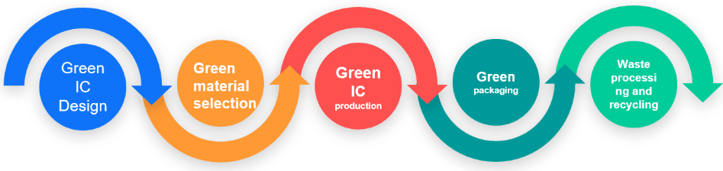
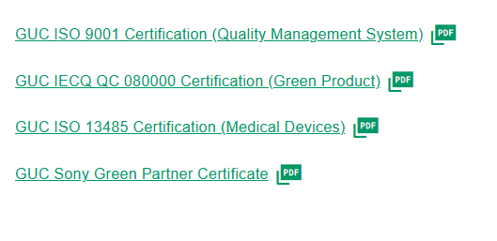

Risk Management
The 《Risk Management Policy》 was approved by the Company's Board of Directors in 2010, serving as the highest guidelines for the Company's risk management. All management units regularly conduct evaluation and review of risk items, and report the evaluation results to Operation Management Risk Committee. The president will then summarize major risk items and report them to the board of directors on a regular basis.
In the process of business operations/management, the Company adopts prevention and control measures for possible risks, and creates relevant alert mechanisms.In addition, the Company also conducts assessments of risks in relation to the Company's operations in accordance with the materiality principle as a reference basis for the Company's risk management and operational strategies. With effective risk identification, assessment and control, the Company’s risks arising from business activities can be controlled within an acceptable range.

GUC's Risk Management Scope
- Intellectual Property Management Plan
- Information Security Risk
- Contract Risk
- Product Quality and Competitiveness Risk
- Climate Change and Emergency Response for Environmental Risk Management
- Operational Risk

Operation
The Operation Management Committee holds two meetings every month. Units included in the Committee give presentations about the implementation of operation plans, and report on the risk control status of relevant duties as well as evaluate latent risks and provide countermeasures. Major risks that will affect operation plans will be summarized, and then be reported to the board of directors by Operation Management Committee’s chairperson.

Operation in 2024
- In 2023, the Company's division-level units had reported to Operation Management Committee on the risk control status of relevant duties based on the annual plan.
- The Company's president also reported on the Company's mid-/long-term plans and critical latent risks as well as countermeasures against them at the board meeting on Jan. 31, 2024.
- Moreover, the Company's management team also reported on the Company's risk management strategies in relation to information security risk management, contract risk management policy, intellectual property management plan, etc. at the board meeting on Oct. 31, 2024.



