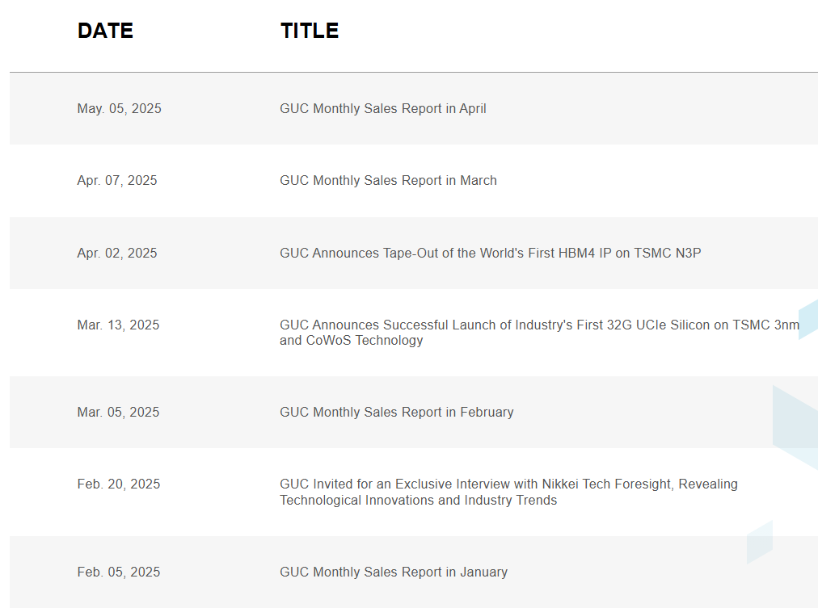

Date | Title
May 05, 2025 | GUC Monthly Sales Report in May
May. 05, 2025
News Content:
Hsinchu, Taiwan, May 5, 2025 - GUC (TAIEX: 3443) today announced its net sales for Apr 2025 were NT1,671 million, decreased 42.2% month-over-month and also decreased 1.3% year-over-year.
Net sales for four months of 2025 totaled NT$8,695 million, increased 17.8% compared to the same period in 2024.

GUC Sales Report
Apr. 07, 2025 | GUC Monthly Sales Report in April
Apr. 07, 2025
News Content:
Hsinchu, Taiwan, Apr 7, 2025 - GUC (TAIEX: 3443) today announced its net sales for Mar 2025 were NT2,892 million, increased 38.2% month-over-month
and also increased 31.9% year-over-year.
Net sales for first quarter of 2025 totaled NT$7,024 million, increased 23.4% compared to the same period in 2024.

GUC Sales Report
Apr. 02, 2025 | GUC Announces Tape-Out of the World's First HBM4 IP on TSMC N3P
Apr. 02, 2025
News Content:
Hsinchu, Taiwan – Apr. 2nd, 2025 – Global Unichip Corp. (GUC), the Advanced ASIC Leader, announced today that it has successfully taped-out the world’s first HBM4 controller and PHY IP. This test chip was implemented using TSMC’s cutting-edge N3P process technology and CoWoS®-R advanced packaging technology.

The HBM4 IP supports data rates of up to 12Gbps under all operating conditions. By leveraging a proprietary interposer layout, GUC has optimized signal integrity (SI) and power integrity (PI) to achieve these high speeds for all types of CoWoS technology. Comparing with HBM3, GUC’s HBM4 PHY delivers 2.5x bandwidth while improving 1.5x power efficiency and 2x area efficiency. In line with previous GUC HBM, GLink, and UCIe IPs, this HBM4 IP integrates proteanTecs’ interconnect monitoring solution to provide high visibility for testing and characterizing the PHY while improving in-field performance and reliability for end products.

This milestone further strengthens GUC’s comprehensive portfolio of advanced IPs, including its 32Gbps UCIe-A and GLink-3D IPs. Together, these offerings deliver a complete 2.5D and 3D total solution, empowering customers to address the most demanding applications in AI, high-performance computing (HPC), and beyond.
“We are proud to be the first company to have taped out a 12Gbps HBM4 controller and PHY IP,” said Sean Tai, President of GUC. “Our commitment to delivering best-in-class 2.5D/3D IPs and services remains strong. By integrating HBM4, UCIe-A, and GLink-3D IPs, we offer a comprehensive solution that meets the evolving needs of the semiconductor industry.”

GUC HBM4 IP Highlight
Signed off at 12Gbps in full range of corners and operating conditions
High bus utilization rate: ~90% at random read/write access
Proprietary interposer layout to achieve best SI/PI for all types of CoWoS technology
Embedded per-lane, in-mission mode I/O and Clock performance and health monitoring by proteanTec

To learn more about GUC’s UCIe IP portfolio and total solutions using TSMC’s CoWoS® and SoIC® technologies, please contact GUC sales representative via email (https://www.guc-asic.com/en/about-offices.php)
Mar. 13, 2025 | GUC Announces Successful Launch of Industry's First 32G UCIe Silicon on TSMC 3nm and CoWoS Technology
Mar. 13, 2025
News Content:
Hsinchu, Taiwan – Mar. 13th, 2025 – Global Unichip Corp. (GUC), the Advanced ASIC Leader, today announced the successful launch of industry’s first Universal Chiplet Interconnect Express™ (UCIe™) PHY silicon, achieving a data rate of 32 Gbps per lane, the highest speed defined in the UCIe specification. The 32G UCIe IP, supporting UCIe 2.0, delivers an impressive bandwidth density of 10 Tbps per 1 mm of die edge (5 Tbps/mm full-duplex). This milestone was achieved using TSMC’s advanced N3P process and CoWoS® packaging technologies, targeting AI, high-performance computing (HPC), xPU, and networking applications.

In this test chip, several dies with North-South and East-West IP orientations are interconnected through CoWoS interposer. The silicon measurements show robust 32Gbps operation with wide horizontal and vertical eye openings. GUC is working aggressively on the full-corner qualification, and the complete silicon report is expected to be available in the coming quarter.

To ensure seamless system integration, GUC has developed bridges for AXI, CXS, and CHI buses utilizing the UCIe Streaming Protocol. These bridges are optimized for high traffic density, low power consumption, minimal data transfer latency, and efficient end-to-end flow control – enabling an effortless transition from traditional single-chip Networks-on-Chip (NoC) to chiplet-based architectures. Additionally, the bridges support Dynamic Voltage and Frequency Scaling (DVFS), allowing real-time voltage and frequency adjustments independently of each die without interrupting data flow.

GUC's UCIe IP also features advanced reliability capabilities, including UCIe Preventive Monitoring functionality and integrated I/O signal quality monitors from proteanTecs. This technology enables continuous, mission-mode monitoring of signal integrity during data transmission without the need for re-training or disrupting operations. Each signal lane is individually monitored, with real-time detection of power and signal integrity anomalies. Potential defects in bumps and traces are identified early, triggering repair algorithms that replace marginal I/Os with redundant ones to prevent system failures. This proactive approach significantly extends chip lifespan and enhances system reliability.

Pushing the boundaries of performance, GUC is committed to further increasing lane speeds while reducing power consumption. GUC has successfully taped out its second-generation UCIe IP, achieving 40 Gbps per lane in late 2024. This new version incorporates Adaptive Voltage Scaling (AVS), delivering approximately 2x power efficiency improvements. In addition, a face-up version of the UCIe-40G IP, designed for 3D integration (SoIC) with Through-Silicon Vias (TSVs), is scheduled for tape-out in the coming months. Looking ahead, GUC’s third-generation UCIe IP, capable of 64 Gbps per lane, is currently in development and slated for tape-out in the second half of this year. UCIe product line is optimized for all types of CoWoS and for future TSMC's SoW-X platform. “We are excited to announce the successful silicon bring-up of the world’s first UCIe IP supporting 32 Gbps,” said Aditya Raina, CMO of GUC. “With a comprehensive, silicon-proven 2.5D/3D chiplet IP portfolio across TSMC’s 7nm, 5nm, and 3nm process technologies, we deliver robust solutions that go beyond IP. Combined with our expertise in design, package engineering, electrical and thermal simulations, design-for-test (DFT), and production testing for TSMC’s 3DFabric® technologies, including CoWoS®, InFO, TSMC-SoIC®, we empower our customers to accelerate design cycles and achieve rapid bring-up of their AI, HPC, xPU, and networking products.”

“We are committed to delivering the highest performance and lowest power 2.5D/3D chiplet and HBM interface IPs,” said Igor Elkanovich, CTO of GUC. “The convergence of 2.5D and 3D packaging technologies, leveraging HBM3E/4/4E, UCIe, and UCIe-3D interfaces, enables the development of highly modular processors that exceed reticle size limitations, paving the way for the next generation of high-performance computing.”
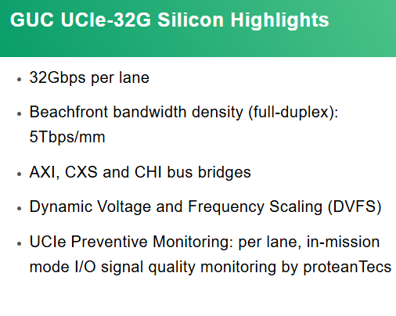
To learn more about GUC’s UCIe IP portfolio and total solutions using TSMC’s CoWoS® and SoIC® technologies, please contact GUC sales representative via e-mail. (https://www.guc-asic.com/en/about-offices.php)
Mar. 05, 2025 | GUC Monthly Sales Report in February
Mar. 05, 2025
News Content:
Hsinchu, Taiwan, Mar 5, 2025 - GUC (TAIEX: 3443) today announced its net sales for Feb 2025 were NT2,093 million, increased 2.7% month-over-month and also increased 18.9% year-over-year.
Net sales for Jan through Feb 2025 totaled NT$4,131 million, increased 18.1% compared to the same period in 2024.

GUC Sales Report
Feb. 20, 2025 | GUC Invited for an Exclusive Interview with Nikkei Tech Foresight, Revealing Technological Innovations and Industry Trends
Feb. 20, 2025
News Content:
GUC Japan Featured in an Exclusive Interview with Nikkei Tech Foresight

GUC is truly honored to be featured in a special report by Nikkei Tech Foresight. This report delves into how GUC has rapidly grown in the market in recent years, as well as the strategies we will strengthen across various fields in the future.

With the increasing global demand for automotive technology and artificial intelligence, our team, leveraging exceptional expertise, ensures that we stand out in the fiercely competitive environment through outstanding engineering skills. This report not only affirms our past efforts but also showcases our determination and confidence to continue leading the industry in the future.

To learn more about the report, please refer to Nikkei Tech Foresight:
https://www.nikkei.com/prime/tech-foresight/article/DGXZQOUC182BA0Y5A210C2000000

To learn more about GUC's technology, please refer to our website.
http://www.guc-asic.com

Feb. 05, 2025 | GUC Monthly Sales Report in January
Feb. 05, 2025
News Content:
Hsinchu, Taiwan, Feb 5, 2025 - GUC (TAIEX: 3443) today announced its net sales for Jan 2025 were NT2,039 million, decreased 24.6% month-over-month but increased 17.3% year-over-year.

GUC Sales Report
Jan. 07, 2025 | GUC Taped Out UCIe 40Gbps IP using Adaptive Voltage Scaling (AVS)
Jan. 07, 2025
News Content:
Global Unichip Corp. (GUC), the Advanced ASIC Leader, announced today that it has successfully taped out Universal Chiplet Interconnect Express™ (UCIe™) PHY IP with 40Gbps per lane on TSMC’s N5 process, beyond UCIe’s highest speed, for AI/HPC/xPU/Networking applications. UCIe 40G chiplet interface provides industry leading bandwidth density 1,645 GB/s per mm of die edge. The IP supports any speed up to 40Gbps and uses Adaptive Voltage Scaling (AVS) to reduce supply voltage achieving 2x better power efficiency for required speed. The chip is assembled using TSMC’s CoWoS® (Chip on Wafer on Substrate) advanced packaging technology.

Following suit GUC’s world first UCIe 32G solution readiness on TSMC’s N3P process in the industry in 2023, GUC further taped out UCIe 40G on the TSMC N5 process for meeting high bandwidth demand of multi-die integration at AI/HP/Networking applications. To further reduce PHY power, GUC features Adaptive Voltage Scaling (AVS), to optimize PHY supply voltage and driving strength, improving power efficiency by 2x. Minimal supply voltage and driving strength are selected by training algorithm to meet eye opening margins criteria ensuring robust operation in changing voltage and temperature conditions. The IP integrates silicon-proven proteanTecs’ I/O signal quality monitors. Signal quality is monitored in mission mode, during data transfer, without re-training or causing any data transfer interruption.

For easy integration, GUC developed bridges for AXI, CXS and CHI buses using UCIe Streaming Protocol. These bridges are optimized for high traffic density, low power, low data transfer latency and efficient end-to-end flow control, facilitating seamless transition from single chip NoC to chiplets architecture. The bridges support Dynamic Voltage and Frequency Scaling (DVFS) allowing digital supply voltage and bus frequency change on the fly while ensuring uninterrupted data flow. To support the IP integration in the bottom dies using TSMC’s SoIC®-X technology, it can be placed “face up” with adding TSVs for supplies and

interface signals.

“We are thrilled to announce our new-generation UCIe IP supporting 40 Gbps with 2x better power efficiency,” said Aditya Raina, CMO of GUC. “We have established a complete silicon-proven 2.5D/3D chiplet IP portfolio at TSMC’s 7nm, 5nm and 3nm technologies. Together with design expertise, package design, electrical and thermal simulations, DFT and production testing for the TSMC 3DFabric®offerings including CoWoS®, InFO, and TSMC-SoIC®, we provide our customers with a robust and comprehensive solution, enabling fast design cycles and quick bring up of their AI/HPC/xPU/Networking products.”

“We are committed to delivering the fastest and the lowest power 2.5D/3D chiplets interface IPs, facilitating seamless transition from monolithic to chiplets architectures,” said Igor Elkanovich, CTO of GUC. “Convergence of 2.5D and 3D packaging using HBM3/4, UCIe and GLink-3D interfaces enables highly modular, much bigger than reticle size processors of the future.
To learn more about GUC’s UCIe IP portfolio, and TSMC’s CoWoS® and SoIC® total solution, please contact your GUC sales representative directly via https://www.guc-asic.com/en/about-offices.php
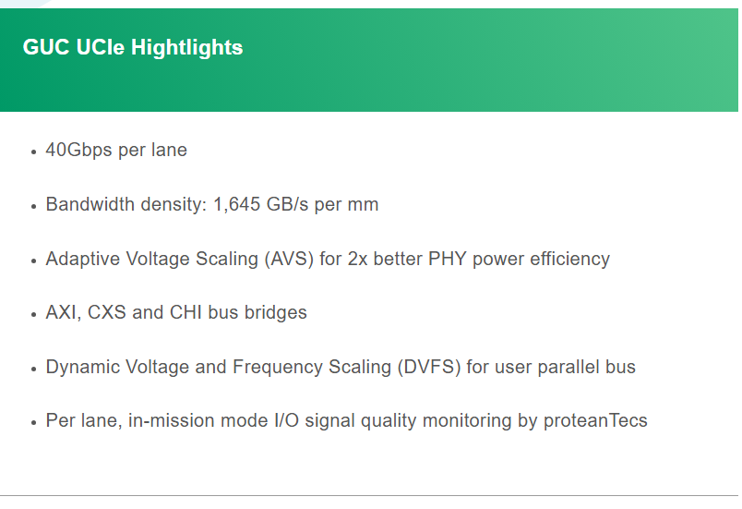

Jan. 06, 2025 | GUC Monthly Sales Report in December
Jan. 06, 2025
News Content:
Hsinchu, Taiwan, Jan. 6th, 2025 - GUC (TAIEX: 3443) today announced its net sales for Dec. 2024 were NT2,702 million, increased 47.1% month-over-month and also increased 22.4% year-over-year.
Net sales for fourth quarter in 2024 totaled NT$6,022 million, decreased 8.9% compared to third quarter in 2024 and also decreased 4.6% compared to the same period in 2023.
Net sales for 2024 totaled NT$25,044 million, decreased 4.6% compared to 2023.

GUC Sales Report

