Flexible Business Model

GUC offers flexible engagement models tailored to diverse customer needs, including Spec-in, Netlist-in, GDS-II-in, as well as production and supply chain management, as illustrated in the following figure.
(figure source: company profile)
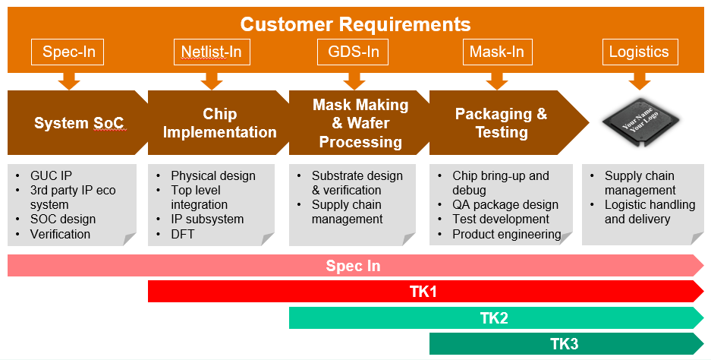

Spec-In Service

Our comprehensive spec-in service encompasses front-end design architecture optimization, IP solutions, IP/subsystem/chip integration and design verification, software services, and system emulation.

TK1 Service (Netlist-In)

Our industry-leading physical design expertise spans advanced process design, 2.5D and 3D design, flagship SoC design, and low-power solutions. It includes floorplanning, partitioning, placement, clock tree synthesis (CTS), routing, scan test insertion, power planning, signal integrity analysis, timing analysis and optimization, physical verification, and final GDSII layout preparation for fabrication, followed by production and supply chain management.

TK2 Service (GDS-In)

Our GDS-in production service covers package design, tape-out, testing, sample delivery, qualification, production ramp, yield enhancement, and supply chain management. With strong foundry relationships and expertise in supply chain management, we ensure seamless service execution.

TK3 Service (Production Transfer)

We offer flexible working models to support successful customer production, leveraging a well-established flow and checklist to ensure smooth and efficient transfers. Our strong foundry relationships and supply chain expertise enable seamless service execution.

