Advanced Packaging Technology
Overview
The advanced packaging technology (APT) is a technology which integrates multiple chips into one package using 2.5D die-to-die interconnections such as silicon interposer, redistribution layers (RDL) and 3D die-on-die stacking. It can achieve high performance, low power and smaller form factor for AI, HPC, Networking and ADAS applications.
GUC provides services for the following TSMC advanced packaging technologies.
CoWoS-S (redraw needed) CoWoS-R (redraw needed) CoWoS-L (redraw needed)
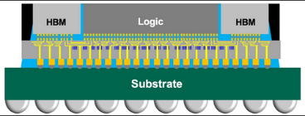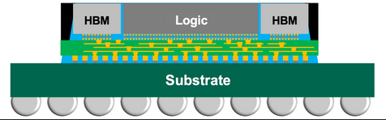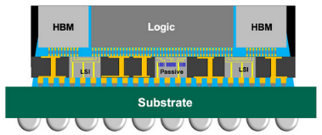

InFO-oS (redraw needed) TSMC-SoIC (redraw needed)
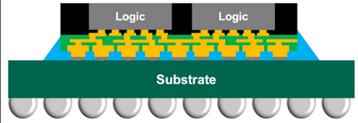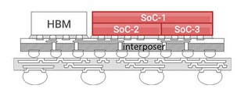

System-on-Wafer (SoW) (redraw needed)
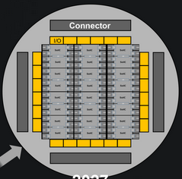
GUC Solutions
- GUC APT Platform
GUC provides a comprehensive solution for advanced packaging, from interposer/RDL design, SI/PI/Thermal simulations, IP, package and substrate design, to high-volume production. Our expert team is well-experienced in the most cutting-edge advanced packaging technologies.
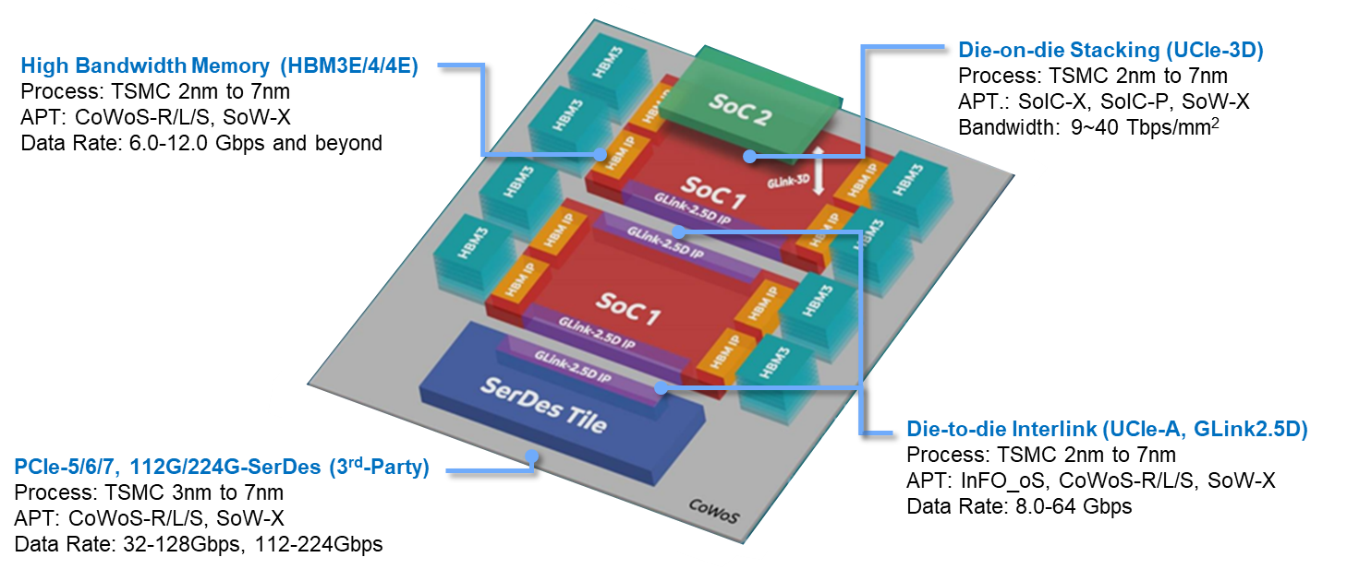
- System Simulation
Chip-Package-PCB co-design and co-simulation sign-off are critical to advanced products for performance and reliability, especially 2.5D/3DIC integration. GUC in-house solution includes electrical signal & power integrity, power distribution networks (PDN), system thermal integrity and mechanical warpage and stress co-simulation. Product performance is enhanced through floorplan, physical designs, bump/ball assignments, I/O signals break-outs and timing budgets optimization.

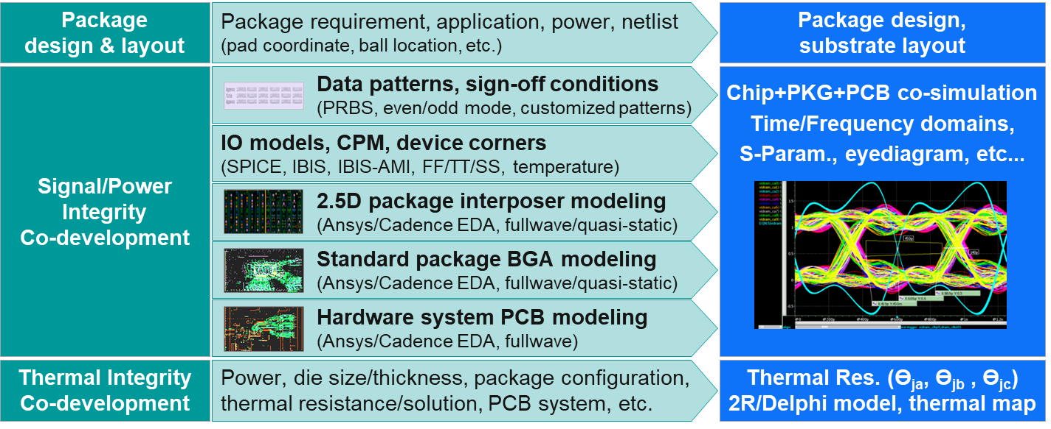
- Total Solution of Signal/Power Integrity & Advance Packaging Design
- HBM and UCIe high speed interconnect design
- Chip, interposer, package and board Power-aware signal Integrity co-optimization
- Si proven with good electrical design margin and eye diagram correlation

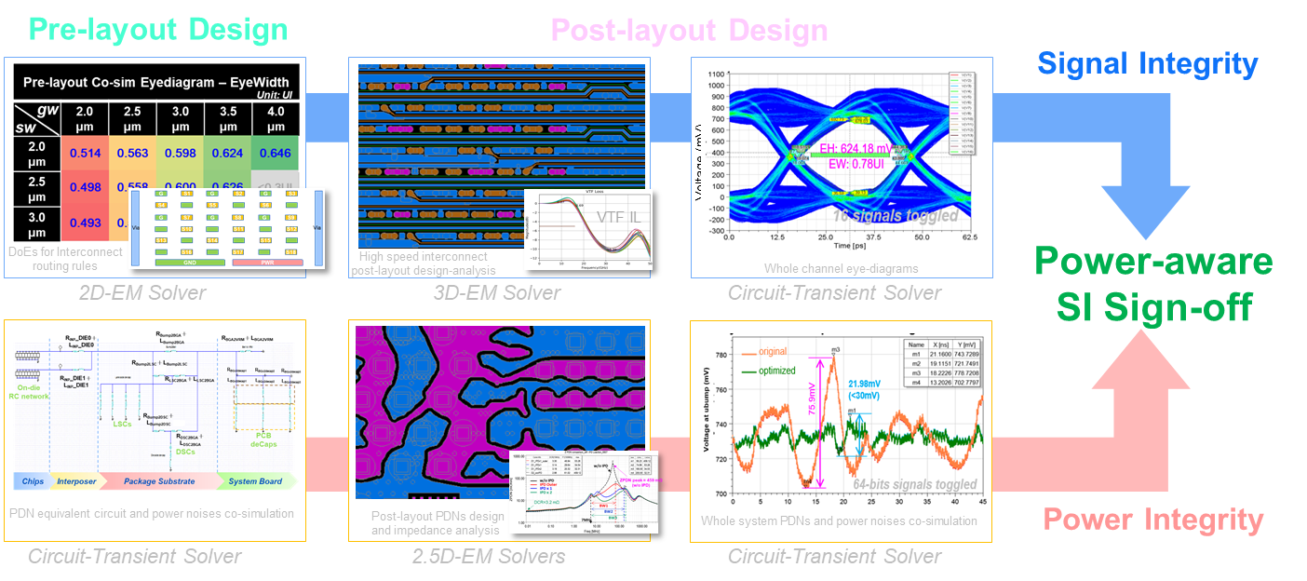
- Whole System Power Integrity
- SoC core power whole system PDNs IR-drop and Ldi/dt co-design & sign-off
- Power distribution networks (PDNs) budgeting design & on-/off-chip decap co-optimization
- Voltage fluctuation & droops co-simulation and Vpeak-peak & Vmin characterization
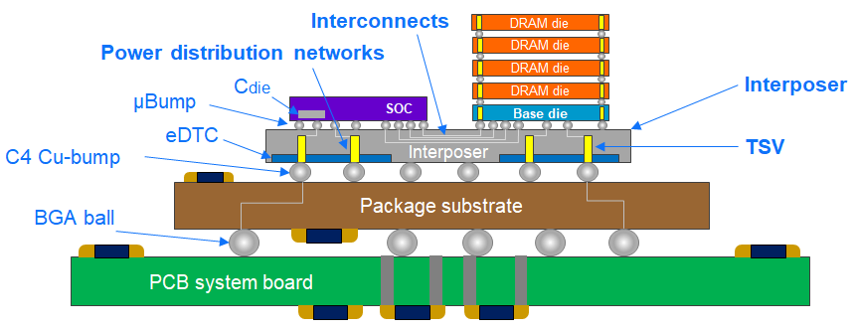
- Packaging & System Thermal Integrity - 2D/2.5D/3D-IC Design
- Early & sign-off stage thermal assessment with chip /chiplet /package /system co-optimization
- Thermal resistance parameter modeling for multiple packaging topology design & decision
- Compact thermal models generation and system-level thermal /cooling co-development
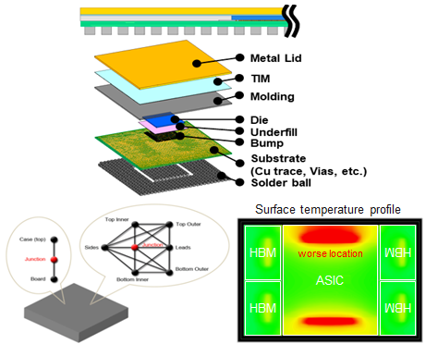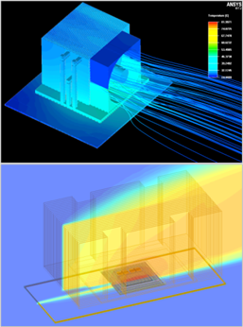
- Packaging Mechanical Warpage & Stress - 2D/2.5D/3D-IC Design
- Early & sign-off-stage mechanical simulation for different packaging solutions
- Mechanical warpage & stress risks assessment and chiplets floor-planning integration
- Package design analysis with mechanical-aware co-optimization, e.g., BoM, layer stacks
- Mechanical stress analyses for package routability and physical design co-optimization
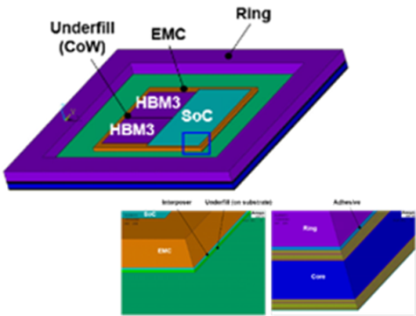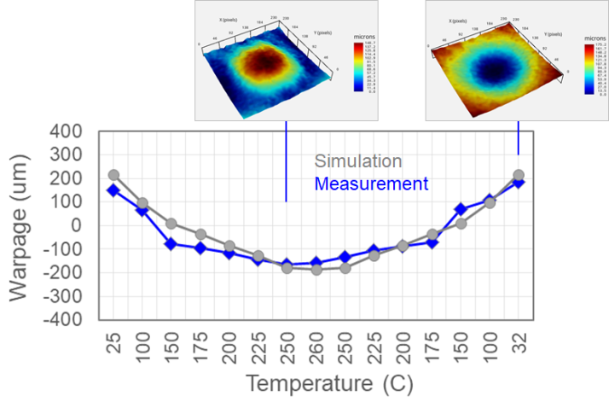

- GUC APT IP Portfolio
GUC APT IP has been well recognized by customers and industry. These award-winning IPs mark our leading position in APT. We also provide IP customization alone with our turn-key ASIC design service to our APT customers.
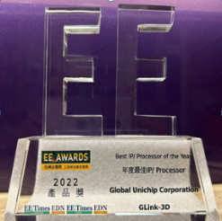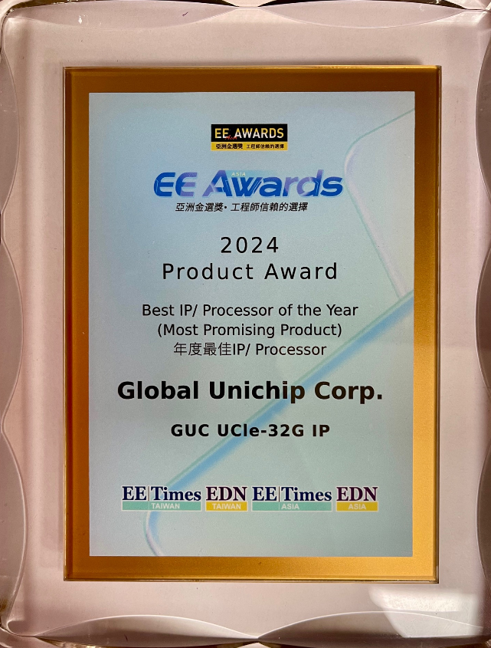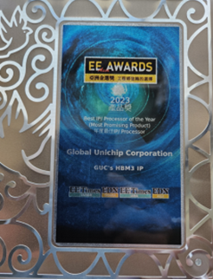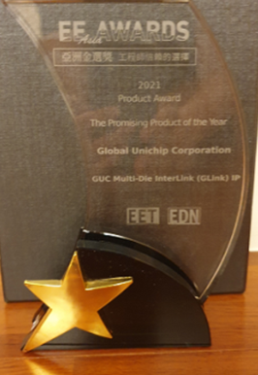

For detailed information, please refer to:
High Bandwidth Memory IP (link)
Die-to-Die (2.5D) IP (link)
Die-on-Die (3D) IP (link)

- Timeline of GUC APT Flow

GUC is a pioneer in the development of advanced packaging technology.

In 2016, GUC developed our first HBM (High Bandwidth Memory) IP in TSMC 16nm FinFET process and CoWoS (Chip-on-Wafer-on-Substrate) technology. In 2018, we delivered the first 16nm CoWoS customer product which integrates four HBM2 chips and high-speed SerDes interface for AI applications.

Our APT flow is reliable and up-to-date. It’s well-proven by our APT IP, in-house testchips, and leading customer products.

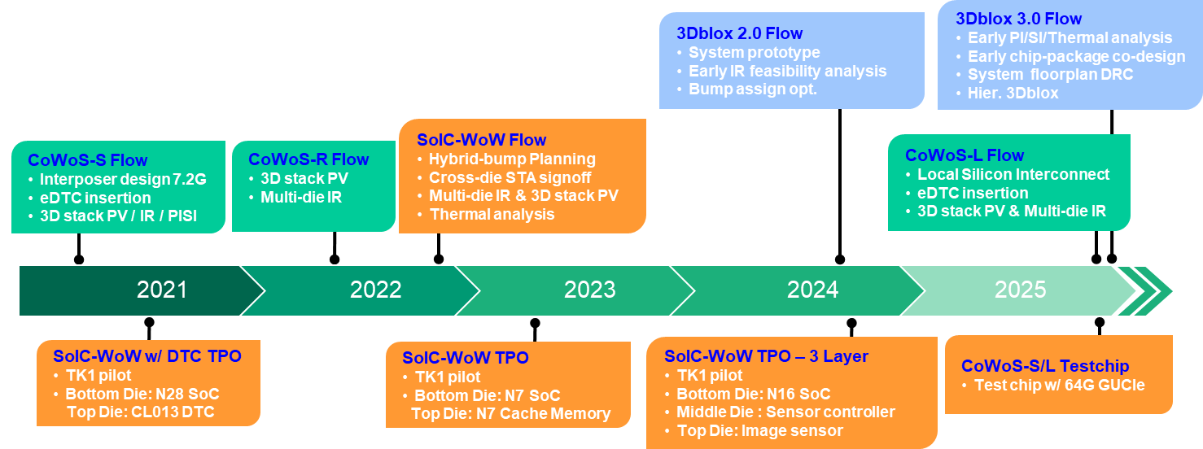
APT Success Story (Link)

