SoC Spec-in Design & Verification

GUC offers comprehensive ‘spec-in’ design services, encompassing SoC architecture design, system integration and verification, software development, power and performance evaluation, and system prototyping.
At the SoC design stage, GUC’s CPU sub-system design platform enables customers to effectively evaluate system performance. Leveraging in-house design automation tools and advanced verification methodologies, GUC accelerates the SoC design cycle while maintaining high quality. The emulation flow delivers simulation speeds approximately 700 times faster, facilitating early hardware-software co-development. Additionally, GUC’s power profiling flow and low power design methodologies address challenges such as power density and IR issues in modern high-end SoCs. With these capabilities, GUC’s ‘spec-in’ services empower customers to achieve first silicon success and significantly shorten time to market.
Service
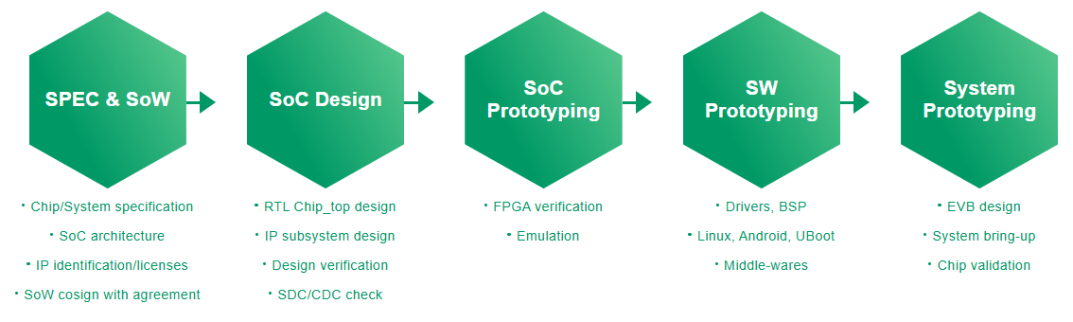

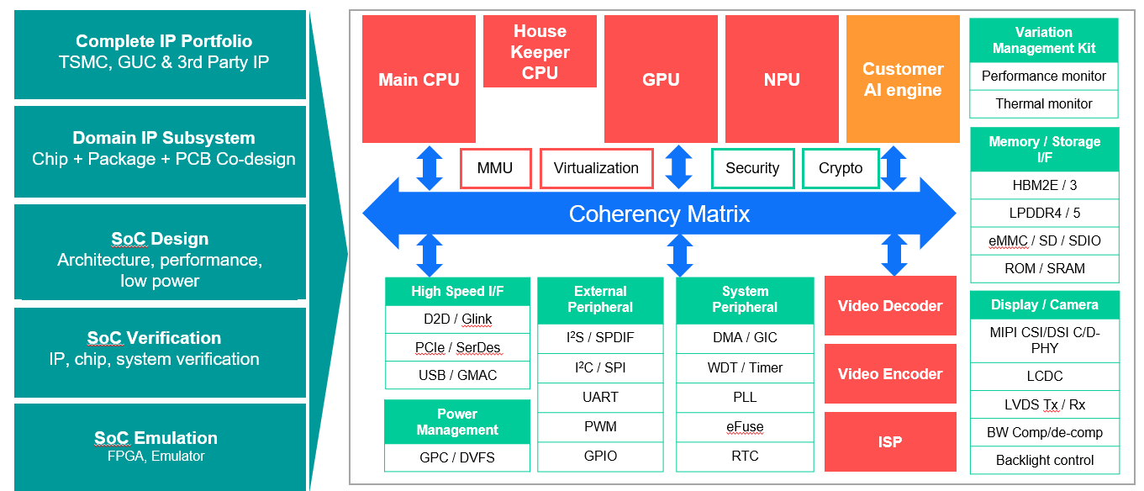
(redesign the visuals)

Success Story

 | Application | Process | Key features | Logic Gates | Technical highlights
1 | AI Datacenter | 5FF | CA55x10, Customer Octa AI engines  PCIe5, HBM3 | ~5000M | AI performance  Complex PCIe5 bifurcation, HBM3 SS
2 | AI AR/VR | 7FF | CM55, CU55, MIPI, Customer AI engine | ~13M | MIPI TX/RX SS
3 | Networking | 12FFC | CA53x4, DDR4, PCIe3, SATA3, Ethernet, USB2 | ~35M | 5G networking bus matrix bandwidth optimization
4 | AI Data Center | 12FFC | Customer AI engine,  PCIe4 | ~1000M | AI engine performance  Complex HS IPSS
5 | 8K Camera | 12FFC | CA35x4, CA5, Crypto, PCIe3,  HDMI2.0, DP1.4, DSI, MPHY,  LPDDR4x, customer ISP | ~160M | Critical bus timing  DDR access efficiency  Complex HS IPSS
6 | 8K Camera | 12FFC | CA35x4/x1, Crypto,  LPDDR4x, customer ISP | ~80M | Critical bus timing  DDR access efficiency
7 | Automotive | 16FFC | Customer engine, ADC  MIPI, SerDes, LBIST | ~30M | High speed ADC  LBIST in automotive
8 | HBM2/CoWoS | 16FF+ | CA72x2, HBM2, PCIe4 | ~50M | HBM, CA72 performance  CoWoS flow
9 | AI Vision | 28HPC+ | Customer AI engine,  CA5, H264, PCIe3, DSI/CSI | ~85M | DDR access efficiency  Bus matrix optimization

系統單晶片開發與驗證

創意電子提供完整「專案規格制定」(spec-in) 設計服務，包括 SoC(系統單晶片) 架構設計、系統整合與驗證、軟體開發、功耗與效能評估，以及系統原型製作等。
創意電子的 CPU (中央處理器) 子系統設計平台，可協助客戶在SoC設計階段評估系統的效能。運用內部的設計自動化工具與流程，我們可以加速實作與整合變更，並重複使用設計。我們所採用的設計驗證方法，能確保SoC發揮最佳功能；自行開發的模擬流程，更可將模擬時間加快約700倍，在設計初期階段就能實現軟硬體的協同開發。此外，結合功耗分析流程與低功耗設計方法，可有效解決主要的SoC功耗和壓降 (IR-Drop) 問題。結合所有以上功能，創意電子的「專案規格制定」服務可協助客戶實現SoC第一次矽晶設計就成功的目標，並加快上市時程。

