Chip Implementation Methodology

GUC integrates commercial EDA and in-house solution to make sure design quality and
Efficiency

- Code purification and constraint analysis
- Physical Synthesis
- DFT integration platform to support HPC multi-core design
- IR aware DFT planning for DFT IR closure
- IP integration/IP quality checking and high-speed IP testing methodology
- 2.5D/3D multi-die DFT solution
- Multi-level hierarchical implementation methodology for HPC multi-billion gate design
- Best PPA APR result with AI-APR implementation solution
- PowerMagic® low power methodology and PowerHERO cell customization
- Dynamic IR, PI, SI and timing aware implementation
- 2.5D Interposer methodology with CoWoS and Die to Die methodology
- Silicon proven 3DIC-SoIC solution
- 3DBlox base 2.5D/3D chip planning and implementation solution
- Function safety format (USF/FFS) implementation solution for automotive application

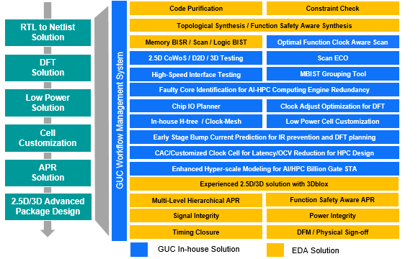

Efficient Chip Implementation Platform

