Design For Testability
Design For Testability (DFT) refers to those design practices that assist designers to reduce cost of test pattern generation, enhance fault coverage, and hence reduce defect levels at mass production.
GUC DFT methodology provides a complete solution including RAM/ROM BIST, DC/AC Scan, Logic BIST, ATPG and boundary scan (JTAG), to achieve ultra-high test coverage.

Advanced DFT Solution
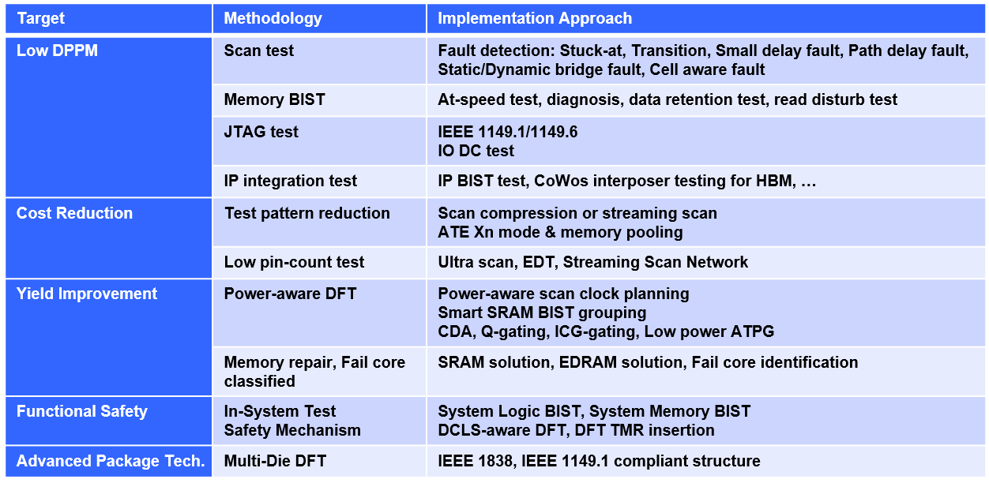

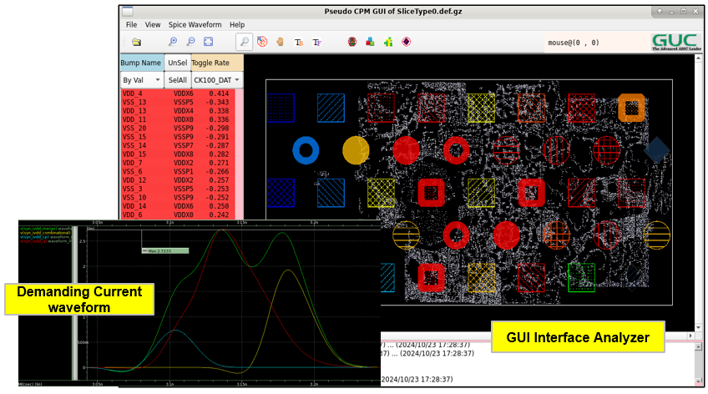 | 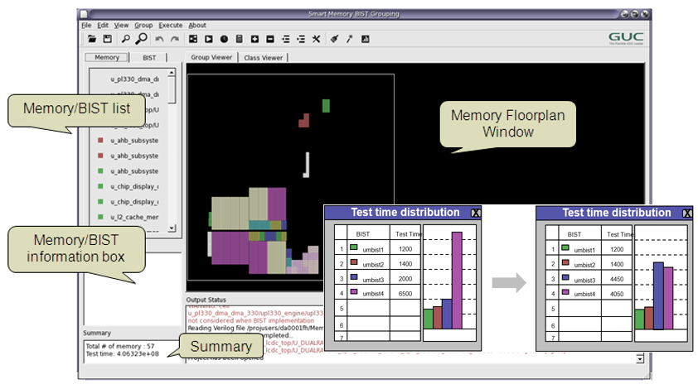
Power Aware Structure Planner | Smart SRAM BIST grouping
- GUI interface bump current prediction  - Early stage power-aware DFT structure planning | - Physical aware auto-group with test time optimization  - GUI interface for grouping quality review
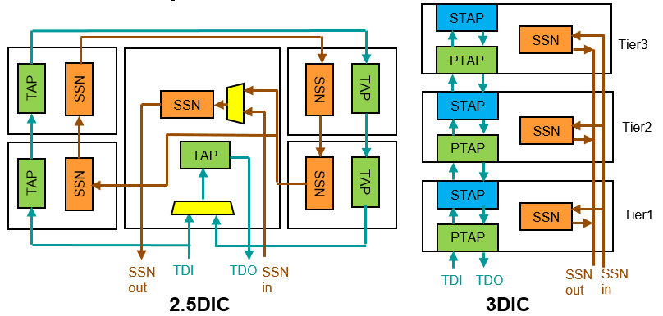 | 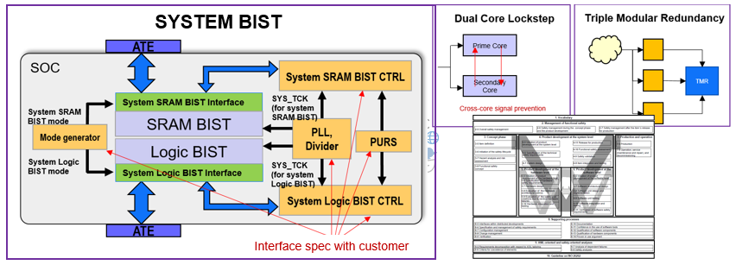
Multi-Die DFT | Functional Safety DFT
- Design notice on IO arrangement and clock strcuture  - IEEE 1838 or IEEE 1149.1 compliant solution  - Streaming scan solution | - In-system test methodology targeting functional test specification  - Safety mechanism aware solution on DFT implementation  - Low DPPM test methodology
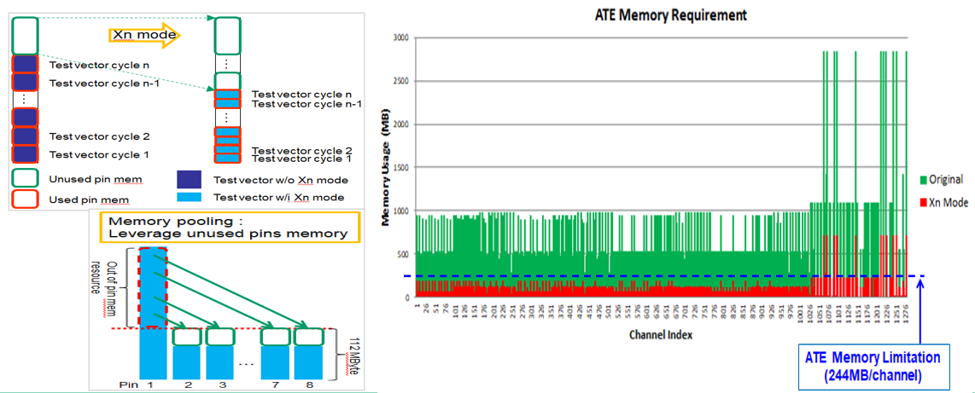 | 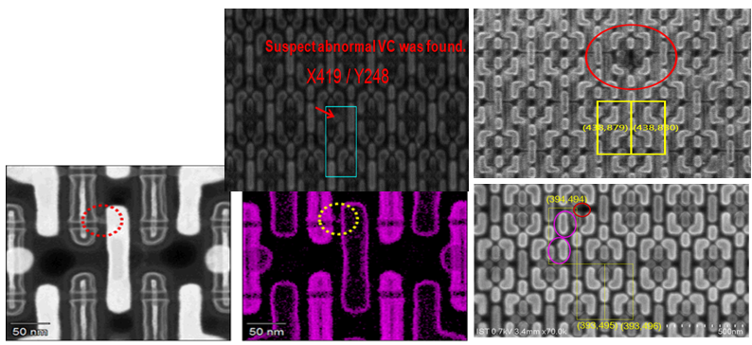
Xn Mode & Memory Pooling | Physical Failure Analysis
- Design flow, pattern notice for max pattern compression  - 83.5% ATE memory usage reduction on large design | - Physical diagnosis for Scan/MBIST for failure syndrome analysis  - Physical defect survey for manufacturing process tunning

Success Story
Process | Gate Count | Application | DFT Feature
5nm | >5B | AI | DC/AC Scan, Fail core testing for core redundancy, MBIST, HBM interposer test, IR aware DFT
5nm | 150M | Network | DC/AC Scan, @speed MBIST, IEEE 1149.1/1149.6
6nm | 1225M | Data Center AI | DC/AC Scan, @speed MBIST, IEEE 1149.1/1149.6, System MBIST
7nm/7nm | 30M | AR/VR | DC/AC Scan, MBIST, TSV interface testing
7nm | 600M | HPC | DC/AC Scan, HBM interposer test, MBIST, IEEE 1149.1/1149.6, Fail core identification
7nm | 3.4B | HPC | DC/AC Scan, HBM interposer test, MBIST, IEEE 1149.1/1149.6, Fail core identification
7nm | 2.75B | Networking | DC/AC Scan, Fail core testing for logic redundancy, MBIST, TCAMBIST
12nm | 1.25B | AI | DC/AC Scan, Ultra-scan, @speed MBIST, SRAM repair
12nm | 220M | Camera | DC/AC Scan for 800+ clock domains, @speed MBIST
12nm | 147M | Drone | DC/AC Scan, @speed MBIST, IEEE 1149.1/1149.6,
12nm | 22M | Storage | DC/AC Scan, @speed MBIST, IEEE 1149.1/1149.6, Thermal sensor test
12nm | 340M | 5G DEF | DC/AC Scan, Scan Compress, Ultra-scan, @speed MBIST, IEEE 1149.1/1149.6, AFE loopback, Thermal sensor test
45nm/40nm/16nm | 21M | AR/VR | DC/AC Scan, MBIST, TSV interface testing
16nm | 1B | HPC | DC/AC Scan, HBM interposer test, @speed MBIST, SRAM repair
16nm | 20.1M | AI | DC/AC Scan, @speed MBIST, System BIST, IEEE 1149.1/1149.6
16nm | 14M | LiDAR | DC/AC Scan, Scan Compress, @speed MBIST, IEEE 1149.1/1149.6, System Logic BIST
28nm | 71M | Networking | DC/AC Scan, @speed MBIST, System BIST,SRAM hard/soft repair
28nm | 100M | SSD | DC/AC Scan, MBIST, IEEE 1149.1, PCIe/ DDR loopback, Thermal sensor test
28nm | 20M | WiGig | DC/AC Scan, Scan Compress, @speed MBIST, IEEE 1149.1, PCIe loopback, AFE loopback, Thermal sensor test

