Flagship SoC Design Solution

HPC, AI and Networking technique are used for many applications such as data center computing, edge computing, connectivity network etc. The built-in repeated computing engine and memory bandwidth is more as possible to enlarge the computing capability, so the design complexity and chip size increase more at HPC/AI/Networking era. Traditional design flow has bottleneck to serve this complexity design. GUC has state-of-art solutions including multi-level hierarchical design, hierarchical timing sign-off, high power IR prevention DFT, high-speed IP integration, 2.5D package (CoWoS/InFO) design with HBM/D2D IP subsystem, SoIC 3D-stack sign-off, and chip-package system PI/SI verification to ensure customer design success. With this total solution, GUC has successfully taped out many flagship SoC designs.

Comprehensive Solution for Flagship SoC Design

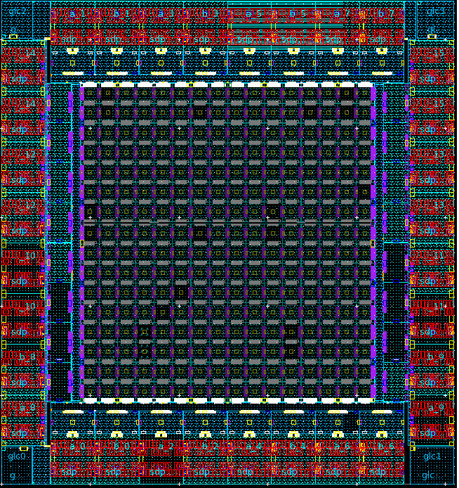  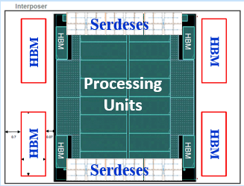 |  |  | 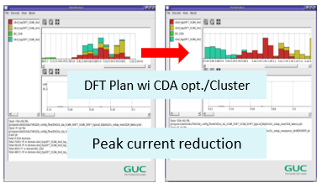  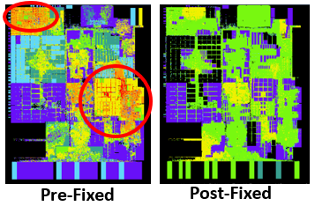
Complex IP integration: SerDes, HBM, D2D  - Multiple-Billion gate design with 112G SerDes * 256 Lanes  - CoWoS interposer with 4 HBM2E(3.2GHz)/HBM3E(8.4GHz), D2D G-link-fs(8~12GHz)  - 2.5D/3D CoWoS/SoIC IR/PI/SI/Thermal Integrity |  |  | High power: IR/PI aware PDN, DFT plan  - Peak current and P/G bump feasibility analysis for early phase IR/PI  - IR aware DFT plan with bump current to mitigate IR and reduce TAT  - Distributed clock useful skew to reduce peak current
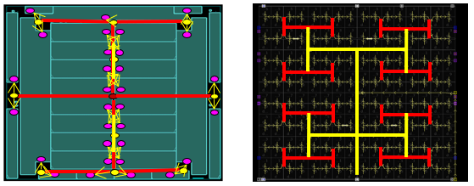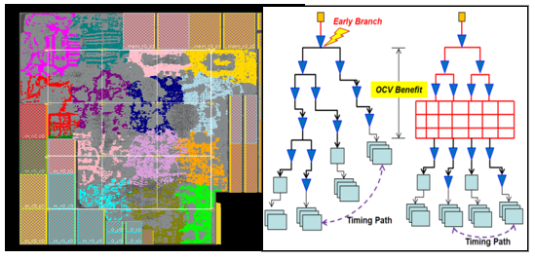 |  |  |  | 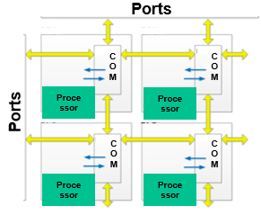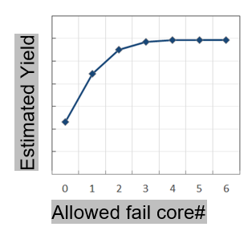
Advanced Clock Design  - H-tree with big clock driver and CAC (clock delay adjust cell) to reduce skew and latency: OCV ~60% reduction & skew ~10ps  - Clock mesh boost chip performance  - Data flow driven clock topology planning in TOP channel |  |  |  | AI/HPC Faulty Core Identification  - Failed core identification by core wrapping and pin mux structure  - Consider pin resource, test power, and test time

Success Story
Process | Gate Count | Application | Key Feature
5nm | >5 B | HPC | CoWoS with 2 HBM3, Fail core identification, Hyper Scale Hier. STA,  5-level Hier. design, IR-aware DFT, PCIe Gen5 integration
5nm | 2.2B | Data Center AI | InFO D2D with GLink 2.0 PHY, GDDR6/PCIe Gen5, Hyper Scale Hier. STA,  4-level Hier. design, channel-less design,
6nm | 1225M | Data Center AI | ARM N2 hardening, PCIe Gen5 / SerDes 112G, Hyper Scale Hier. STA,  4-level Hier. design, Customized binning and AVS strategy
7nm | >3 B | HPC | CoWoS with 4 HBM, Fail core identification, Hyper Scale Hier. STA, H-tree CTS  2-level Hier. design, IR-aware DFT, channel-less design
7nm | >3B | Networking | Fail core identification for redundancy, H-tree, 112G SerDes integration,  2-level Hier. design, IR-aware DFT
12nm | 1.25B | AI | SRAM repair, IR-aware DFT, 2-level Hier. design, multi-core IR ramp-up analysis
16nm | 1B | HPC | CoWoS with 4 HBM, IR-aware DFT, 2-level Hier. design
16nm | 1.6 B | AI | Fail core identification, IR-aware DFT, Hyper Scale Hier. STA, fishbone clock, channel-less design
28nm | 407M | AI | IR-aware DFT, H-tree CTS, shift clock distribution for peak power reduction
28nm | 240M | Networking | SerDes integration, Chip-package PI/SI

