Quality & Reliability Service
GUC's Quality mission is to provide customer the advanced technology product with high quality and sincere service. The service offers the proven and well defined one stop shopping reliability assurance and qualification test services, including component level and board level qualifications according to JESD, AEC and IPC standards
- L1: ESD/EOS, Latch up, HTOL/ELFR, MSL/TCT/HAST/HTSL/LTSL/PTC/THB, etc.
- L2: TCT, Drop, Shock, Bend test, vibration test, etc.
- ORM: On-going Reliability Monitoring
- Automotive AEC-Q100 qualification
- Production burn-in
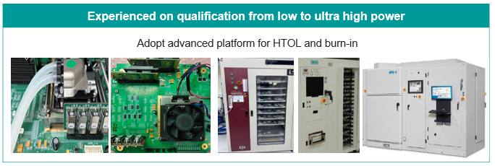
Quality & Reliability Assurance
New product quality control starts from BOM selection then followed by product qualification according to the standards. Product is verified by PVT and system correlation then determined production screen condition for quality.
Manufacturing quality control by product yield and regular reliability monitoring
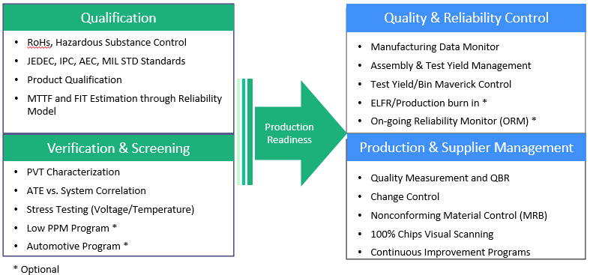

GUC Suppliers' Quality System Certificates
- GUC passed ISO9001 in 2008 for general quality management and IEC/QC080000 for Hazardous substance management.
- All manufacturing service vendors passed ISO9001 Advanced Quality System Certificates.

