Supply Chain Management
At GUC, we recognize that a robust and sustainable supply chain is critical to delivering innovative technologies that empower businesses worldwide. Our supply chain management are designed to ensure seamless operations, on-time delivery while meeting the highest standards of quality, sustainability, and customer satisfaction.

GUC manages both wafer-buy or chip-buy business models, and has delivered more than 300 production products to customers since 2016.
- Ship average >70Kpcs of 12” wafer equivalent components per year
- Single product High Volume Manufacture management, 10K+pcs wafers per month, 2M+ package units per month
- N5/N4P/N3E, and CoWoS package in volume production

By choosing GUC's production operation, our customers can enjoy the following benefits:
- Identify and select the most suitable top tier supplier
- Secure capacity to fulfill customer demand
- Capacity and material planning and testing H/W expansion plan
- NRE engineering lot fast cycle time support
- On-time delivery rate exceeds 99%
- Drop shipment service
- Inventory management aligned with customer demand
- Provide web-based reporting to customer through GUC online e-Commerce Service
GUC integrates Environmental, Social, and Governance (ESG) principles into our supply chain to promote a positive environmental and social impact and setting science-based targets to reduce greenhouse gas emissions across the supply chain. Our mission is to ensure a robust and efficient supply chain and deliver world-class ASIC solutions while fostering a positive impact on society and the environment.

Turnkey Service Strategic Alliance
Partnership with top-tier supply chain suppliers to provide the sufficient and flexible production support.
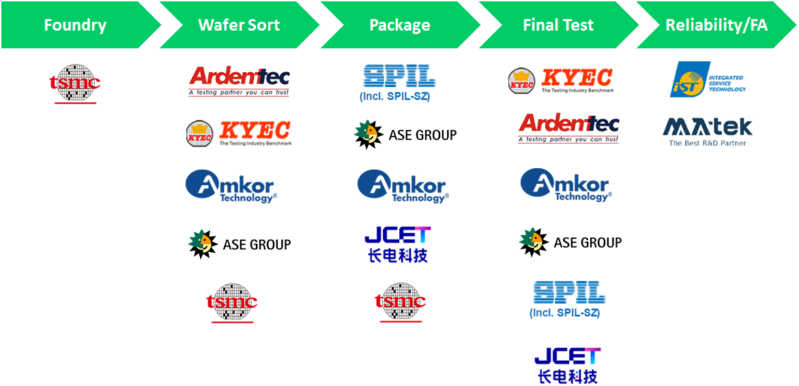
e-Commerce Service
GUC online e-Commerce Service is a web-based service tool designed for customers who wish to keep track of their project progress. This powerful tool provides an easy access to the customers for their order status and real-time WIP check from Foundry, Wafer Sort, Assembly, Final Test and product shipments 24 hours a day, 7 days a week.

GUC online portal
- Integrate Foundry /OSAT B2B to generate WIP, inventory, etc. reports for regular reviews
- Include real time WIP, hold lot report, WIP vs demand, order status /open PO and shipment record
- Data management >5 years

