High Bandwidth Memory IP

GUC’s HBM IPs deliver comprehensive solutions for SoC designs targeting high-bandwidth applications, such as AI, HPC, data centers, and networking. Fully compliant with JEDEC standards, GUC’s HBM IPs support 12Gbps (HBM4) and 9.4Gbps (HBM3E). By leveraging fully optimized hard macro designs on advanced process technologies and proprietary CoWoS interposer routing, GUC’s HBM IPs deliver top-tier performance with an optimal balance of power and area for high-end SoCs.
GUC’s HBM IP and Total Service
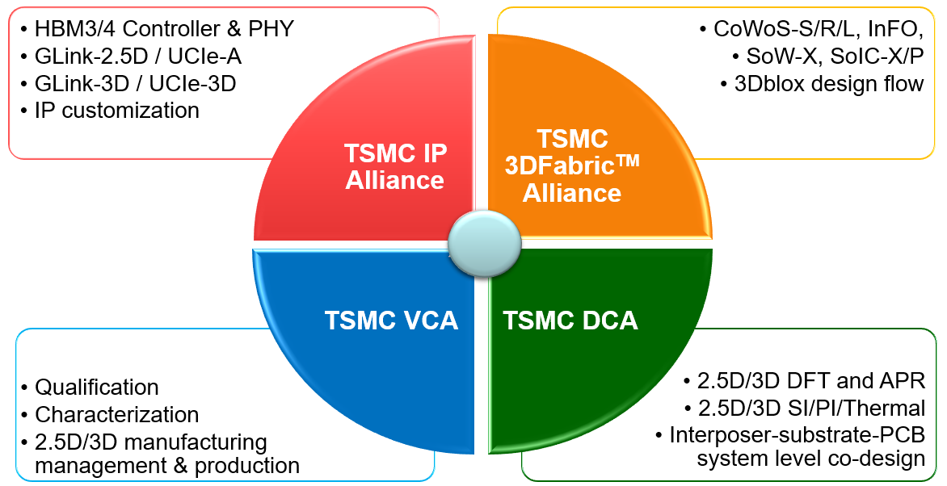
(redesign the visuals)

HBM IP Portfolio

Part Number | Process | Description | Download
IGAHBMY02A | 5 nm | HBM2E 3.6 Gbps
IGAHBMX03A | 7 nm | HBM3E 8.0 Gbps
IGAHBMY03A | 5 nm | HBM3E 9.2 Gbps
IGAHBMZ01A | 3 nm | HBM3E 9.4 Gbps
IGAHBMZ03A | 3 nm | HBM4 12 Gbps
IGDHBM003A | All | HBM2E Controller
IGDHBM004A | All | HBM3E Controller
IGDHBM005A | All | HBM4 Controller

