GUC’s multi-die interLink (GLink-2.5D/-3D) and UCIe IP provide the world’s best-in-class solution for high-bandwidth, low-power, low-latency multi-channel interconnection in a package for applications such as High Performance Computing, Data Center, Artificial Intelligence and Networking.

GLink-2.5D IP utilizes single-ended signaling on parallel bus with DDR clock forwarding. This allows for up to 8/16Gbps per pin, consuming only 0.25pJ/bit on TSMC’s RDL-based InFO (Integrated-Fan-Out) or CoWoS (Chip-on-Wafer-on-Substrate). One slice has 32 full-duplex lanes, and one PHY has 8 slices with a maximum bandwidth of 2/4Tbps. For the most advanced GLink version, one slice will have 56 full-duplex lanes, and one PHY has 8 slices with a maximum bandwidth of 7.5Tbps.

GUC leverages its multi-year, multi-generation GLink-2.5D experience to the development of UCIe IP. GUC’s UCIe 32G IP follows the UCIe standard to provide industry-leading, 32G per lane die-to-die inter connect, achieving the best beachfront efficiency of 5+ Tbps/mm in full duplex. The new generation UCIe LP 40G even achieves beyond UCIe’s highest speed, for AI/HPC/xPU/Networking applications. UCIe LP 40G chiplet interface provides industry leading bandwidth density 1,645 GB/s per mm of die edge. The IP supports any speed up to 40Gbps and uses Adaptive Voltage Scaling (AVS) to reduce supply voltage achieving 2x better power efficiency for required speed. For supporting SoIC-X face-to-face stacking, GUC also provides UCIe LP/Up IP, i.e. face-up IP for using in the bottom die of SoIC-X.

UCIe consortium is proposing to extend UCIe spec for higher data rates for meeting rapidly growing bandwidth and performance needs due to Gen-AI trend. GUC takes the lead to develop UCIe 64G version and the solution is expected to be ready in 4Q25 for serving GUC customers.

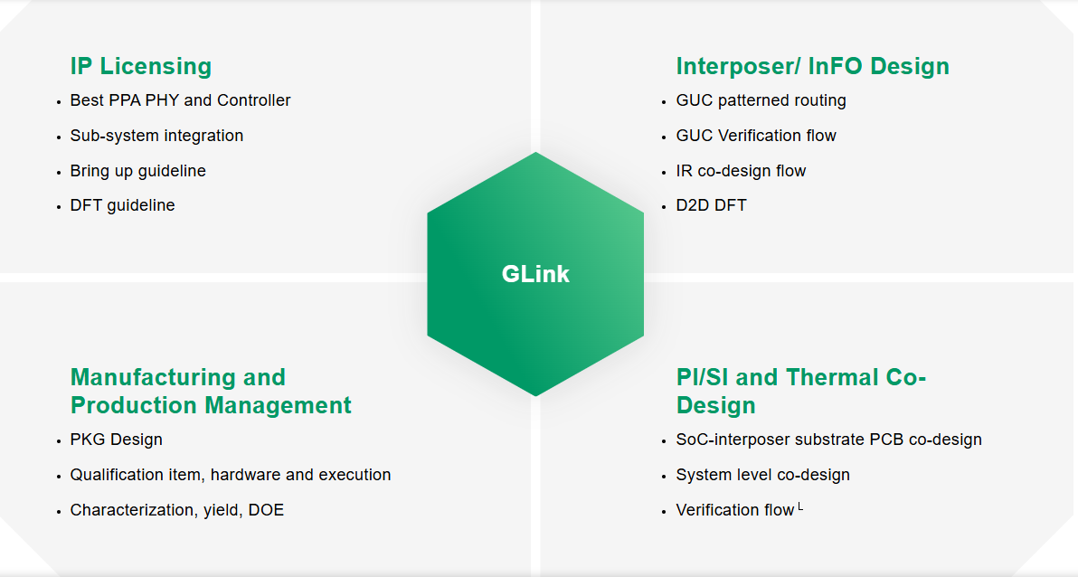
(GLink in green Hexagon, please change to UCIe / GLink)

Die-to-Die (GLink-2.5D) IP
Part_Number | Process | Description | Download
IGAD2DX01A | 7nm/6nm | Die to Die Interface PHY with full-duplex 2Tbps/3mm
IGAD2DY01A | 5nm | Die to Die Interface PHY with full-duplex 4Tbps/3mm
IGAD2DY04A | 5nm | Die to Die Interface PHY with full-duplex 7.5Tbps/3mm
IGPD2DZ01A | 3nm | Die to Die Interface PHY with full-duplex 7.5Tbps/3mm
IGDD2D004A | All | GLink Multi-Slice PCS
IGDD2D005A | All | GLink (GLink 2.x + PCS-replay) AXI Wrapper
IGDD2D006A | All | GLink (GLink 2.x + PCS-replay) CXS-Bridge
IGID2DY01A | 5nm | GLink GPIO for low speed connection between two dies
IGPD2D001A | All | GLink Multi-Slice PCS

Die-to-Die (UCIe-A) IP
Part_Number | Process | Description | Download
IGAD2DZ02A | 3nm | UCIe-A Interface PHY with full-duplex 32Gbps/lane
IGAD2DY08A | 5nm | UCIe-A Interface PHY with full-duplex 40Gbps/lane

