AFE IP

GUC offers a wide range of Communication Analog Front-end (AFE) IPs for ASIC design across TSMC processes from 2nm to 65nm, including Analog-to-Digital Converter (ADC), Digital-to-Analog Converter (DAC), and Phase-Lock-Loop (PLL) IPs. GUC supports IP customization to meet customers’ specific functional and electrical requirements. By combining GUC’s IPs with its design services, we enable customers to achieve high-quality ASICs with faster time-to-market.
Multi-Channel AFE
- 4 channel Tx (DAC), 4 channel Rx (ADC), 1 channel FB (ADC)
- Build in PLL and clock buffer
- Internal pattern generator and SRAM build in for production testing
- Both internal and external loopback mode are available
- APB/I2C/JTAG 3-in-1 register interface

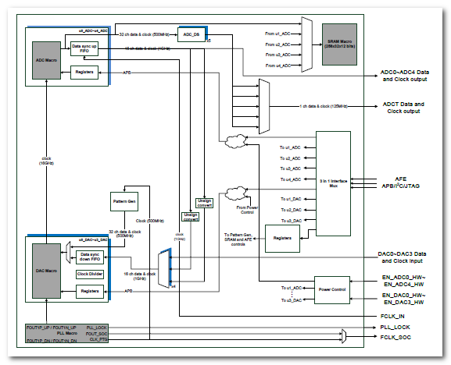

SoC IP Portfolio

Part Number | Process | Description | Download
Analog Front-End (AFE)
 | 12 - 28 nm | 5G AFE, 12-bit Analog Front-end (ADC/DAC/PLL) up to 16Gsps | IGAAFEV03A
 | 12 - 28 nm | WiFi AFE, 12-bit Analog Front-end (ADC/DAC/PLL) up to 500Msps | IGAAFEV04A
Analog-to-Digital Converter (ADC)
 | 130nm – 65 nm | Pipelined ADC, 10 – 12bit, 10Msps - 100Msps | IGAADCR13A
 | 3 - 65 nm | SAR ADC, 10 - 12 bits, 50Ksps – 16Gsps | IGAADCX04A
Digital-to-Analog Converter (DAC)
 | 12 - 65 nm | Current steering DAC, 10 - 12 bits, up to 16GHz | IGADACT01C
 | 5 - 65 nm | R2R DAC, 8 - 13 bits, <10MHz | IGADACT09A

